BEFORE THE WASHINGTON UTILITIES AND TRANSPORTATION COMMISSION

DOCKET NOS.
SHUTTLE EXPRESS, INC.,

Petitioner and Complainant,

v.

SPEEDI SHUTTLE WASHINGTON, LLC

Respondent.
TC-143691
TC-160516

OPPOSITION OF SHUTTLE EXPRESS, INC. PURSUANT TO NOTICE OF OPPORTUNITY TO RESPOND

- Pursuant to the October 6, 2016 Notice Of Opportunity To Respond To Request For Suspension Of Procedural Schedule, Shuttle Express hereby opposes the Speedishuttle request that if the Commission does not reconsider Order 08, the Commission suspend or stay these proceedings to enable Speedishuttle to reevaluate whether it will continue to operate in the marketplace as a regulated carrier.
DISCUSSION
  - It Would be Error to Tie These Dockets With the TNC Waiver Proceeding, as They Are Completely Unrelated.

- A popular and highly-valued public service offered by Shuttle Express for over two decades has recently come under assault from two independent and unrelated directions. The only commonality between the two is that both are harmful—both to Shuttle Express and to the public interest. Shuttle Express proactively filed two very different regulatory proceedings seeking orders responding to the assaults in two very different ways to preserve and promote the public interest.
- One proceeding sought regulatory relief—essentially regulatory inaction—to hopefully enable Shuttle Express to deal with a new type of competition it has never before faced, from unregulated TNCs. The regulatory relief afforded by the Commission is fully consistent with the statutes and thus required no legislative action.
- In contrast, this proceeding seeks regulatory action against a traditional, certificated, and fully-regulated auto transportation company that appears likely to have obtained its certificate by misrepresenting that its proposed services would be new and different and would carry previously unserved demographic of travelers, rather than merely split a shrinking market in half. The relief sought here would ensure that the requirements of RCW 81.68.040 were, and are, fully met. And, unlike the TNC proceeding, a decision not to enforce or to vary the restrictions of that statute would require legislative action.
- The Commission has now done its best to deal with one assault, by granting a limited and temporary waiver that may help Shuttle Express compete with TNCs. But that waiver has done nothing to address the other (and unrelated) assault, by Speedishuttle. Nor will a 10-month delay address or ameliorate the alleged harms that flow directly from Speedishuttle’s artful and successful effort to give the Commission the impression that, “Speedishuttle would [not] offer to serve any and all customers seeking door-to-door service to or from the airport.”
- Even if Shuttle Express is wildly successful in competing with TNCs under the recent waiver, it will have zero impact on the loss of a quarter to a third of its passenger base to a new auto transportation company that was not supposed to be offering the same service, except perhaps marginally. And while the Commission may favor more open competition, as it did in Docket TC-160819, the fact remains that it must still follow the law that restricts free entry by new auto transportation companies until the legislature changes that law. Laudably, the Commission has heretofore done its best in these dockets to follow RCW 81.68.040. It should not stop now based on an unrelated proceeding.
II. Granting a 10-month Stay Would Give Speedishuttle Exactly What it Has Been Unsuccessfully Seeking Since May, Which is to Avoid Any and All Scrutiny of its Alleged Wrongs and the Ongoing Harm to Shuttle Express and the Public Interest.

- First, Speedishuttle’s request for time to consider exiting the market if its service might be limited to the business plan it proffered is tantamount to an admission that the “entire demographic” that Shuttle Express “could not serve” either did not exist or is so minimal that there is no market that it could serve at a profit without also serving a substantial part of the market that was already being served satisfactorily by Shuttle Express. The supposed “new and unserved market” is so small that Speedishuttle wants “to reevaluate its multi-million dollar commitment” and may “exit” the market. The Commission should affirm Order 08 and allow Speedishuttle to make its decision, not reward it by giving it the very delay it has been seeking unsuccessfully for months.
- All a 10-month suspension will do is enable Speedishuttle to succeed in its Herculean efforts to avoid both discovery and a hearing on the merits of the Shuttle Express Petition and Complaint, at least for another 10 months. In essence, it would reward Speedishuttle for its alleged wrongs, and for reasons that have nothing to do with this case. In the meantime, both the public interest and Shuttle Express are being, and will be, further harmed. And if violations, misrepresentations, or even misunderstandings in the application phase of Docket TC-143691 are established, Speedishuttle will have succeeded in accomplishing an “end run” around RCW 81.68.040.
- Shuttle Express is certainly weary of dealing with all the procedural roadblocks that Speedishuttle has thrown up in an effort to prevent the truth about its services and fallout from being aired publicly. Indeed, Speedishuttle has yet again failed to respond timely to discovery that it offered to provide by October 11th, apparently based on a belief that somehow a suggestion to “stand down” from two unrelated pending matters (that was never agreed to) excused Respondent from providing discovery responses that were originally due nearly two months ago, on August 31st. The ongoing lack of meaningfully complete discovery responses despite a motion to compel and direction from the judge is unfortunate, because the Commission is still being denied the facts it truly needs to protect the public interest—which is implicated even in this scheduling decision.
- Speedishuttle’s foot dragging and unsuccessful procedural maneuvering to date should not be rewarded with a lengthy Commission-initiated delay. If Speedishuttle has committed the wrongs and caused the harms as alleged, it should not avoid review merely because the Commission has acted appropriately to allow Shuttle Express to try to respond to the entry of a completely unrelated mode of competition from TNCs. As the Commission itself just noted:
Shuttle Express correctly observes that the Commission’s ultimate responsibility is to ensure compliance with RCW 81.68.040 and other applicable laws. Consistent with the legislature’s directive, we did not and cannot authorize Speedishuttle to depart from its business model and offer the same service Shuttle Express provides. If the evidence demonstrates that Speedishuttle is doing so or is otherwise violating its regulatory obligations, we will take appropriate enforcement action.
Order 08, ¶ 26 (emphasis added).
- Going forward, the legislature may change the law and the Commission may change its rules. Until that time—which will likely take years, not months—the Commission should enforce the law, protect the public interest, and deal appropriately with Respondent for its unlawful acts and omissions as established after discovery and hearing.
III. The Commission Must Gather the Facts Before it Can Determine What Actions—Including Scheduling and Order of Proceeding—Will Best Serve the Public Interest.

- The Commission appears poised to effectively determine that the public interest will be served by delaying this case for nearly a year, despite having no facts in the record yet regarding what is actually going on in the real world. That would put the cart before the horse. Shuttle Express here offers just some of the data it expects to adduce at the hearing. It is offered not for a ruling on the merits, as it is very preliminary, but rather to show the lack of a relationship with the TNC issue and to support the need for prompt action. The data almost conclusively shows that the suggested delay will likely prove extremely harmful to Shuttle Express. And it further strongly implicates potential harm to the public interest.
- The fundamental factual disconnect between the entry of Speedishuttle in 2015 and the entry of TNCs in 2016 can be seen by publicly reported passenger data. Based on outbound trips reported to the Port of Seattle, there has been a steady decline in the number of auto transportation passengers carried by Shuttle Express and Speedishuttle combined since 2012. It can readily be seen that the entry of Speedishuttle did nothing to attract a new, entirely unserved demographic of tech-savvy tourists, as promised. The overall downward trend continued almost without change:
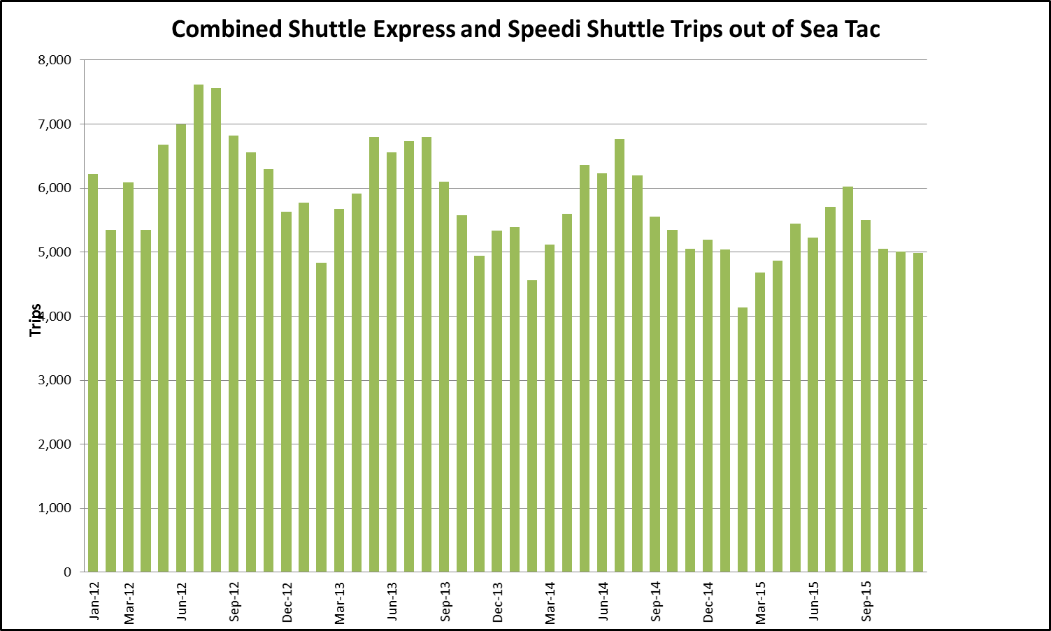
- Importantly, all the foregoing data precedes the advent of TNC service to SeaTac Airport. Thus, this issue can have nothing to do with the TNC issue raised by the Shuttle Express waiver petition. It is an independent issue.
- Separating the reports for two carriers, it appears that not only did Speedishuttle fail to grow the market for share ride services, in actuality it merely served the same passengers that would have been served (and were being served to the satisfaction of the Commission) by Shuttle Express:
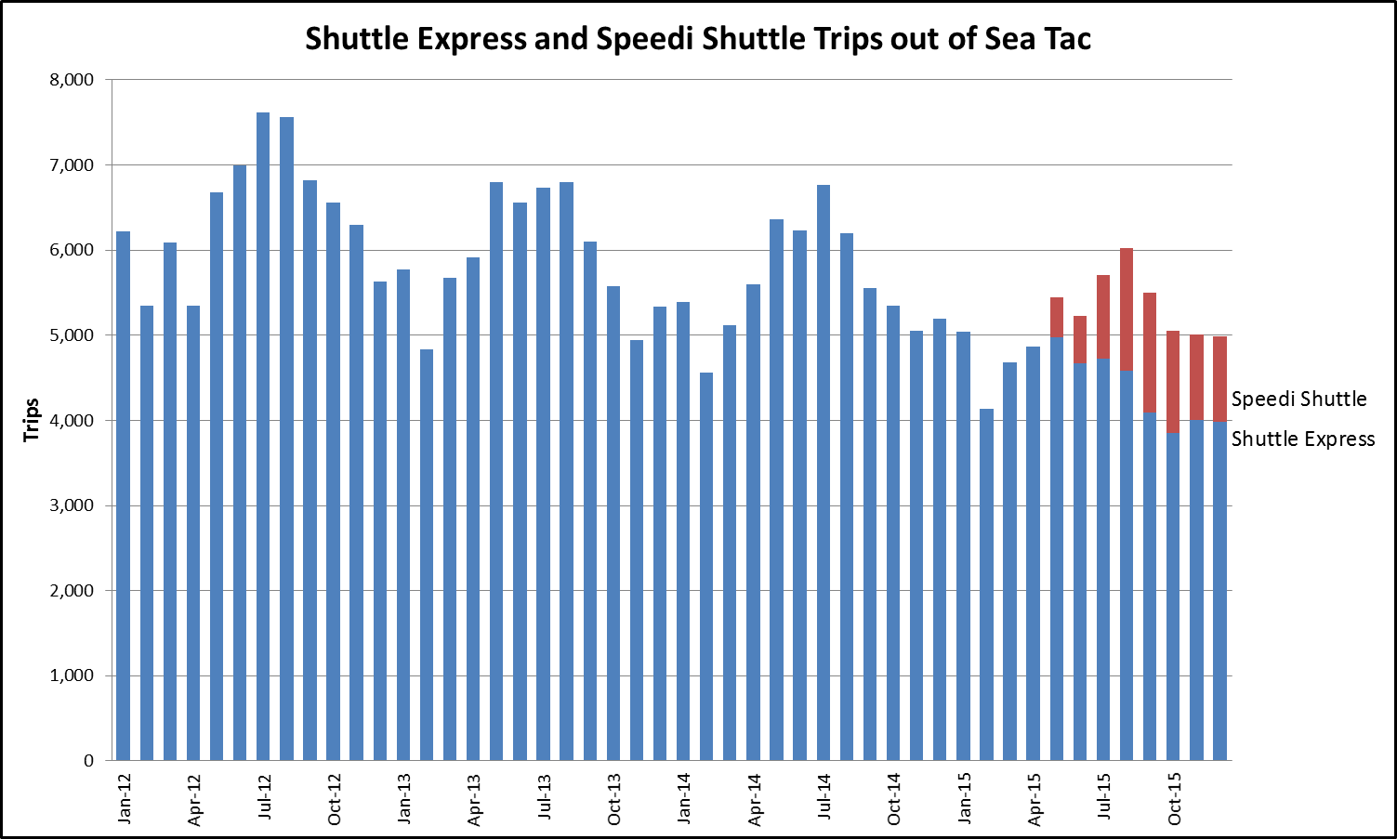
As the Speedishuttle passenger counts grew rapidly, the Shuttle Express counts moved in the opposite direction, by nearly the same magnitudes. Again, all this data precedes the entry of TNCs into the airport ground transportation market.
- Even before the production of any meaningful and substantive discovery by Speedishuttle, the public data is powerful evidence that no “unserved” demographic has been served since the Speedishuttle entry. The public data indicates that Speedishuttle has merely captured a significant portion of the pre-existing, already-served, base of travelers. Moreover, absent a stay or suspension, discovery is likely to further establish this fact. For example, it is known that the Go Group (“Go”) supported the Speedishuttle application because Shuttle Express had terminated its Go franchise agreement. Marks Declaration, ¶ 6. Shuttle Express did not terminate its third party ticket agreement with Go, but after Speedishuttle was granted its certificate Go refused to renew the Shuttle Express ticket agreement and instead entered into a third party ticket agreement with Speedishuttle. Id.
- By June of 2015, Go’s wholesale ticketing passenger counts for Shuttle Express dropped from four figures per month to essentially zero. At the same time, Speedishuttle’s passenger trips jumped from zero almost immediately to four figures. It is reasonable to infer that the same passengers who previously booked their transportation on Shuttle Express vans through the Go Group now instead book their transportation on Speedishuttle vans through Go. Marks Declaration, ¶¶ 2, 6, and Exh. A. Discovery should further bolster this conclusion, not only from Go, but also from Speedishuttle’s other wholesale third party ticket sellers.
IV. Long Term Public Policy Initiatives Would be Better Served by Completing This Case First and Then Considering Legislative or Rule Changes.

- In an unfortunate ironic twist, Speedishuttle misled the Commission into an inadvertent (and unlawful) experiment into what would happen if there were two door-to-door share ride van carriers providing the same service to the same territory, King County. Evidence will show it is not going that well, for the public and certainly not for Shuttle Express. It is probably not going well for Speedishuttle, either. After all, Speedishuttle’s Petition sought a conditional and limited stay (“sufficient time”) to consider exiting the SeaTac market.
- If the Commission stays this case for 10 months, it will presumably hold workshops, conduct a rulemaking, and maybe go to the legislature. It can expect that the various stakeholders will pontificate and opine on what may or may not happen if the laws or rules are changed in some way. But what generally is sorely lacking in such policy proceedings is discovery, sworn evidence, and testing of the evidence with the rigors of cross-examination by the parties and the bench. This proceeding not only tees up some of the issues that the Commission may wish to consider in the long term, it provides a perfect—if unintended—opportunity to meaningfully investigate what competition in auto transportation business does in the real world. Actual, rather than merely hypothetical mpacts on the carriers and the public can be demonstrated, under oath, and after reasonable discovery.
- The staff’s vision that “all parties [will] work together” in the as-yet unscheduled and unspecified policy or legislative proceedings is not consistent with the high level of discord between Petitioner and Respondent that the Commission has observed. And even if the parties could all agree, they could not rewrite RCW 81.68.040, which is what would be required for Speedishuttle to have had the right to offer the exact same service as Shuttle Express was already satisfactorily providing. Nor does staff attempt to connect the rule waiver with this case. Finally, it is likely impossible to change the statute in 10 months, especially if workshops are to be held first. The earliest a new law could likely become effective would be sometime after the 2018 legislative session.
- Shuttle Express urges the Commission to continue this proceeding and enforce the law and its rules as they existed in 2015, as they exist today, and as they will likely exist for the foreseeable future. After the facts are in and appropriate remedies are meted out, the Commission will be in a better position to make long-term policy decisions and it may even be possible for the parties to starting working together. The staff’s goal of a “greater prize” is reasonable, but the suggested timing is backwards. And there is ongoing harm today that needs to be addressed as soon as practicable, not delayed indefinitely.
CONCLUSION
- The Commission has many tools at its disposal to protect the public interest. It should not abdicate, even temporarily. Doing so would fail to deal with substantive issues that are: readily apparent from public data, all but admitted, and not going away. Most importantly,
in the extra 10 months, additional and perhaps irreparable harm to the public interest and Shuttle Express will continue unabated.
Respectfully submitted this 21st day of October, 2016.
LUKAS, NACE, GUTIERREZ & SACHS, LLP

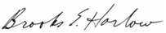
_______________________________________
Brooks E. Harlow, WSBA 11843 Counsel for Shuttle Express, Inc. 8300 Greensboro Dr. Suite 1200
McLean, VA 22102
Phone: 703-584-8680
Fax: 703-584-8696
bharlow@fcclaw.com

CERTIFICATE OF SERVICE

I hereby certify that on October 21, 2016, I served a copy the foregoing document via email, with a copy via first class mail, postage prepaid, to:

Julian Beattie
Office of the Attorney General Utilities and Transportation Division 1400 S. Evergreen Park Dr. SW
PO Box 40128
Olympia, WA 98504-0128
(360) 664-1192
Email: jbeattie@utc.wa.gov

David W. Wiley Williams Kastner Two Union Square
601 Union Street, Suite 4100
Seattle, WA 98101
206-233-2895
Email: dwiley@williamskastner.com

Dated at McLean, Virginia this 21st day of October, 2016.

Elisheva Simon Legal Assistant

Petitioner/Complainant Shuttle Express, Inc. (“Shuttle Express”) notes its appreciation for the consideration of counsel’s travel schedule in setting the due date for this answer.
Speedishuttle of Washington, LLC d/b/a Speedishuttle Seattle (“Speedishuttle”).
Transportation Network Company, e.g., Uber, Lyft, etc., which are not presently regulated by the Commission.
It was also an appropriate response and is much appreciated by Shuttle Express.
The legal standards applicable to the two proceedings are vastly different. The legislature expressly mandated that new auto transportation applicants cannot be approved in a territory already served unless the Commission finds the existing certificate holder will not provide satisfactory service. Thus the Commission lacks authority to waive the requirement. In contrast, the legislature did not mandate the auto transportation companies must only use employee operators, making the Commission’s rule waivable.
Order 08, ¶ 23.
See Order 08, ¶ 23. Indeed, in Order 08 the Commission committed to act if Speedishuttle is shown to be “offer[ing] the same service Shuttle Express provides.” Id., ¶ 26.
See Order 04, ¶ 20, (Dkt. TC-143691).
Shuttle Express also has a multimillion dollar commitment to this market, built up over the last 20 plus years. It is being unfairly devastated by Speedishuttle.
See Petition for Reconsideration of Order 08, ¶ 17.
The Petition and Complaint are replete with allegations regarding the ongoing and potential future harm to the public interest, including, for example: “fewer passengers will be carried per trip, fares may have to be higher, the extent of geographic coverage may be narrowed, and/or passengers will have to wait longer until a shared ride van can be filled to a reasonable capacity.” Petition and Complaint, ¶ 26. Shuttle Express already has evidence of some of these harms and discovery will likely provide even more evidence of ongoing harm.
At the discovery conference on September 27th, the Judge order substantial discovery responses over the objections of Respondent and asked when they could be provided. Respondent offered October 11th. Petitioner said that October 17th would be acceptable, as its counsel was out of the office until that day. Respondent stated it’s “appreciation” for the extra days and committed to “go forward right away.” However, not a single response was provided on October 17th. Harlow Declaration, ¶ 2.
The emails among counsel regarding Speedishuttle’s failure to respond and its rationale are attached to the Harlow Declaration as Exhibits A and B. The Commission can draw its own conclusion as to what was or was not agreed regarding the outstanding and long overdue discovery responses.
It reflects a quintessential “result injuriously affecting [Shuttle Express] which was not considered or anticipated at the former hearing….” Order 08, ¶ 23.
See Declaration of Wesley Marks, ¶¶ 3-4, filed herewith.
Graph and data from Marks Declaration.
Marks Declaration, ¶ 5.
Graph and data from Marks Declaration. Note: if printed, a color rendition is needed to clearly see the split in the bars showing the breakout of the Shuttle Express versus Speedishuttle trips after April, 2015.
It did not ask for a 10-month stay to continue what may well be found in these dockets to be unfair competition, harm to the public interest, or even predatory pricing, as could occur pursuant to the Commission’s Notice.
Commission Staff’s Response, ¶ 3 (Oct. 13, 2016).
Because the door-to-door auto transportation market is continuing to shrink overall, for a number of reasons outside the control of either the Commission or Shuttle Express, splitting the market in half as Speedishuttle has done may even threaten the long-term viability of county-wide airport shuttle service. In 10 months it could be too late to undo long-term damage to the market.

