December 4, 2012

David W. Danner, Executive Director and Secretary
Washington Utilities and Transportation Commission
1300 S. Evergreen Park Dr. SW
P. O. Box 47250
Olympia, Washington 98504-7250

RE: Washington Utilities and Transportation Commission v. New Horizons Communications Corp.
Commission Staff’s Response to Application for Mitigation of Penalties
Docket UT-120991

Dear Mr. Danner:

On July 31, 2012, the Washington Utilities and Transportation Commission issued a $1,900 Penalty Assessment in Docket UT-120991 against New Horizons Communications Corp. (New Horizons) for 19 violations of Washington Administrative Code (WAC) 480-120-382, which requires permitted telecommunications companies to furnish annual reports to the commission no later than May 1 each year.

On August 9, 2012, New Horizons wrote the commission requesting mitigation of penalties (Mitigation Request). In its Mitigation Request, New Horizons disputes that the violations occurred. The company states, “Enclosed is a payment of $475. This represents 19 business days @ $25 per day as indicated in the penalty notification. New Horizons also requests a review of arrival. The document was prepared in April and New Horizons believes it arrived well before the indicated date … The company respectfully requests an adjustment to the total amount due based on the Commission’s corresponded. For your convenience, I have enclosed a copy of that correspondence. The correspondence states in paragraph 5 that the $100 per day penalty has been mitigated to $25.00 per business day and therefore using the Commission’s adjusted fee of $25.00 per day at the Commission’s calculated nineteen (19) business days, the Company is enclosing the above mentioned check at the adjusted amount. However, although the Company has paid in full at the adjusted rate, the Company also respectfully requests a review of the amount of days it took for the Commission to receive this report. The correspondence specifies that the report was filed nineteen (19) business days late and was received on May 26, 2012. New Horizons is surprised that the arrival date was May 26, 2012, the document was prepped on April 29, 2012 and sent for an officers signature and then to be mailed and should not have taken almost a full moth for the Commission to receive. I do not believe the Company received a date stamp cover letter back from the Commission as requested and therefore it is hard to track the actual date of arrival.”

It is the company’s responsibility to ensure that the regulatory fee and the annual report are filed by the May 1 deadline. On February 29, 2012, Annual Report forms and Regulatory Fee packets were mailed to all regulated telecommunications companies. In addition to other information, the cover letter informed the regulated company it must complete the annual report form, pay any regulatory fees and return the material by May 1, 2012 to avoid enforcement action. On May 14, 2012, the commission mailed a letter to those companies that had not yet filed an annual report or filed an incomplete annual report, notifying them that, to date, they had incurred a penalty of $800. The letter went on to explain that companies who filed their annual reports no later than May 25, 2012, would receive mitigated penalties of $25 per day, with an additional $25 per day for each instance in the previous five years that the company received a penalty for filing a late report.

Commission staff reviewed the penalty assessment and the language in the fifth paragraph does say, “The penalty was mitigated from $100 per day to $25 per day for a total of $1,900.” This language is not consistent with the penalty amount of $1,900 which is reflected at the top of the assessment and again on the final page, which allows for payment of the penalty. New Horizons is responsible for a penalty of $100 per business day for a total of $1,900 because it did not file the documents necessary to complete its annual report until May 26, 2012.

The annual report on file with the commission is dated April 29, 2012, and shows a commission received date stamp of May 8, 2012. The annual report also shows a date stamp of May 30, 2012, which is the date the annual report was entered into the commission’s database.

Compliance staff received a delinquent filing status report from Financial Services on May 18, 2012 and New Horizons was on that report. Commission Financial Services staff has indicated the annual report received date stamp is the date the report was originally received and the other date stamp is the date the annual report was completed.

Commission staff reviewed the commission’s Annual Reports Tracking System (ARTS) and the system shows the report was completed on May 26, 2012.

On May 26, 2012, Ronald A. Sheehan of New Horizons emailed commission staff the following, “Hi Mr. Perkinson. I have received a notice from the UTC indicating that my Annual Report for New Horizons Communications was not complete. To my surprise I just found a VM message from Ralin (not sure if I am spelling that correctly) which for some strange reason I did not receive until today. She had indicated that I did not include the my [sic] company’s financials. Attached please find the company’s balance sheet and Income [sic] statement. Should there be anything else I need to do to clear this deficiency [sic] please contact me at the [sic] below. Note I have left a message for Ralin to indicate this email was sent.”

New Horizons filed its annual report on May 26, 2012, which is 19 business days past the deadline of May 1, 2012. The penalty is $100 per day for a total of $1,900. New Horizons has never received a penalty for filing a delinquent annual report in the past. New Horizons enclosed a payment of $475 with its mitigation request. In reviewing the penalty assessment, staff finds the penalty of $1,900 is appropriate.

Staff supports mitigating the assessed penalty from $1,900 to $950, which represents a 50 percent reduction because this is New Horizons first late filing. New Horizons has already made a payment of $475. If the commission follows staff’s recommendation, New Horizons would have a remaining balance of $475.

If you have questions regarding this recommendation, please contact Mathew Perkinson, Compliance Investigator, at (360) 664-1105, or at mperkinson@utc.wa.gov.

Sincerely,

Sharon Wallace, Assistant Director
Consumer Protection and Communications

Attachment A
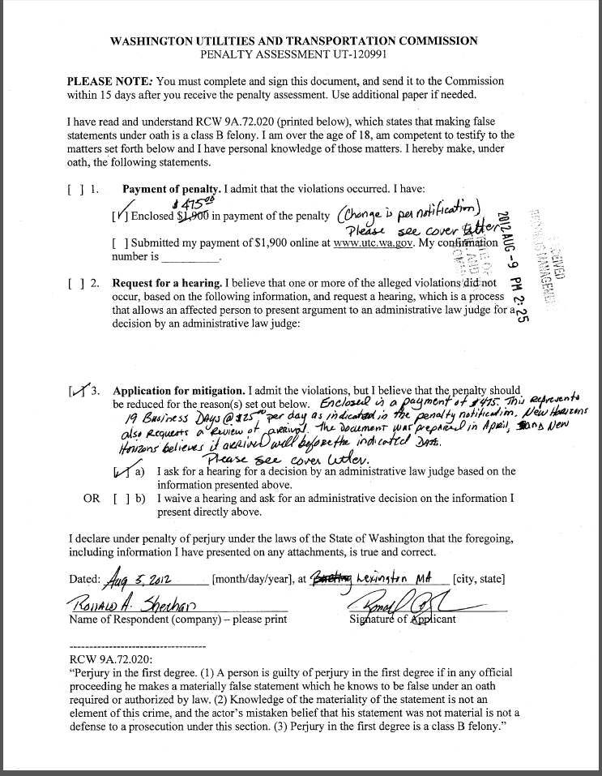
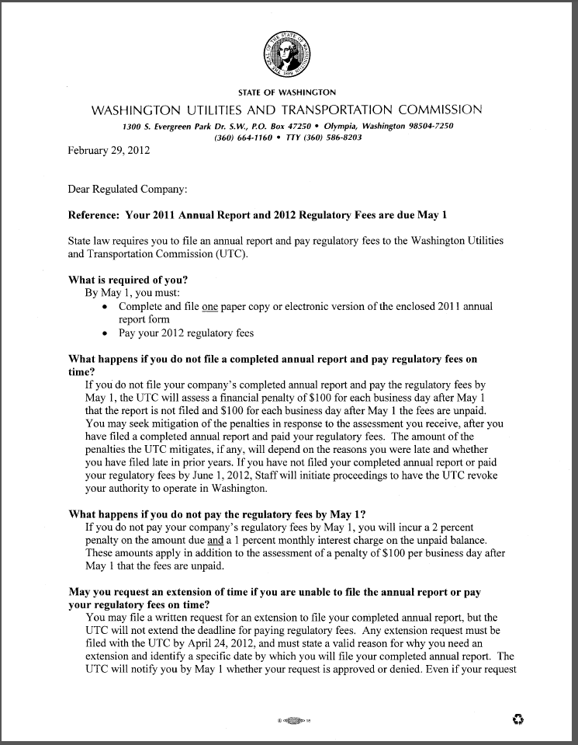
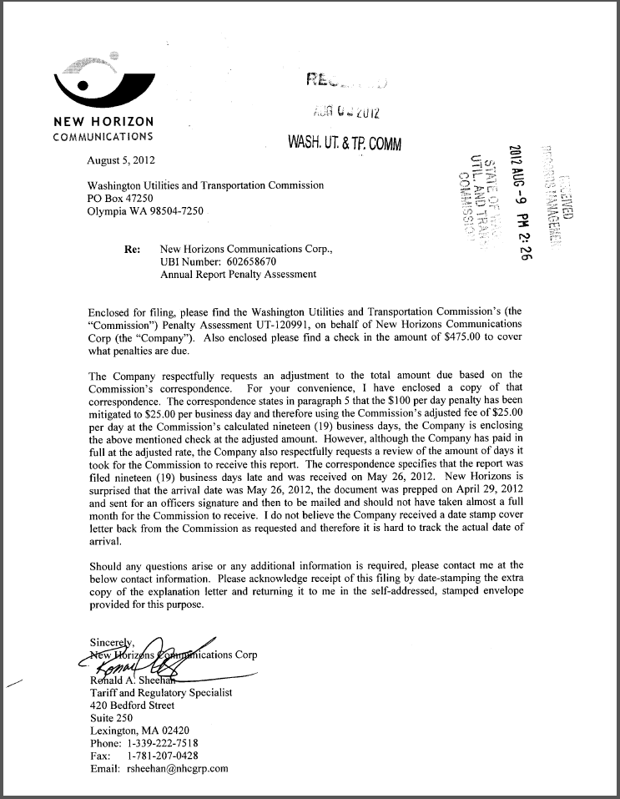
Attachment B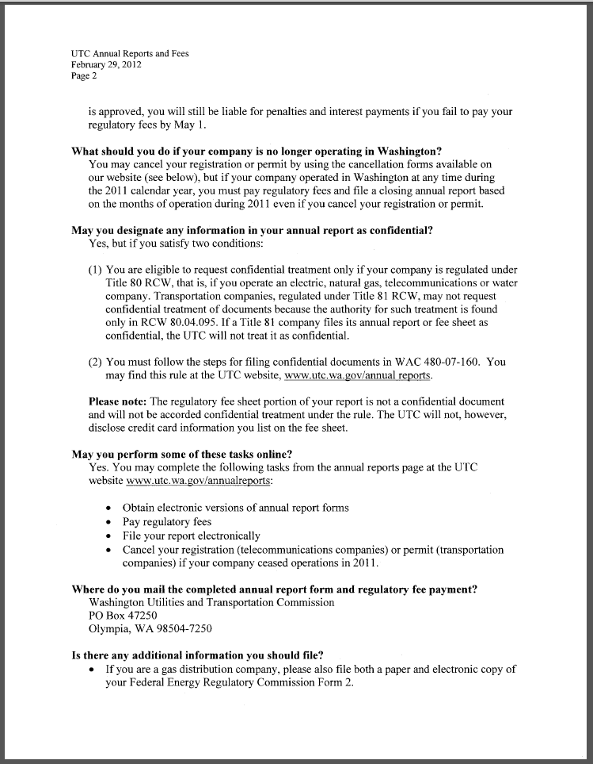

Attachment C
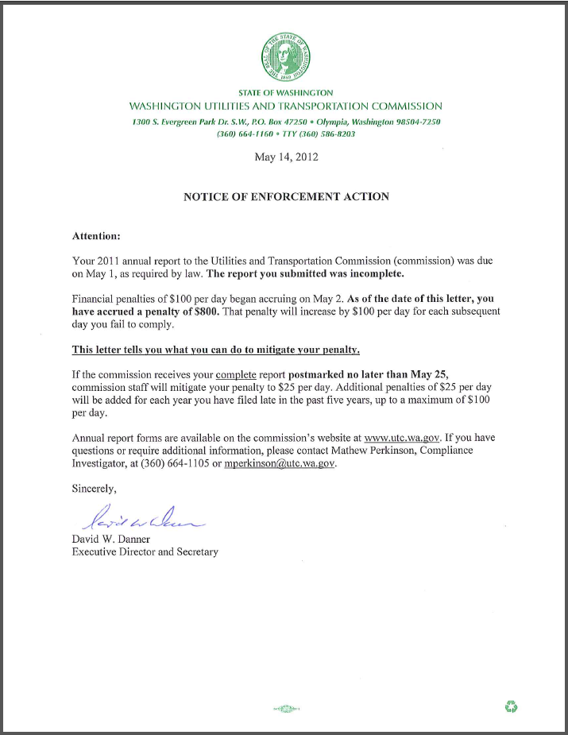

Attachment D

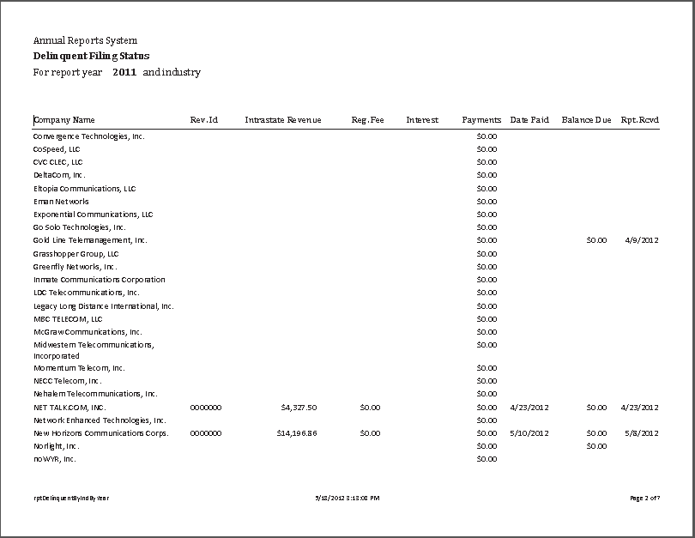

See attachment A for a copy of New Horizons’ Mitigation Request.
See attachment B for a copy of the letter sent to all regulated companies on February 29, 2012.
See attachment C for a copy of the enforcement letter sent to the company on May 14, 2012.
See attachment D for a copy of the delinquent filing status report received May 18, 2012.

