Is Inflation a Risk? Not Now, but Some See Danger Ahead

Though slack in the economy and a vigilant Fed currently keep prices well in check, some economists say political pressure and new emphasis on maximizing employment could test central bank’s resolve

Inflation remains under Fed target
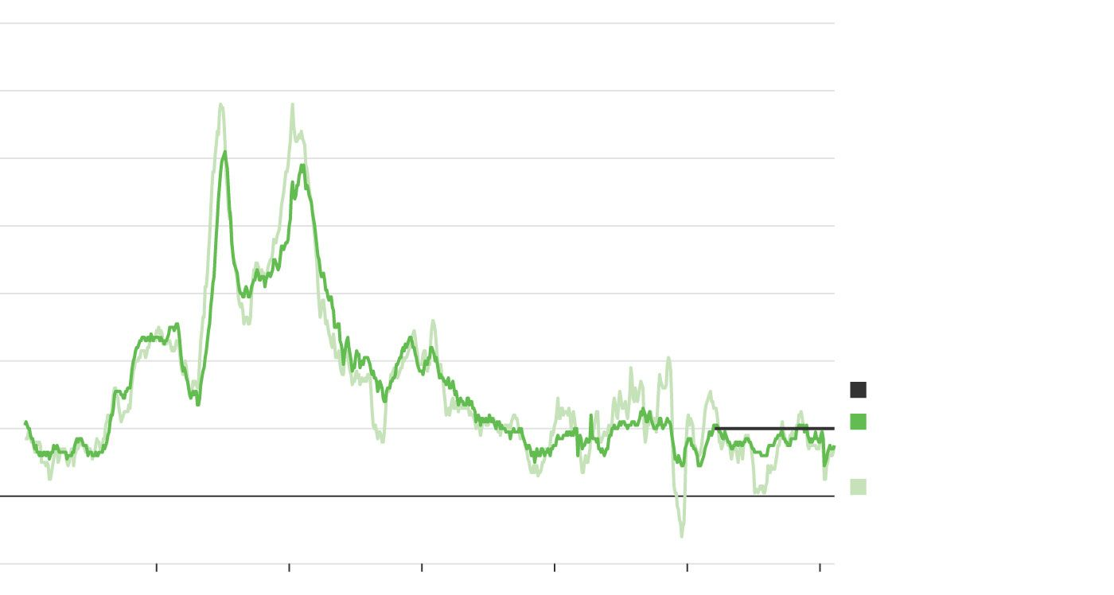
14
%
12
10
8
6
4
Federal Reserve target
2
Inflation, excluding
food and energy
0
Overall inflation*
–2
1960
’70
’80
’90
2000
’10
’20
*Annual change in price index of personal consumption expenditures
Sources: U.S. Commerce Dept. (inflation), Federal Reserve (target)
By
Greg Ip
March 1, 2021 11:09 am ET
  - SAVED
  - SHARE
  - TEXT

436 RESPONSES
Listen to this article
15 minutes
00:00 / 15:04
1x

Inflation is near a decade low and well below the 2% level the Federal Reserve targets as ideal. The usual conditions for rising inflation—tight job markets and public expectations of rising prices—are glaringly absent.
Yet anxiety about inflation is at a fever pitch, among economists and in markets, where long-term interest rates have been grinding higher since President Biden unveiled plans for huge new fiscal stimulus.
Behind this dichotomy is a clash of forces. In the near term, plentiful unused capacity and decades of habits are likely to keep inflation low. After years of undershooting 2%, the Fed would like inflation to slightly overshoot. That, it hopes, would banish the specter of deflation and stagnation that has haunted advanced economies for a decade.
“The kind of troubling inflation that people like me grew up with seems far away and unlikely,” Fed Chairman Jerome Powell said in late January.
But in the longer term, some economists and investors see a shifting political climate more conducive to inflation rising well past 2%. They argue the Fed’s pursuit of over-2% inflation, Mr. Biden’s $1.9 trillion stimulus plan and new goals such as narrowing racial economic disparities reduce the priority that policy makers will place on inflation.
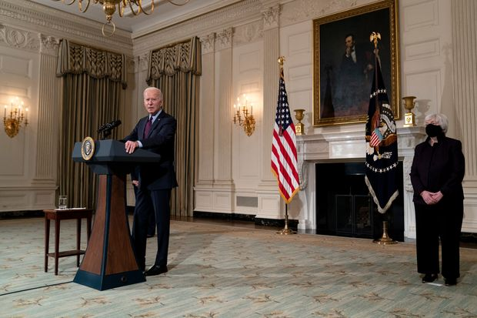

Treasury Secretary Janet Yellen listened as President Biden spoke about the economy in the State Dining Room of the White House on Feb. 5.
PHOTO: STEFANI REYNOLDS/PRESS POOL
“The prevailing zeitgeist is all about accepting and even being enthusiastic about higher inflation,” said Larry Summers, the Harvard University economist and former adviser to Presidents Bill Clinton and Barack Obama. He says the risk of inflation expectations shifting dramatically, leading to a disorderly fall in the dollar, is at its highest since the 1970s.
The inflation picture has been muddied by the pandemic. As the global economy shut down last spring, prices for gasoline, lodging and airfares plummeted, helping drive inflation, as measured by the 12-month change in the consumer price index, down from 2.3% in February 2020 to 1.4% this January. Core inflation, which excludes the more volatile food and energy components, was also 1.4%, around the lowest since 2011.
As last spring’s negative numbers drop out of the 12-month calculation and oil prices rebound, the inflation rate will automatically rise. At the same time, businesses may regain pricing power as vaccinated customers flock back. Economists surveyed by The Wall Street Journal expect the inflation rate to rise to 2.75% in the second quarter, then drop again.
Julia Coronado, an economist who runs the research service MacroPolicy Perspectives, expects core inflation to fall to 1.2% by the end of the year. That’s because rent, the biggest piece of the consumer price index, is being pushed down by unemployment.
The Fed’s 2% target is based on a different inflation measure: the price index of personal consumption expenditures. PCE inflation typically runs below CPI inflation, but right now it is running above, at 1.5%.
Temporary effects from the pandemic likely won’t influence where inflation is heading, because inflation is typically driven by how much room the economy has to grow. Right now, idle businesses and unemployed workers, as well as inflation expectations, which determine price and wage setting behavior, suggest inflation will be subdued.
Unemployment rateSources: U.S. Labor Dept. (unemployment rate);Federal Reserve (natural rate)*Federal Open Market Committee's consensusestimate of long-run unemployment rate, belowwhich cost pressures are expected
%Currentrate'Natural'rate*2010'15'2002468101214
At the end of last year, gross domestic product was 3% to 4% below the Congressional Budget Office’s estimate of GDP “potential,” the level the current labor force and business capital can sustain without inflationary bottlenecks.
The unemployment rate in January was 6.3%, well above Fed officials’ median estimate of the “natural” unemployment rate of 4.1%. Below the natural rate, cost pressures build. Including the millions of people who have quit the labor force or have been misclassified would raise unemployment to 10%, according to the Fed.
Bond yields have risen sharply since Democrats won control of the Senate in early January, on expectations of more stimulus, more growth and more inflation. On Friday, expected inflation in the next five years stood at 2.39%, the highest in eight years, according to the yields on regular and inflation-protected Treasury bonds. But that might reflect rebounding oil prices and other transitory effects. Expected inflation over the subsequent five years is just 1.9%.
Economists project that a combination of fiscal and monetary stimulus plus vaccinations allowing most of the economy to reopen should largely eliminate the output gap this year. Wendy Edelberg and Louise Sheiner of the Brookings Institution project that if Mr. Biden’s full $1.9 trillion plan is enacted, GDP will soar 7.8% this year. By early next year, they say, GDP would stand 2.6% above the CBO’s estimate of potential, and unemployment would temporarily dip to 3.2%.
While this would qualify as a hot economy, whether it would push inflation much above 2% is fiercely debated. For most of the past 25 years, inflation has run close to or below 2%, even when GDP was above potential and unemployment was below its natural rate.
Future inflation implied by Treasury yields has risen sharply since a plunge in MarchSource: Federal Reserve Bank of St. Louis
%Next 5 yearsSubsequent 5 years2019'20'210.000.250.500.751.001.251.501.752.002.252.50
Economists cite several possible reasons. First, inflation expectations have been anchored at around 2%, so companies and workers haven’t built higher inflation into their behavior even when the economy overheats. Second, globalization and automation have weakened workers’ and companies’ ability to raise wages and prices, while aging populations have slowed economic growth.
Third, the CBO and the Fed might have underestimated the economy’s potential and overestimated the natural rate of unemployment. The idea is that a hot economy pulls marginalized workers into the labor market, creating additional capacity.
Mr. Powell appears to share this view. He recently noted that unemployment had fallen to 3.5% just before the pandemic. This “did not result in unwanted upward pressures on inflation, as might have been expected,” he said in a speech. “In fact, inflation did not even rise to 2% on a sustained basis.”
Adam Ozimek, chief economist at freelance job site Upwork, estimates that the Fed, by raising interest rates starting in 2015 based on an overestimate of the natural rate of unemployment, cost the U.S. a million jobs.
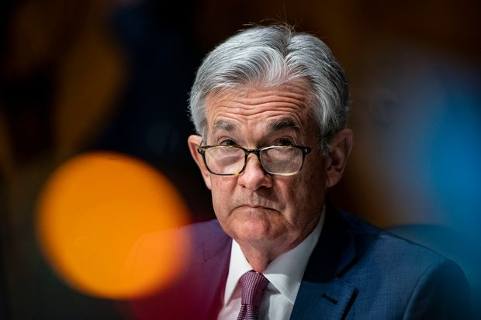

Federal Reserve Chairman Jerome Powell
PHOTO: AL DRAGO/PRESS POOL
That sort of cost now weighs heavily on the Fed’s thinking. “We should be less fearful about inflation around the corner and recognize that that fear costs millions of jobs—millions of livelihoods, millions of hopes and dreams,” Mary Daly, president of the Federal Reserve Bank of San Francisco, said in February.
The Fed worries that if inflation persistently runs below 2%, inflation expectations will also drift down, making too-low inflation self-reinforcing. Over time, lower inflation leads to lower interest rates and thus less room to cut them to counteract recessions, a situation that embroiled Japan when inflation turned negative in the 2000s.
To counteract this risk, the Fed announced last August that to make up for below-target inflation, it would seek to push inflation over 2%, so that over time, inflation and thus inflation expectations both averaged 2%. Mr. Biden’s stimulus brings that goal closer.

From the Archives
What the Fed’s Shift in Monetary Policy Means for Interest Rates
YOU MAY ALSO LIKE
UP NEXT
0:00 / 6:14
2:36
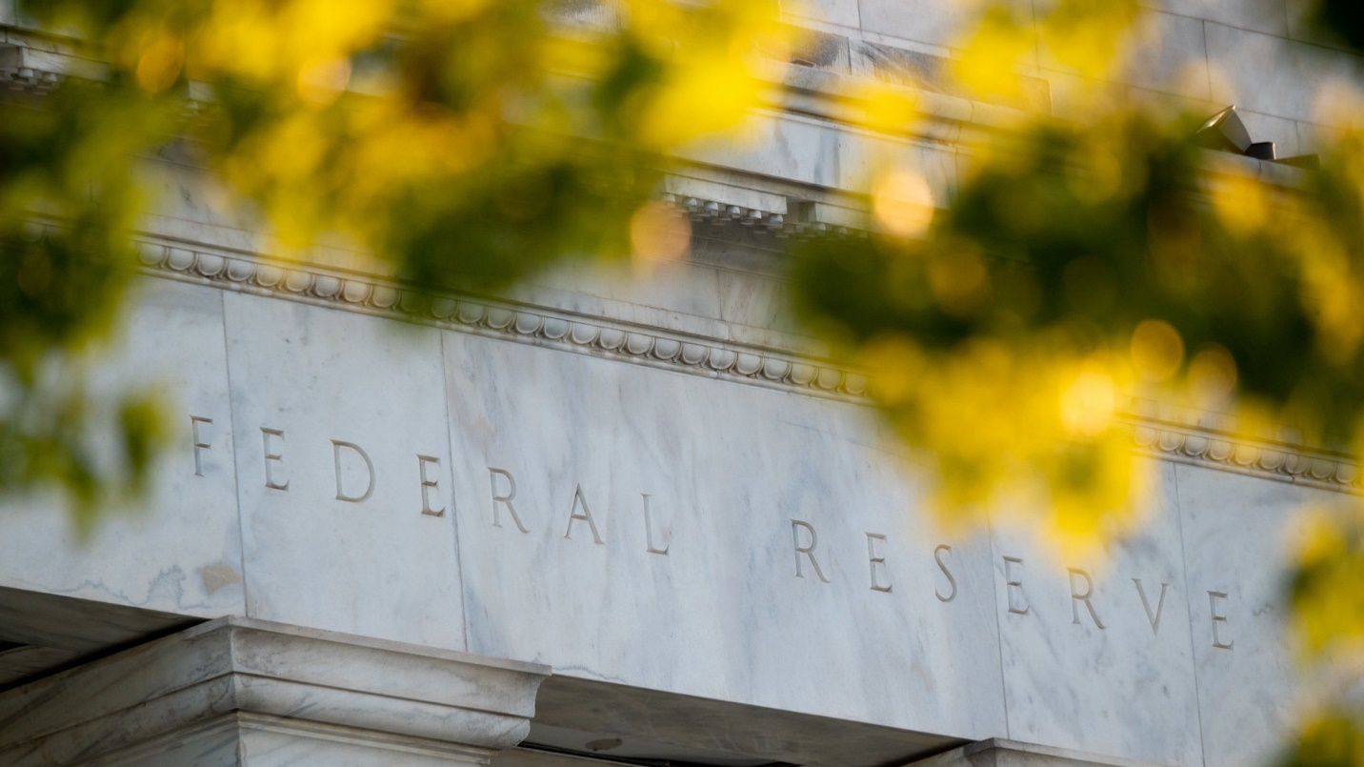
What the Fed’s Shift in Monetary Policy Means for Interest Rates
Federal Reserve Chairman Jerome Powell announced in late August a major shift in how the central bank sets interest rates. WSJ’s Greg Ip explains the strategy behind the changes and what they mean for consumers. Photo: Erin Scott/Bloomberg (Originally Published Aug. 27, 2020)
Neither markets, the Fed nor most economists think it will push inflation meaningfully above the Fed’s target. They argue, for example, that as the fiscal boost expires next year, the upward pressure on spending and therefore on prices will recede. Economists surveyed by the Journal see CPI inflation at 2.2% at the end of 2023.
But some influential economists disagree; they say Mr. Biden’s stimulus is so large it will push the U.S. past any reasonable estimate of the economy’s potential output, which could boost inflation much higher than the Fed wants.
Mr. Biden is motivated in part by Democrats’ belief that former President Barack Obama’s $831 billion stimulus in 2009 was too small. Mr. Summers, who helped design Mr. Obama’s package, acknowledges it was only about half the gap between the economy’s output and its potential. Yet Mr. Biden’s is equal to about three times the gap, which Mr. Summers said is “entirely unprecedented territory.”

Gap between actual and ‘potential’* GDP
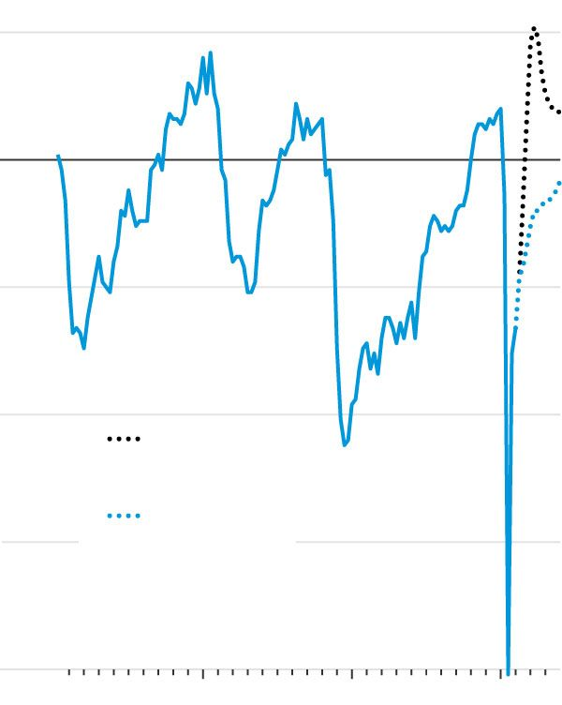
2.5
%
TIGHT
CAPACITY
0
EXCESS
CAPACITY
–2.5
–5.0
With Biden
stimulus
Baseline
projection
–7.5
–10.0
1990
2000
’10
’20
*Sustainable without inflationary bottlenecks
Sources: Congressional Budget Office (historical & baseline); Wendy Edelberg & Louise Sheiner, Brookings Institution (Biden stimulus)
Many forecasts assume that because social distancing restrictions limit how much people spend, each dollar of Mr. Biden’s stimulus will generate less than a dollar of GDP—that is, the “multiplier” will be less than one. But Olivier Blanchard, former chief economist at the International Monetary Fund, says the multiplier could easily be much more because the stimulus favors lower-income families, who spend more of their income. Add to that $900 billion of stimulus enacted in December and $1.6 trillion in savings that households have on hand, he says.
“This would be an increase in demand that I have not seen in my lifetime,” said Mr. Blanchard, an academic who has taught and written extensively on macroeconomics since the 1970s. Indeed, it could drive unemployment down to 1.5%, he estimates.
Mr. Summers and Mr. Blanchard see worrying parallels to the 1960s. President John Kennedy’s advisers at the start of the decade were right to think fiscal policy could push unemployment lower without inflation, Mr. Summers said. “It’s just that the idea got taken to political excess [under President Lyndon Johnson] with ‘guns and butter,’ ” he added. Unemployment went below 4% in 1966, and inflation, which had been below 2% since 1960, jumped to 5% in 1969.
Mr. Summers said today’s economists are too quick to conclude from recent decades that low unemployment is no longer inflationary. He said unemployment hasn’t stayed low long enough to prove that, because when unemployment dropped to low levels, the Fed usually responded by raising rates and causing a recession.
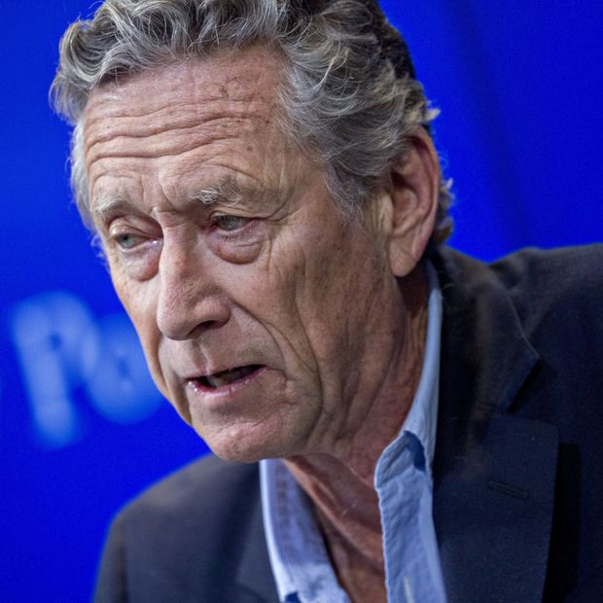

Olivier Blanchard
PHOTO: ANDREW HARRER/BLOOMBERG NEWS
Both Fed and Biden administration officials are confident that central banks have learned from the 1960s and 1970s and won’t repeat those mistakes. And while the Fed has limited ability to cut rates when inflation is low, it can raise them as much as needed when inflation is high.
Jared Bernstein, a member of Mr. Biden’s Council of Economic Advisers, said the administration believes the risks of high and persistent unemployment, hunger, eviction and other fallout from Covid-19 without stimulus outweigh the risks of inflation with stimulus. That doesn’t mean that the risk of inflation is zero. “It does mean we have a central bank laser-focused on maintaining anchored inflation expectations to guard against that risk,” he said.
The Fed has said it would start raising interest rates from around zero only when inflation is 2% and likely to stay above that, and the U.S. is at maximum employment.
It has not, however, said what level of inflation would be too high. In January, Charles Evans, president of the Federal Reserve Bank of Chicago, said: “I’m not worried about inflation going up substantially beyond 2.5%. I don’t even fear 3%.”
The Fed has hinted at how interest rates will adjust as inflation rises. Vice Chairman Richard Clarida has said the Fed will consult a rule he and two other academics developed in a 1999 paper. When inflation is on target, interest rates will gradually rise to neutral—a level that neither restrains nor stimulates activity, which the Fed currently puts at 2.5%. When inflation persists above the 2% target, rates will eventually rise by 150% of the difference. So if actual and long-run expected inflation hit 3%, this rule would ultimately prescribe interest rates at 4%. That should damp spending and inflation.
This formula doesn’t target unemployment. But in mainstream economic models, including the Fed’s, for inflation to fall, unemployment has to rise—perhaps by a lot. And that has happened only during recessions.
Some economists think this means the Fed would be reluctant to push back that hard against higher inflation, especially since its definition of maximum employment now considers unemployment, employment and labor-force participation by different demographic groups.
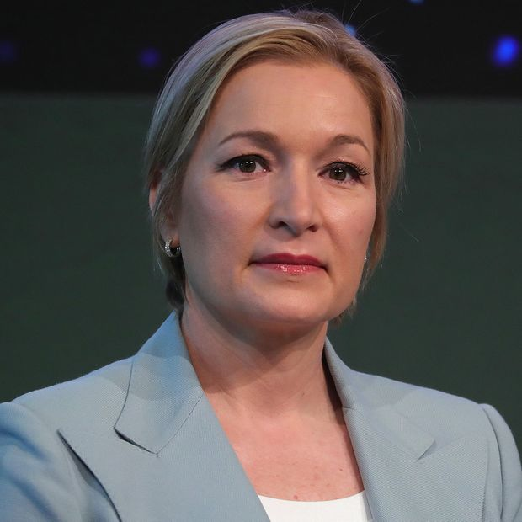

Ellen Zentner
PHOTO: KRISZTIAN BOCSI/BLOOMBERG NEWS
“The focus on inequality drives this maximum-employment mandate, and it really takes precedence over the inflation mandate,” said Ellen Zentner, chief U.S. economist at Morgan Stanley. She sees inflation persisting above 2% through 2023 because “fiscal policy activism” such as bigger budget deficits and a higher minimum wage make for a more inflationary economy.
The Fed might also face political pressure against raising rates because higher rates increase the cost of soaring federal debt and deficits. The “joint fiscal-monetary policy revolution...risks greater political constraints on the ability of central banks to lean against inflation,” strategists at fund manager BlackRock wrote last year.
If inflation ever did reach 3%, the Fed might face internal or external pressure to raise its target rather than try pushing inflation back to 2%.
Indeed, some economists have challenged the wisdom of the 2% target around which central banks have coalesced. In 2010, Mr. Blanchard suggested a higher target, such as 4%, would mean higher interest rates over time and thus more room to cut to counteract recessions.
Citing similar logic, a group of progressive economists including Mr. Bernstein and Heather Boushey, another of Mr. Biden’s economic advisers, urged the Fed to raise its target in a 2017 letter.

SHARE YOUR THOUGHTS
Do you see a danger of inflation getting too high? Why or why not? Join the conversation below.
The Fed’s independence became less sacrosanct under former President Donald Trump, who departed from his three predecessors by pressuring Mr. Powell to cut rates. Mr. Biden, who portrays himself as a defender of independent American institutions, is unlikely to do the same. Treasury Secretary Janet Yellen, as a former Fed chair, is also likely to defend its independence.
Mr. Powell demonstrated under Mr. Trump that he would resist political pressure on monetary policy. Still, his term as chairman expires next year, and already one liberal activist group, Fed Up, opposes reappointing him for allegedly not doing enough to address racial unemployment gaps.
One year is unlikely to answer the question of where inflation is ultimately headed. “For a quarter of a century, all of the pressures were…pushing downward on inflation,” Mr. Powell told Congress last week. “Inflation dynamics do change over time, but they don’t change on a dime.”

