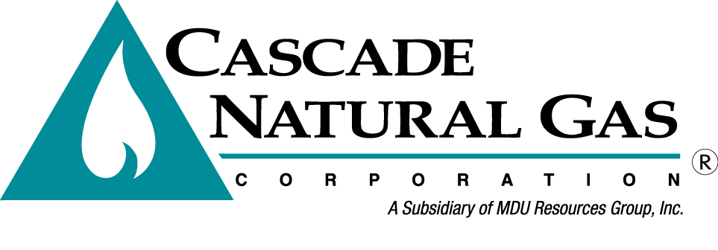
2nd External TAG Meeting
07/17/2016 – 09:00-11:30 AM
Presenters: Mark Sellers-Vaughn & Brian Robertson
In attendance: Mark Sellers-Vaughn, Brian Robertson, Mike Parvinen, Chris Robbins, Eric Wood, Bruce Folsom – Consultant, Connor Reiten – NWGA, Deborah Reynolds – WUTC, Kathy Scanlan- WUTC
Called in: Bob Morman, Garret Senger, Laura Flanders - NWP, Chad Luginbill, Josh Romine, Tom Pardee – Avista, Monica Cowlisha, Carolyn Stone, Pam Archer, Mark Chiles, Deborah Reynolds, Ed Finklea – NWIGU, Brian Cunnington.
Minutes by: Carolyn P Stone
The meeting began with introductions to those attending in person and by phone. Bruce Folsom talked briefly about his experience with IRP’s. Garret Senger thanked everyone for attending. Bob Morman reiterated that he is committed to the IRP and thanked everyone.
IRP Staffing & Support
Mark Sellers-Vaughn went over the Agenda and then began the meeting discussing new and changed staffing for the IRP as follows:
- Brian Robertson is now a Senior Resource Analyst and will head up the IRP work.
- One additional analyst has been hired and will start at the end of this month.
- Another analyst will be hired soon as well.
- The IRP staff has a new Consultant, Bruce Folsom.
Mark went over the deliverables Bruce will provide for Cascade. He explained that Bruce has already suggested areas for improvement. His input will provide transparency for stakeholders.
Bruce went over his experience and said that he believes Cascade to be 100% committed to the IRP.
Mark also mentioned that today’s meeting has a lot of information contained within and if there is some confusion or further need for clarification on this material another meeting will be scheduled.
Case Demand Study
Brian Robertson then went over his Demand Forecast, starting with Slide #7. Brian explains the overview shows the changes from the old forecast model to the new. He emphasized the model is flexible as many inputs can be modified.
Question: How big is Non-core load?
Answer: Mark said Non-core has the largest load but we only supply distribution services to Non-core customers, not transport.

Question: Would CNG provide more descriptive labels in the last 3 columns, referencing Slide 16?
Answer: YES

Brian explained the use and calculation of Heating Degree Day (HDD) on Slide #17. On Slide 18 & 19
you can see what the difference is in using a 60 degree HDD vs. a 65 degree HDD. Demand is flat using 65, but increases using 60.

Question: Is that true with all scenarios? Did you calculate using each CityGate?
Answer: Brian explained that each CityGate has different temperatures so it would be possible to test this using Citygate but “tricky”.

Question: Does your weather data show that cold or warm weather “trends” at the beginning or end of the years used?
Answer: I do not know, but I can say that for year 2015 warmer temperatures are more recent. We can look this up for you.
**Staff would like that sent to them.

Brian then went over the Growth Data. This data is obtained from Woods & Poole’s (W&P) State Profiles

Question: Is this data used for just CORE or all customers?
Answer: Just Core customers. Mark mentioned that the average data is over a 3-5 year time period and that there must be care in how this information is applied to certain locations.

Question: How do the W&P numbers compare with the State Economist Report? This analysis will likely be needed.
Answer: We have not done this analysis yet.

Brian then went over the Commercial and Industrial Growth formulas and definitions used by W&P. He stated that the final Demand forecast is done by year, month, rate schedule and CityGate.

Brian explained that the HDD weighting is applied to CityGates to determine which day produced the coldest day in 30 years (1986-2015). This ensures Cascade can plan for that coldest day. The coldest day was Dec 21, 1990.

Question: What was the coldest day reported in the last IRP?
Answer: The same date. Although this coldest day hasn’t happened in recent years it is still applied to the forecast.

Question by CNG: Do you want us to prepare a forecast using the 2014, unacknowledged IRP or a narrative comparing 2014’s IRP to 2016’s?
Answer: I don’t know, I will ask the commissioners and get back to you.

Question by CNG: Mark asked if CNG should show the rate schedules for each of the regions?
Answer: Staff said yes, at some point.

Question: Staff asked if it is more useful to have these graphs to show residential vs commercial or number of therms?
Answer: Mark said it depends on the CityGate.

Cascade Gas Supply Overview – Current Resources
Eric Wood discussed current resources, transport, and supply.

The next Slide #88 shows our NWP (Northwest Pipeline) Transport by transport contract. This slide is a little hard to see but Eric notes that some contracts drop off during the summer months.

Question: GTN has a TF-2 rate schedule?
Answer: TF-2 is essentially storage but treated as “firm”. TF-1 is considered “firm”. Laura Flanders from NWP, on the on phone agrees this is correct. Mark stated that historically TF-2 came out of JP (Jackson Prairie storage facility) but 2 years ago that changed and Plymouth became available. We can now access Plymouth 100% on a Peak Day!

Eric showed the “Transport Summary” graph Slide #91 & the Impact of Constraints, OFO’s and Entitlements explanation Slide, #92. He explains that the OFO’s and Entitlements are “tools” NWP uses to get customer behavior to change.

Question: What does “drafting” mean?
Answer: That is when the gas that is being delivered is less than that being used. This means we “owe” the pipeline more gas.

Question: What is an “OFO”?
Answer: That is an “Operational Flow Order”. Eric gives an example of a Kemmerer OFO. There can be a constraining in this area and not enough gas can get through to satisfy NWP customers. In this case NWP wants shippers to modify their behavior to redirect supply. NWP can call individual shippers.

Eric then discussed Gas Supply’s Asset Management Agreement (AMA) with Tenaska Marketing Ventures (TMV). TMV provides scheduling services, isolates CNG from cuts and pipeline operational issues, and assumes risk that CNG cannot tolerate, Slide #93.

Eric then discussed the portfolio that was agreed upon by the Gas Supply Oversight Committee (GSOC).

Mark clarified that the GSOC consisting of senior management (Regulatory, Gas Supply, Finance & Operations executives) approves the Portfolio and reviews our Risk Management policy and our Hedging Policy.

On Slide #100 it shows RFP Percentage by Month, and Slide #101 by Basin. Sumas/Hunt is the highest.

Question: Are these “actual” purchases?
Answer: These are planned purchases. Some have already been purchased but not all.

Mark mentioned that CNG has 25 signed NAESB’s and Comet automatically sends out RFP’s to all of our suppliers (who are signed up with Comet) at the same time. Comet provides liquidity and transparency.

Mark discussed the “Hedging Strategy”. CNG has been contributing to a docket regarding our Hedging Strategies for LDC’s and the possibility of Financial Hedges. CNG is waiting to see what the other LDC’s have done. We are working with Staff and other stakeholders on this matter!

Cascade Gas Supply Overview Alternative Resources

Mark started this presentation by mentioning that in the previous IRP there were indications of shortfalls in Oregon and parts of Washington. He will talk more about this in Tag meeting #4.

Mark then discusses potential storage solutions. Choices include Mist, AECO Hub, Clay Basin, Wild Goose, Ryckman Creek & Gill Ranch.
*Ryckman Creek - is near OPAL in Wyoming. This would be an ideal location for us but it has a reliability concerns.
*Wild Goose - has a high demand cost at .41 per Dth! Customers have access to PG&E system.
*Gill Ranch - charges $1.16 for transportation, located in California. This site has potential
*Mist storage may not be available now. This is owned by Northwest Natural. It is a long way to get storage!
*Jackson Prairie – is a potential resource for expansion but doesn’t include transportation so can’t be used as a peak day resource. There are no plans to model JP as an alternative resource at this time.
AECO Hub – Possible alternative.
Clay Basin – Not a good fit for our system at this time due to possible constraints and financial concerns.

All of the above mentioned storage resources except Ryckman Creek require incremental GTN capacity!

Mark then showed Slide #121, Major Resource Issues on the horizon…

Question: Mike Parvinen asked if these are resources in which someone else would be the “driver”?
Answer: Mark said we wouldn’t “drive”, we would “zig zag”! We would use the one which fits into our optimum Portfolio.

Mark explained that the ultimate decision will be made by the GSOC including analysis. The IRP is a “tool” not the end result!

Question: There are a lot of stakeholders here today, but some are missing. How can we make sure everyone sees this presentation?
Answer: Mark reassures that everyone gets the material and can make comments and states that CNG will be happy to come to your shop for a day and explain everything but reminds that Stakeholders have some responsibility to look at the materials and provide input!

Deborah asked if there will be minutes. She also said perhaps Mark could state who is “expected” to attend. She mentioned that it might be worth a call to Public Council.

Next Steps (Slide #122)
- TAG #3 is on August 23rd, all day at the Kennewick GO
- TAG #3 covers conservation, distribution system planning, planned scenarios & sensitivities
- Other items??

