Report to the Washington Utilities and Transportation Commission

Electric Service Reliability - Major Event Report

Event Date: January 16, 2017
Date Submitted: March 2, 2017
Primary Affected Locations: Walla Walla
Primary Cause: Loss of Transmission
Exclude from Reporting Status: Yes
Report Prepared by: April Brewer
Report Approved by: Heide Caswell / Kevin Putnam / David O’Neil / Pablo Arronte

Event Description
On January 16, 2017, Walla Walla, Washington experienced a system average interruption frequency index (SAIFI)-based major event when a damaged lightning arrestor inside the Bowman Substation caused the transmission line circuit breaker to open. The outage affected 4,430 customers; approximately 16% of the Walla Walla operating area’s customers, for 1 hour 41 minutes.

Event Outage Summary
# Interruptions (sustained) | 5
Total Customer Interrupted (sustained) | 4,431
Total Customer Minutes Lost | 447,318
State Event SAIDI | 3.33 Minutes
CAIDI | 101
Major Event Start | 1/16/17 12:00 AM
Major Event End | 1/17/17 12:00 AM

Restoration Summary
At 12:24 p.m. on January 16, 2017, Walla Walla, Washington experienced a loss of transmission event when a lightning arrestor on a station transformer within the Bowman substation experienced a fault event causing the circuit breaker to trip. Personnel was dispatched to the substation. Meanwhile dispatch began reviewing the system configuration in an effort to create switching orders to restore service to customers as rapidly as possible. Upon arrival at the substation, the field personnel were able to isolate the damaged substation transformer high side lightning arrestor and reenergize the transmission line and the substation.
There were no company or commission customer complaints made regarding the major event.

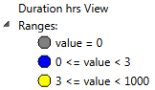
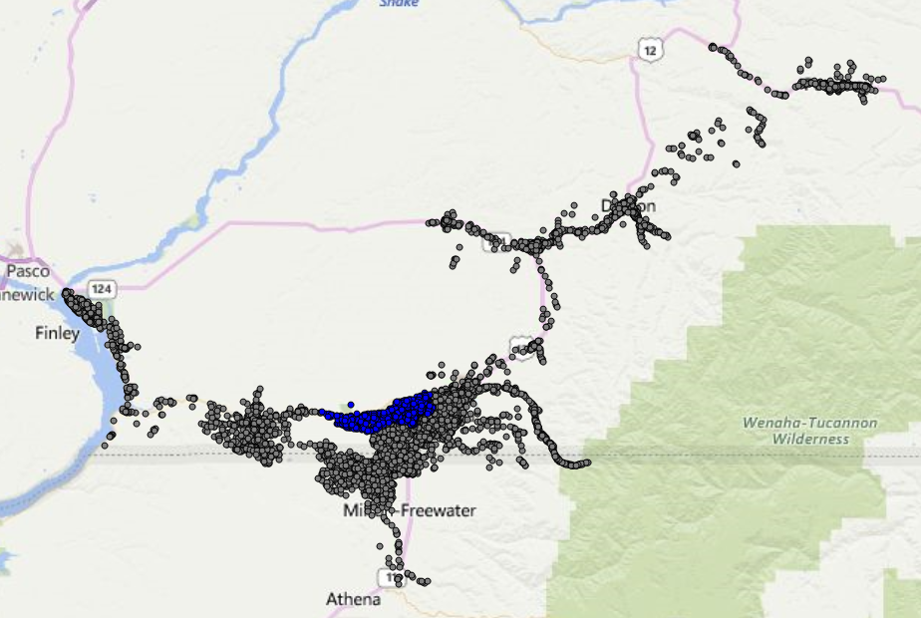

Restoration Intervals

Total Customers Sustained | < 3 Hrs. | 3 - 24 Hrs. | 24+ Hrs.
4,431 | 4,430 | 1 | 0

Restoration Resources
Personnel Resources
Journeyman | 7
TOTAL | 7

State Estimated Major Event Costs
Estimate $ | Labor | Material | Contract Resources * | Total
Capital | $3,102 | $434 | $0 | $3,536
Expense | $0 | $0 | $0 | $0
Total | $3,102 | $434 | $0 | $3,536

Major Event Declaration
Pacific Power is requesting designation of this event and its consequences to be classified as a “Major Event” for exclusion from underlying network performance reporting. This major event exceeded the company’s current Washington system average interruption frequency index-driven (SAIFI) threshold of 10% total operating area customers served sustained interruptions (4,430 customers interrupted out of 28,387 Walla Walla operating area customers, or 16% of the operating area customers) simultaneously in a 24-hour period.

Event Detail
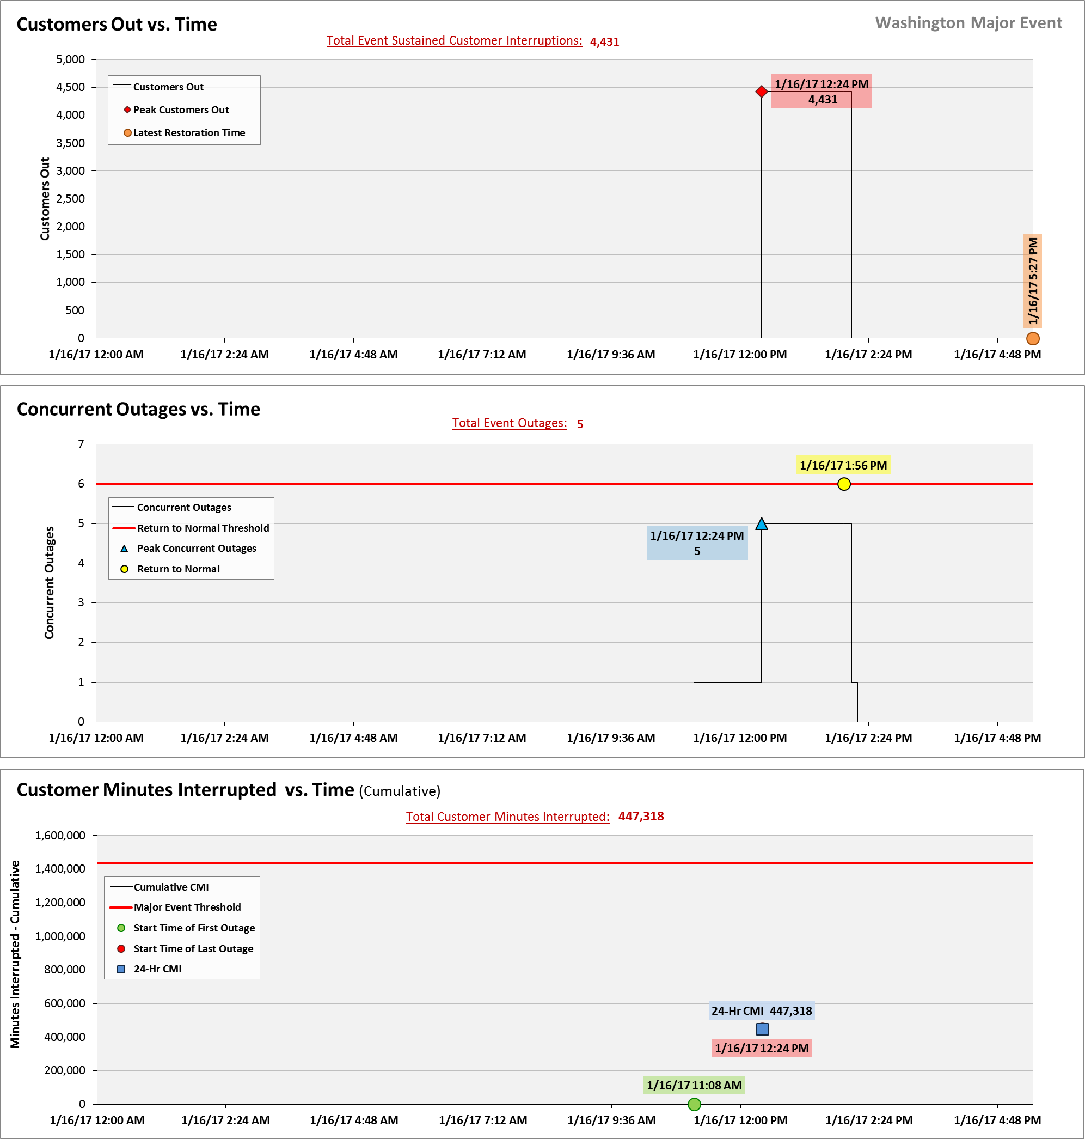
SAIDI, SAIFI, CAIDI by Reliability Reporting Region
Please see the attached system-generated reports.

A SAIFI-based major event threshold (as identified in PacifiCorp’s reporting plan, pursuant to Washington Administrative Code (WAC) 480-100-393 & 398 Electric Reliability Annual Monitoring and Reporting Plan) is defined as an event in which more than 10% of an operating area’s customers are simultaneously without service as a result of a sustained interruption. Walla Walla operating area’s Calendar 2017 Frozen Customer Count is 28,387 customers.

