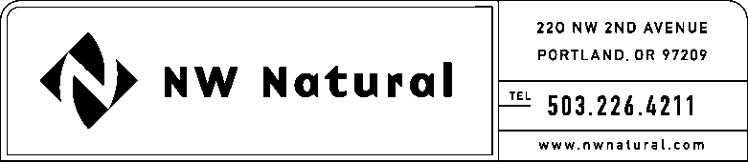

GAIL HAMMER
Tariffs and Regulatory Compliance
Tel: 503.226.4211 ext. 5865
Fax: 503.721.2516
Email: gail.hammer@nwnatural.com

April 22, 2016

Steven King, Executive Director & Secretary
Washington Utilities and Transportation Commission
1300 S Evergreen Park Drive SW
Post Office Box 47250
Olympia, Washington 98504-7250

Re: UG-132147 - related to Dockets UG-143895 and UG-080546
2015 Annual Report on NW Natural’s Energy Efficiency (EE) Program

Dear Mr. King:

Northwest Natural Gas Company, dba NW Natural (“NW Natural” or the “Company”) hereby submits an original and two copies of the 2015 Annual Report on the Company’s Energy Efficiency program. This report is submitted in compliance with the Company’s Energy Efficiency Plan (“EE Plan”) which is by reference part of the “Company’s” Tariff Schedule G, “Energy Efficiency Services and Programs – Residential and Commercial,” and was filed and approve in Docket UG-143895.

The Company’s Energy Efficiency program is monitored by the interested parties who have formed the Energy Efficiency Advisory Group (EEAG) in compliance with the stipulated agreement approved in Order 04 in the Company’s last rate case, Docket UG-080546 and the Company’s Energy Efficiency Plan.

If you have any questions, please call me at (503) 226-4211, extension 5865.

Respectfully submitted,

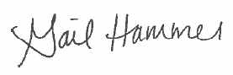
Gail Hammer
Tariffs and Regulatory Compliance

cc: EEAG

Enclosures

