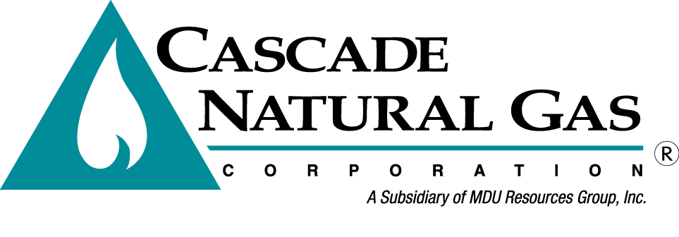
8113 W. GRANDRIDGE BLVD., KENNEWICK, WASHINGTON 99336-7166
TELEPHONE 509-734-4500 FACSIMILE 509-737-9803
www.cngc.com

August 2, 2018

Washington Utilities & Transportation Commission
Mr. Mark Johnson, Executive Director & Secretary
P.O. Box 47250
Olympia, WA 98504-7250

RE: Cascade Natural Gas Corporation 2018 Integrated Resource Plan
(Docket UG-171186)

Dear Mr. Johnson:

Cascade submits an electronic version of the 2018 WA IRP price forecast workpaper as well as the price forecast design document workpaper in the above docket. The workpapers have confidential forecasted price information and is being provided as confidential per WAC 480-07-160.

If there are any questions regarding this matter, please contact Brian Robertson at (509) 734-4546 or myself at (509) 734-4589. Alternatively, we may be reached at brian.robertson@cngc.com and mark.sellers-vaughn@cngc.com.

Sincerely,
CASCADE NATURAL GAS CORPORATION
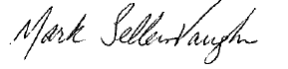
Mark Sellers-Vaughn
Manager, Supply Resource Planning

Enclosures

