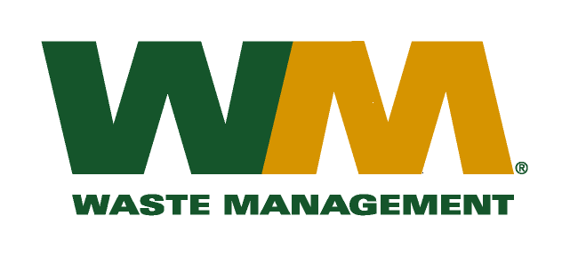

December 9, 2009
Washington Utilities and Transportation Commission
Chandler Plaza Building
1300 S. Evergreen Park Drive SW
P.O. Box 47250
Olympia, WA. 98504-7250

Dear Sirs:
Subject: Waste Management of Skagit County, a division of Waste Management of Washington, Inc.(G-237); Tariff # 17; Docket No. TG-091777

Please find enclosed substitute tariff pages 2, 22, 23, 24, 26, 31, 32, 33, 34 and 35 to above referenced docket number. These pages are being submitted to in accordance with staff recommendations. Please do not re-docket.

If you have any questions or need additional information, please contact me at (425) 814-7840.

Very truly yours,
Michael A. Weinstein
Senior Pricing Manager, Pacific Northwest Market Area

