8113 W. GRANDRIDGE BLVD., KENNEWICK, WASHINGTON 99336-7166
TELEPHONE 509-734-4500 FACSIMILE 509-737-9803
www.cngc.com

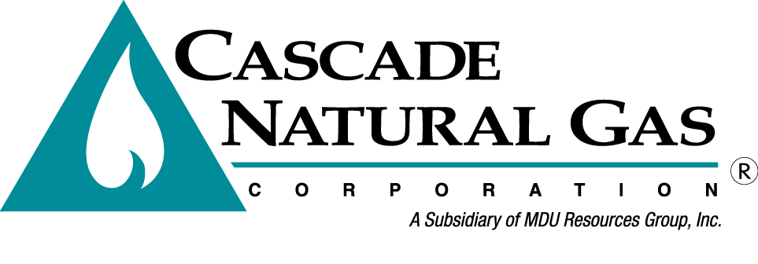
August 12, 2016

Mr. Steven V. King
Executive Director and Secretary
Washington Utilities & Transportation Commission
P.O. Box 47250
Olympia, WA 98504-7250

Re: Advice No. W16-08-01, Supplemental Compliance Filing
UG-152286, Cascade Natural Gas Corporation General Rate Case

Dear Mr. King,

On August 1, 2016, Cascade Natural Gas Corporation (Cascade or Company) submitted Advice No. W16-08-01 in compliance to Commission Order No. 4, issued in UG-152286. The Company now supplements its August 1, 2016, filing with the following replacement sheets to its Tariff WN U-3, which are stated to become effective September 1, 2016:

Original Sheet No. 25-A
Original Sheet No. 25-B
Original Sheet No. 303
Original Sheet No. 303-A
Original Sheet No. 303-B
Original Sheet No. 593
Sixteenth Revision Sheet No. 663
Fourth Revision Sheet No. 687

All other sheets remain as submitted on August 1, 2016.

In the cover letter attached to the August 1, 2016, compliance filing submitted in the subject docket, the Company noted that tariff sheets related to the Company’s Washington Energy Assistance Fund (WEAF) program were not included, although required per the UG-152286 settlement agreement, because the Company needed to provide its WEAF Advisory Group additional time to review the proposed tariffs. The WEAF Advisory group formed per the settlement agreement is comprised of parties from the rate case as well as community action agencies. The WEAF Advisory Group has reviewed proposed Schedule 303 defining the WEAF program and proposed Schedule 593, the WEAF Cost Recovery adjustment schedule over email as well as on an August 3, 2016, teleconference. The rate included in Schedule 593 is consistent with Appendix B to the Settlement Agreement.

Other changes include revisions to Schedule 21, Sheet Nos. 25-A and 25-B. The language explaining the earnings test is revised for clarity. Revisions to Sheet No. 25-A forced text to move to Sheet No. 25-B.

Sheet Nos. 663 and 687 are revised to include the correct Gross Revenue Fee of 4.469%.

If you have questions regarding this filing, please contact Jennifer Gross at (509) 734-4635.

Sincerely,

/s/ Michael Parvinen

Michael Parvinen
Director, Regulatory Affairs

Enclosures

