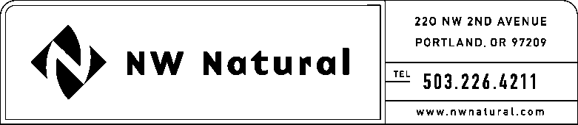

Gail A. Hammer
Tariff and Regulatory Compliance
Tel: 503.226.4211 ext. 5865
Fax: 503.721.2516
email: gail.hammer@nwnatural.com
August 19, 2016

Stephen V. King, Executive Director & Secretary
Washington Utilities and Transportation Commission
1300 S Evergreen Park Drive SW
Post Office Box 47250
Olympia, Washington 98504-7250

Re: UG - 152349 - related to Docket UG-080546
2016 Second Quarterly (Q2) Report on NW Natural’s Energy Efficiency (EE) Program

Dear Mr. King:

Northwest Natural Gas Company, dba NW Natural (“NW Natural” or the “Company”), hereby submits an original and two copies of its 2016 Q2 report on the Company’s Energy Efficiency program. This report is submitted in compliance with the Company’s Energy Efficiency Plan (“EE Plan”) which is by reference part of the Company’s Tariff Schedule G, “Energy Efficiency Services and Programs – Residential and Commercial,” and was filed and approved in Docket UUG-152349U.

The Company’s Energy Efficiency program is monitored by the interested parties who have formed the Energy Efficiency Advisory Group (EEAG) in compliance with the stipulated agreement approved in Order 04 in the Company’s last general rate case, Docket UUG-080546U and the Company’s Energy Efficiency Plan.

Please address correspondence on this matter to me with copies to the following:
eFiling
Rates & Regulatory Affairs
220 NW Second Avenue
Portland, Oregon 97209
Telecopier: (503) 721-2516
Telephone: (503) 226-4211 ext. 3589
E-mail: eFiling@nwnatural.com

Sincerely,

/s/ Gail A. Hammer

Gail A. Hammer

NW Natural

cc: EEAG

Enclosure: Q2 2016 EE Report

