June 12, 2014

Steven V. King, Executive Director and Secretary
Utilities and Transportation Commission
1300 S. Evergreen Park Dr. SW
P.O. Box 47250
Olympia, WA 98504-7250

RE: Washington Utilities and Transportation Commission v. Umpqua Indian Development Corp.

Commission Staff’s Response to Request for a Hearing UT-140926

Dear Mr. King:

On June 3, 2014, the Utilities and Transportation Commission issued a $1,000 Penalty Assessment in Docket UT-140926 against Umpqua Indian Development Corp. for 10 violations of Washington Administrative Code (WAC) 480-120-382, which requires telecommunications companies to furnish annual reports to the commission no later than May 1 each year.¹

On June 10, 2014, Matt Dean with Telecom Professionals, Inc. contacted the commission on behalf of Umpqua Indian Development providing a UPS Internet Shipping Receipt for an Extension Request mailed on April 24, 2014.² Telecom Professionals, Inc. also represents several other regulated telecommunications companies for which extension requests were received. Commission staff verified the extension request for Umpqua Indian Development Corp. was not erroneously attached to another company’s request. The company requested a hearing in response to the penalty assessment.³ In its Hearing Request, Umpqua Indian Development Corp. does dispute that the violation occurred. The company references the extension request mailing and immediate contact with the commission upon receipt of the penalty assessment and asks the fine be waived and the extension request be granted.

It is the company’s responsibility to ensure that the regulatory fee is paid and the annual report is filed by the May 1 deadline. On February 28, 2014, Annual Report packets were mailed to all regulated telecommunication companies. The instructions for annual report completion page of

UTC Annual Reports
June 12, 2014
Page 2

the annual report informed the regulated company that it must complete the annual report form, pay the regulatory fees, and return the materials by May 1, 2014, to avoid enforcement action.

Umpqua Indian Development Corp. filed and was granted extensions during the 2012 and 2009 annual report years as required. The company did receive penalty assessments for late annual report filings during the 2008 and 2007 annual report years. Due to Umpqua Indian Development Corp. prior history of extension requests, in addition to the good faith documentation the extension request was provided to UPS for delivery, staff supports the company’s request that the fine be waived and the extension request be considered.

If you have any questions regarding this recommendation, please contact Amy Andrews, Regulatory Analyst, at (360) 664-1157, or aandrews@utc.wa.gov.

Sincerely,

Sondra Walsh, Director
Administrative Services

ATTACHMENT A
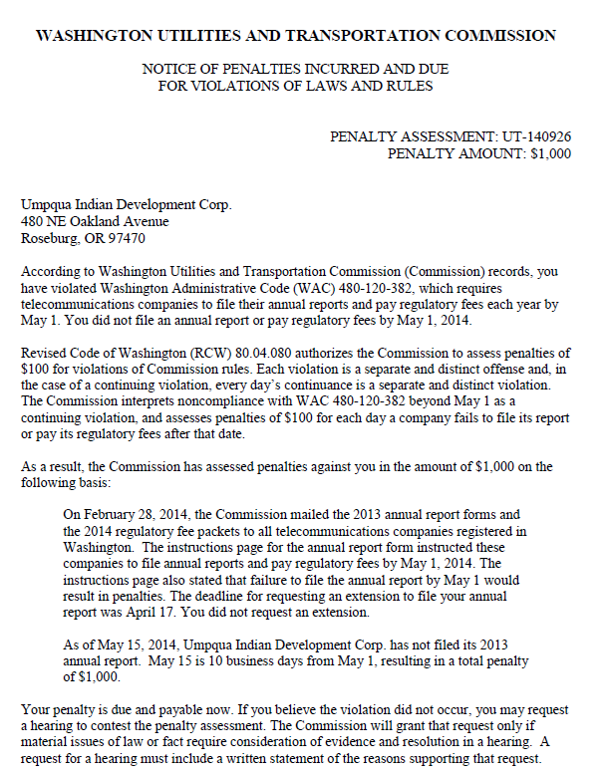

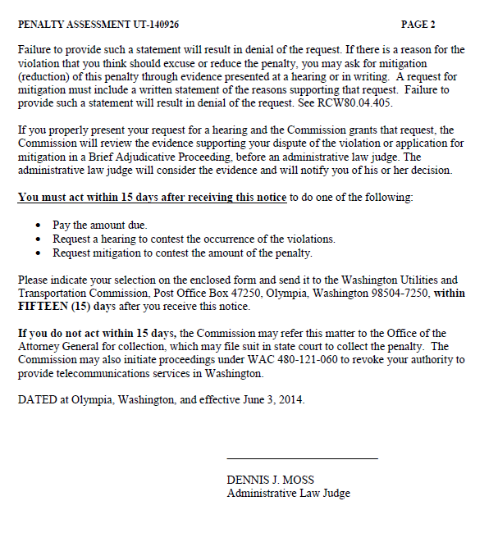

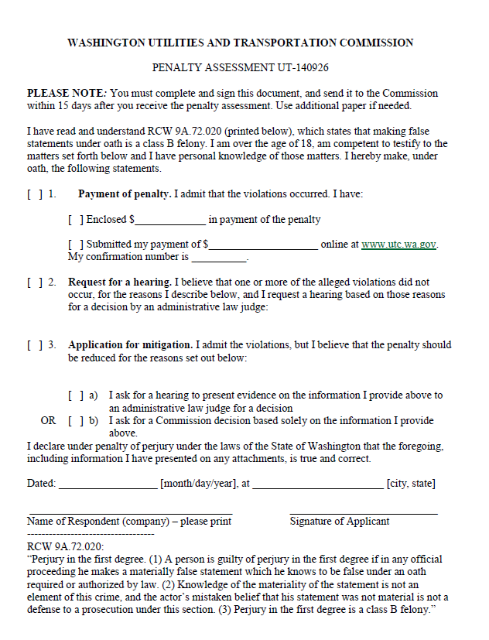

ATTACHMENT B
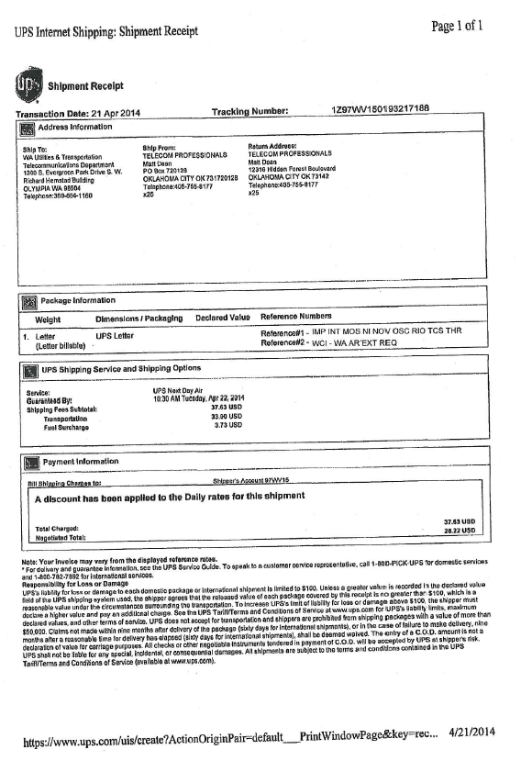
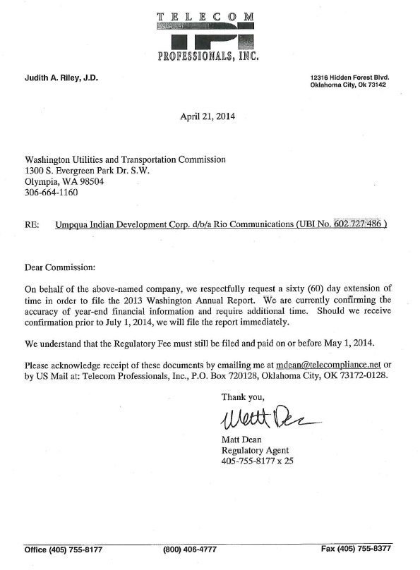

ATTACHMENT C
