SECTION 4

SUPPLY SIDE RESOURCES

Overview

Cascade's core market residential and small volume commercial and industrial customers expect and require the highest reliability of energy service. Because of the Company's obligation to provide gas service to these customers, the Company must determine and achieve the needed degrees of service reliability and attain it at the lowest cost possible while maintaining infrastructure that is sufficient for customer growth. Assuming such an infrastructure is operating effectively, the most important functions necessary for reliable natural gas service are planning for, providing and administering the gas supply, interstate pipeline transportation capacity, and distribution service components that constitute the "bundled services" purchased by core market customers.
Key Points
- To meet the Company’s core market demand, Cascade accesses: 1) Firm gas supplies and 2) Short-term gas supplies purchased on the open market, plus storage.
- Cascade purchases gas from Rockies, British Columbia (Sumas), and Alberta (AECO). Gas is transported to the Company’s system by either bundled or unbundled contracts.
- The long-term planning price forecast is based on a blend of futures market pricing along with long-term funda-mental price forecasts from multiple sources.
- The Company identifies potential incremental supply resources for the 2016 IRP.
- Risk management policies are implemented to promote price stability.
- Cascade’s Gas Supply Oversight Committee (GSOC) oversees the Company’s gas supply purchasing strategy.
- Modeling of Cascade’s available resources result in the lowest reasonably priced optimum portfolio.

This section describes the various gas supply resources, storage delivery services from Jackson Prairie and Plymouth LNG service, and transportation resource options that are available to the Company as supply side resources.

Gas Supply Resources

Gas supply options available to Cascade to meet the core market demand requirements generally fall into two groups: 1) Firm gas supplies on a short or long-term basis, and 2) Short-term gas supplies purchased on the open market as needed for a particular month for one or more days. A separate and important source of gas supply is natural gas storage service, which is required to provide economical service to low load factor customers during seasonal peak and the needle peaks of the heating season.

Cascade’s gas supply portfolio is sourced from three basic areas of North America: British Columbia, Alberta, and the Rockies. Figure 4-1 provides a general overview of regional gas flows to Cascade’s distribution system. A larger map of Figure 4-1 is also provided in Section 13, Glossary and Maps, with Figure 13-12.

Figure 4-1: Regional Map Showing General Flow Paths for System Gas Supplies

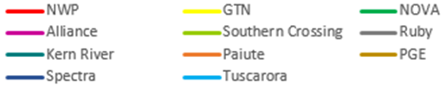
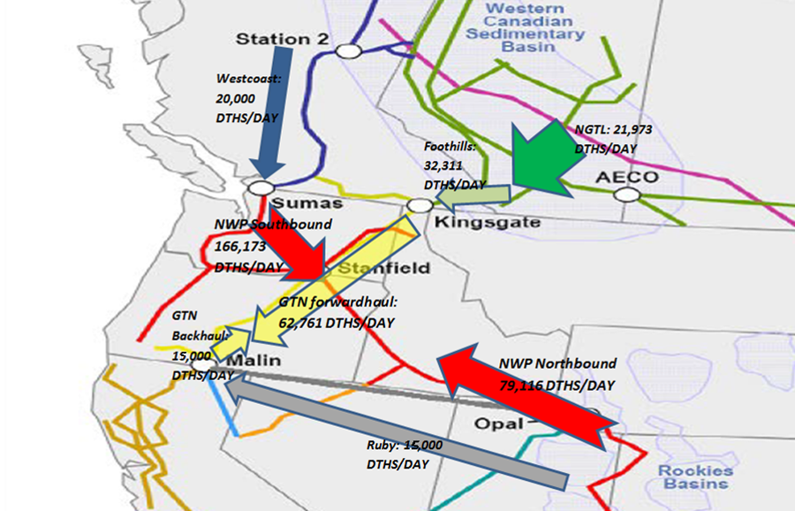

Firm Supply Contracts

Firm supply contracts commit both the seller and the buyer to deliver and take gas on a firm basis, except for during force majeure conditions. From Cascade's perspective, the most important consideration is the seller's contractual commitment to make gas available day in and day out regardless of market conditions. Firm supplies are a necessary component of Cascade's core market portfolio given its obligation to serve and the lack of easily obtainable alternatives for customers during periods of peak demand. Firm supply contracts can provide base load services, seasonal load increases during winter months, or be used to meet daily needle peaking requirements. Quantities vary, depending on the need and length of the contract. Operational considerations regarding available upstream pipeline transportation capacity and any known constraints must also be considered. Base load contracts can range from as small as 500 dths/day to quantities in excess of 10,000 dths/day. Blocks of 1,000, 2,500, 5,000 and 10,000 dths/day are standard as these are the most operationally and financially viable blocks for suppliers.

Base load supply resources are those that are typically taken day in and day out, usually 365 days a year. As a result, base load gas tends to be the least expensive of the firm supply contracts because it matches the production of gas and guarantees the producer that the volumes will be taken. The Company’s ability to contract for base load supplies is limited because of the relatively low summer demand on Cascade’s system. Base load resources are used to meet the non-weather sensitive portion of the core market requirements or may be used to refill storage reservoirs during periods of lower demand.

Winter gas supplies are firm gas supplies that are purchased for a short period during the winter months to cover increased loads, primarily for space heating. The contracts are typically three to five months in duration (primarily November through March). This enables the Company to ensure firm winter supplies without incurring obligations for high levels of “take” during periods of low demand in the summer months. Winter supplies combined with base load supplies are adequate to cover the moderately cold days in winter.

Peaking gas supplies, similar to storage, are firm contracts purchased only as load actually materializes due to high winter demand. That is, the seller must deliver the gas when the Company requires it, but the Company is not required to take gas unless it is needed to meet customer load requirements. Peaking resources typically allow the Company to take between 15 and 20 days of service during the winter period. These resources are more expensive than base load or winter supplies and typically include fixed charges to cover the costs for the sellers to stand by to deliver the supplies.

Needle peaking resources are utilized during severe or “arctic” cold experiences when demand can increase sharply. These resources are very expensive and are available for a very short period of time. One source of needle peaking gas supply that is actually a form of demand side management may be obtained from Cascade's core interruptible customer base. These customers are required to maintain standby or alternate fuel capability so that Cascade can request the customer to switch to its alternate fuel source so Cascade can utilize (divert) the gas supply and transportation capacity to meet the Company’s core firm market requirements. The benefits associated with this type of resource would include lowering the demand of the industrial facility and providing a like amount of additional gas supply with pipeline capacity to meet core demand. Needle peaking requirements can also be met through the use of propane air plants or on-site liquefied natural gas (LNG) facilities. Currently, Cascade does not own or operate any LNG facilities along the distribution system.

A cost comparison between propane and natural gas can be done based on their individual BTU ratings. Assuming the cost for LNG is $6.00 per 1,000 cubic feet, $6.00 will purchase approximately 1.03 million BTUs of energy. This would be equivalent to 11.26 gallons of propane. At $2.00/gallon of residential propane (as of October 2016), natural gas would be a more cost effective energy solution under these conditions. Breaking it down even further, natural gas needs to be priced at more than $22.52 per 1,000 cubic feet for propane to be a more cost effective energy solution (provided the cost for propane is $2.00/gallon).

Supply contract terms for firm commodity supplies vary greatly. Some contracts specify fixed prices, while others are based on indices that float from month to month. Some contracts have fixed reservation charges assessed each month, while others may have minimum daily or monthly take requirements. Most contain penalty provisions for failure to take the minimum supply according to the contract terms. Contract details will also vary from year to year, depending on company and supplier needs and the general trends in the market.

Gas that is purchased for a short period of time (1 to 30 days) when neither the seller nor the buyer has a longer-term firm commitment to deliver or take the gas is referred to as a spot market purchase. Spot market supplies differ from firm resources in that they are more volatile, both in terms of availability and price, and are largely influenced by the laws of supply and demand.

In general, spot market supplies (also called “day gas” or “just-in-time gas”) are provided from gas supplies not under any long-term firm contract. Therefore, as firm market demand decreases, more gas becomes available for the spot market. Prices for spot market supplies are market driven and may be either lower or higher than prices under firm supply contracts. In warmer weather, as firm market demand requirements decrease, usually more gas becomes available for the spot market, resulting in lower prices. In colder weather, as firm markets demand their gas supplies, the remaining spot market supplies can carry higher prices until the price equates or exceeds that of alternate energy supplies (such as oil or electricity). Spot supplies can be expected to move to the markets that offer the highest price, which in turn can affect delivery reliability.

Due to the potential for interruption of the spot market, these supplies are not considered as reliable a source of gas supply for the winter peaking requirements of Cascade’s core market. As identified earlier, part of the reason these supplies are considered less reliable is that these volumes are made available after longer-term firm commitments have been contracted for delivery by upstream suppliers. The available volumes are likely to vary daily, depending on production or the suppliers’ ability to store un-marketed supply. Under a NAESB (North American Energy Standards Board) contract, parties have the ability to identify firm, variable, or interruptible quantities for these supplies. This is the standard contract used by buyers and sellers when entering into short-term supply transactions. Therefore, these spot volumes are more susceptible to daily operational constraints on the upstream pipelines. This is particularly true in the case of the Northwest Pipeline, which is a displacement pipeline with bi-directional flow. Depending on how gas is scheduled versus how it physically flows between compressor stations, constraints can possibly occur. Complicating matters is that each of the pipelines have multiple supply scheduling deadlines, allowing scheduled volumes to be adjusted. As a result, at any given point in the process, constraints can occur, leading to the potential of the scheduled spot supply volumes being reduced or not delivered to the citygate at all.

The role for spot market gas supply in the core market portfolio is based upon economics. Spot market supplies may be used to supplement firm contracts during periods of high demand or to displace other volumes when it is cost-effective to do so. For example, should prices in one basin drop radically compared to another basin, a supply contract may allow the flexibility to reduce takes in order to take advantage of spot supply from a lower priced basin. Depending upon availability and price, spot market volumes may be used in place of storage withdrawal volumes to meet firm requirements on a given day or for mid-heating season refills of storage inventory during periods of moderate weather.

Storage Resources

Cascade also utilizes natural gas storage to meet a portion of the requirements of its core market. Storing gas supplies, purchased and injected during periods of low demand, is a cost-effective way of meeting some of the peak requirements of Cascade’s firm market. Natural gas can be stored in naturally occurring reservoirs, such as depleted oil or gas fields, salt caverns or other geological formations with an impermeable cap over a porous reservoir. Gas can also be stored in vessels or tanks under pressure as compressed natural gas, or cooled to a liquid state, which is liquefied natural gas (LNG).

Natural gas storage service is not only an excellent supply source for meeting peak winter demand, but it can also be an important gas supply management tool. Storing excess or unused supply during periods of low demand increases the annual utilization rate of a supply contract, therefore, improving the annual load factor for the Company’s gas supplies. Improving the annual load factor of a supply contract improves the Company's ability to purchase gas supplies on a more economical basis. Purchasing natural gas for storage during periods of low demand generally yields prices at the low point on the seasonal price curve.

Depending upon the location of the storage facility, pipeline transportation may also be required to move the gas from the facility to the distribution system. Storage facilities located within the Company’s distribution system or on the interstate pipeline are preferable to those located “off-system”. Off-system storage requires additional upstream pipeline transportation and may limit the flexibility of the resource. Cascade does not own any storage facilities and, therefore, must contract with storage owners to lease a portion of those owners’ unused storage capacity. Figure 4-2 displays the location of some of the storage facilities in the region.

Figure 4-2: Regional Map Showing Location of Various Gas Storage Facilities
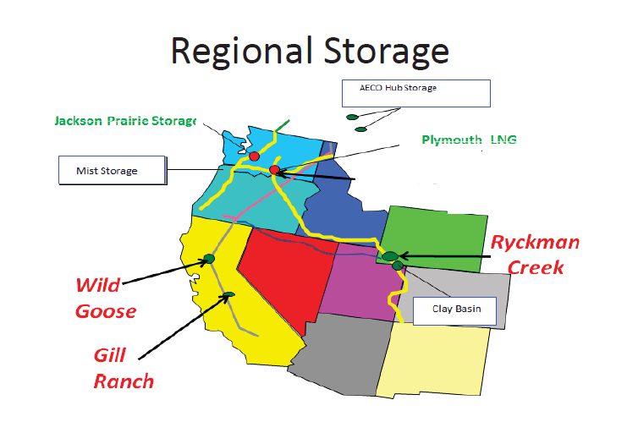

Cascade has contracted for storage service directly from Northwest Pipeline since 1994. Jackson Prairie is located in Lewis County Washington approximately 10 miles south of Chehalis. The following extract explaining the Jackson Prairie facility was found on Puget Sound Energy’s website. Puget is 1/3 owner of the Jackson Prairie facility.

Jackson Prairie is a series of deep underground reservoirs-basically thick porous sandstone deposits. The sand layers lie approximately 1,000 to 3,000 feet below the ground surface. Large compressors and pipelines are employed at JP to both inject and withdraw natural gas at 45 wells spread across the 3,200-acre facility. Currently it is estimated that Jackson Prairie can store nearly 25 BCF of working gas. The facility also includes “cushion” gas which provides pressure in the reservoir of approximately 48 BCF. In terms of withdrawal capability, the facility is capable of delivering 1.15 BCF of natural gas per day.

The Company also has contracted for service from NWP's Plymouth, Washington LNG facility. According to NWP’s website, the total facility has storage capacity of 2.4 BCF. Cascade has leased approximately 28% of this storage capacity.

Both Jackson Prairie facilities and the Plymouth facility are located directly on NWP's transmission system. Therefore storage withdrawal rates can be changed several times during an individual gas day to accommodate weather driven changes in core customer requirements. This type of operating flexibility would not necessarily be available with off-system storage. Withdrawal capabilities must also be accompanied by firm capacity on the transporting pipeline(s) to be of any value as a reliable source of gas supply. Cascade's Jackson Prairie storage and Plymouth LNG service requires TF-2 firm transportation service for storage withdrawals; Cascade has sufficient firm TF-2 service to meet its storage daily deliverability levels. The Company’s contracted storage services are summarized in Table 4-1.

Table 4-1: Cascade Leased Storage Services (Volumes in Therms)

Facility | Storage Capacity | Withdrawal Rights
Jackson Prairie (Principle) | 6,043,510 | 167,890
Jackson Prairie (Expansion) | 3,500,000 | 300,000
Jackson Prairie (2012) | 2,812,420 | 95,770
Plymouth LNG (Principle) | 5,622,000 | 600,000
Plymouth LNG (2016) | 1,000,000 | 181,250

Capacity Resources

Capacity options are either interstate pipeline transportation resources or capacity on Cascade's local distribution system. Cascade's local distribution system was built to serve the entire connected load in its various distribution service areas, on a coincidental demand basis, regardless of the type of service the customer may have been receiving.

Pipeline transportation resources are utilized to transport the gas supplies from the producer/supply sources to Cascade's system. Cascade currently purchases supplies from three different regions or basins: U.S. Rockies, British Columbia, and Alberta, Canada. Unless the gas supplies have been "bundled" by the supplier (i.e. a citygate delivery), these resources require pipeline transportation to deliver them to Cascade's local distribution system. Transportation resources historically have been purchased from the pipeline at the time of an expansion under long-term (twenty to thirty year) contracts.

Cascade has a few dozen long-term annual contracts with NWP, numerous long-term annual and winter-only transportation contracts with GTN (including the upstream capacity on TransCanada Pipeline’s Foothills and Alberta systems), a long-term, winter-only contract with Ruby Pipeline and one long-term annual contract with Spectra (Westcoast Transmission) in British Columbia, Canada. These contracts do not include storage or other peaking services that may provide additional delivery capability rights ranging from 9 to 120 days. Figure 4-3 provides a general flow of Cascade’s combined contracted pipeline transportation rights.

Figure 4-3: Regional Map Showing Current Contracted Pipeline Transportation Flow

A complete listing of Cascade’s current transportation agreements can be found in Appendix E, Current and Alternative Supply Resources.

At minimum, in order to ensure a diversified physical portfolio, the basic design of Cascade’s transportation portfolio considers incorporating these general physical products or elements:

- Annual supply package
- Nov-Mar (the whole heating season)
- Dec-Feb (peak of the heating season)
- Spring Seasonal (Apr-Jun)
- Spring/Summer Seasonal (Apr-Oct)
- Day Gas
- On annualized basis supplies are typically secured 1/3 British Columbia, 1/3 Alberta and 1/3 Rockies
- No more than 25% of the overall portfolio can be supplied by a single party
Natural Gas Price Forecast

For IRP planning purposes the Company develops a baseline, high, and low natural gas price forecast. Demand, oil price volatility, the global economy, electric generation, opportunities to take advantage of new extraction technologies, hurricanes and other weather activity will continue to impact natural gas prices for the foreseeable future. Cascade has considered price forecasts from several sources, such as Wood Mackenzie, Energy Information Administration (EIA), Bentek, Northwest Power and Conservation Council (NPCC), as well as Cascade’s observations of the market to develop the low, base, and high price forecasts. For confidentiality purposes, the Company will refer to the selected sources as Sources 1-4 when discussing how these sources are weighted in Cascade’s Henry Hub forecast. The following discussion provides an overview of the development of the baseline forecasts.

Cascade’s long-term planning price forecast is based on a blend of futures market pricing along with long-term fundamental price forecasts from multiple sources. Since pricing on the market is heavily influenced by Henry Hub prices, the Company closely monitors this market trend. While not a guarantee of where the market will ultimately finish, the futures market (NYMEX) is the most current information available that provides some direction as to future market prices. On a daily basis, Cascade can see where Henry Hub is trading and how the future basis differential in the Company’s physical supply receiving areas (Sumas, AECO, Rockies) is trading.

Cascade believes that relying on a single source for developing the Company’s 20-year price forecast may not necessarily be the most reasonable approach. Some sources such as EIA and Wood Mackenzie produce Henry Hub pricing over the long term, whereas other sources like the NYMEX basis (e.g., Sumas) provide price indicators over a shorter period of time. Additionally, price forecast sources produce their forecasts or indicators at varying points in time throughout the year. Finally, most forecasts are at an annual level vs a monthly level. In order to capture the potential seasonality as well as the variances of monthly price within the producing basins, the Company blends the pricing data from these various forecast sources. It should be noted that at the time the 2016 IRP price forecast was developed, Cascade did not have one of the Company’s outside consultant’s price forecast for the final years of the planning horizon. As a result, the weight in the final few years of the forecast heavily favors Source 4, as it was the only forecast available to the Company at the time. As will be noted in Section 8, Resource Integration, incremental resource decisions are anticipated to be in place before 2030; consequently, the Company does not feel using Source 4’s 2034-36 price forecast would have a material impact on resource selection or the avoided costs.

The fundamental forecasts of Wood Mackenzie, the EIA, NPCC, and Cascade’s trading partners are resources for the development of a blended long-range price forecast. Wood Mackenzie publishes a long-term price forecast twice a year to subscribing customers. This forecast is broken down by month through the planning horizon and includes Henry Hub as well as basis differentials for the Company’s receiving areas. Cascade also considers the EIA forecast; however, it has its limitations since it is not always as current as the most recent market activity. Further, the EIA forecast provides monthly breakdowns in the short term, but longer term forecasts are only by year. Many of the other sources mentioned only provide price forecasts by year. Given Cascade’s load profile and the need for more winter gas than summer, the Company develops a pattern based on the market monthly forward prices to create a long-term, monthly Henry Hub price.

With a monthly Henry Hub price determined from the above sources, the Company assigns a weight to each source to develop the monthly Henry Hub price forecast for the 20-year planning horizon. The forecast weighting factors are shown in Table 4-2. The Company gives Source 1 the most weight at the start of the planning horizon based on nearness to term. In recent years, the EIA forecast has often been higher than the forecast price of the other sources; however, it is still a respected industry barometer of prices (Figure 4-4). As Cascade’s forecast moves ahead, the Company starts to reduce the impact of Source 1 and gives greater weight to the other sources.

Table 4-2: Cascade’s Henry Hub Price Forecast Weights

Year | Source 1 | Source 2 | Source 3 | Source 4
2017 | 40% | 5% | 35% | 20%
2018 | 35% | 5% | 35% | 25%
2019 | 30% | 5% | 35% | 30%
2020 | 25% | 5% | 40% | 30%
2021 | 20% | 5% | 45% | 30%
2022 | 15% | 5% | 55% | 25%
2023 | 10% | 5% | 60% | 25%
2024 | 10% | 5% | 65% | 20%
2025 | 5% | 5% | 70% | 20%
2026 | 5% | 0% | 75% | 20%
2027 | 0% | 0% | 75% | 25%
2028 | 0% | 0% | 75% | 25%
2029 | 0% | 0% | 75% | 25%
2030 | 0% | 0% | 75% | 25%
2031 | 0% | 0% | 75% | 25%
2032 | 0% | 0% | 75% | 25%
2033 | 0% | 0% | 75% | 25%
2034 | 0% | 0% | 0% | 100%
2035 | 0% | 0% | 0% | 100%
2036 | 0% | 0% | 0% | 100%

Figure 4-4: Henry Hub Price Forecast by Source ($US/Dth)

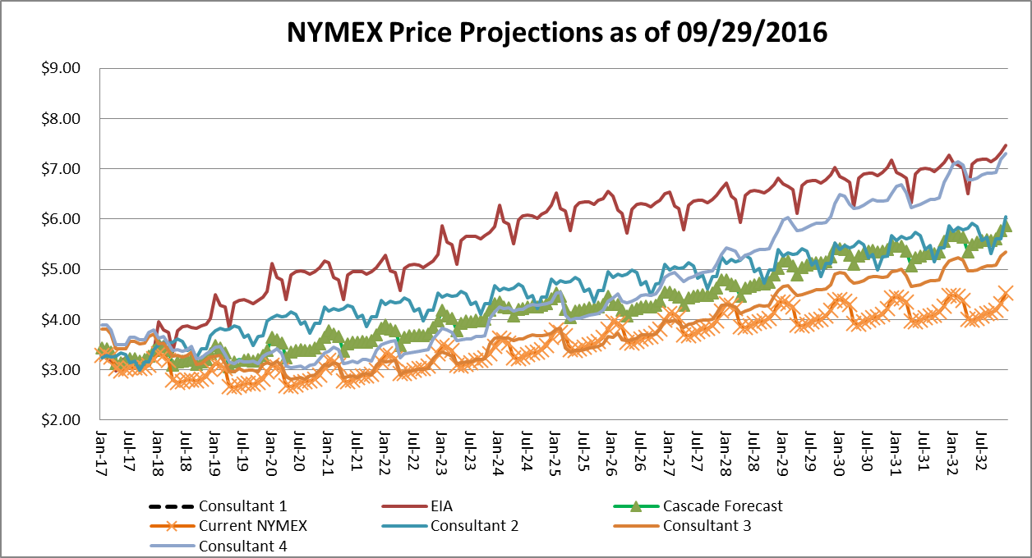

Development of the Basis Differential for Sumas, AECO and Rockies

Since the Company’s physical supply receiving areas (Sumas, AECO, and Rockies) are at a discount to Henry Hub, the Company utilizes the basis differential from Wood Mackenzie’s most recently available update and compares that to the future markets’ basis trading as reported in the public market. Correspondingly, the Company applied a weighted average to determine the individual basis differential in the price forecast.

In order to determine the low case and high case, the Company utilized the EIA economic growth factors which are 2.1 for the Low Case, 2.7 for the Reference Case, and 3.2 for the High Case.

Please see Appendix G, Weather & Price Uncertainty Analyses, for the 20-year price forecasts details.

Incremental Supply Side Resource Options

As is more thoroughly described in Section 8, Resource Integration, some of the load growth over the planning horizon will require Cascade to secure incremental supply side resources. The purpose of this section is to identify the potential incremental supply resources the Company considered for the 2016 IRP.

Pipeline Capacity

- Cross Cascades, Trail West (Palomar, NMax, Sunstone, Blue Bridge, et al): Trail West is a pipeline starting at GTN’s system near Madras, Oregon, and connecting NWP’s Grants Pass Lateral near Molalla, Oregon. Since portions of the Company’s distribution system are not connected to Molalla, incremental pipeline capacity would be needed to transport gas northbound to certain load centers. NWP has proposed a transport service that would bundle Trail West capacity with NW Natural’s northbound Grants Pass Lateral capacity. From Cascade’s perspective this might present an alternative means to move Rockies’ gas to the I-5 corridor.

- GTN Capacity Acquisition: The Company would acquire currently unsubscribed capacity on GTN in order to secure its gas supplies at liquid trading points to serve Central Oregon.

- NWP Eastern Oregon Expansion: This alternative resource would be incremental NWP capacity from a Washington State receipt point that is designed to serve load growth needs in Zone 24 and Zone ME-OR. Examples of the Cascade service areas that would benefit from this project are Pendleton and Baker City. Similar to a proposed NWP Wenatchee expansion, it would have a relatively small scale and so could be expected to have a relatively high unit cost.

- NWP I-5 Expansion (Regional or Cascade Specific Project): Cascade envisions this project as expanding capacity from Sumas on a potential NWP project that is the successor to the Western Expansion project. It would potentially combine Cascade’s infrastructure expansion needs with other regional requests from parties such as LDCs, power generators, and large petrochemical projects. The scale of this project is larger, potentially resulting in a more favorable unit cost; although with scale and multiple parties involved, timing for in-service dates may vary by the various participants. Examples of the Cascade service areas that would benefit from this project are Bellingham, Mount Vernon, Bremerton and Longview. Recently, Avista, Cascade, NW Natural and Puget Sound Energy agreed to combine its efforts as a group to work with the regional pipelines (GTN, NWP) on potential expansions in the region.

- NWP Wenatchee Expansion: This alternative resource would be incremental NWP capacity from a Washington State receipt point (e.g. Sumas) that is designed to serve load growth needs in Zone 10 and Zone 11. Examples of the Cascade service areas that would benefit from this project are Yakima and Wenatchee. Accordingly, it would have a relatively small scale and so could be expected to have a relatively high unit cost.

- NWP Zone 20 Expansion: This alternative resource would be incremental NWP capacity from a Washington State receipt point that is designed to serve load growth needs in Zone 20. Examples of the Cascade service areas that would benefit from this project are Kennewick and Moses Lake. Similar to a proposed NWP Wenatchee expansion, it would have a relatively small scale and so could be expected to have a relatively high unit cost.

- Pacific Connector: The Pacific Connector Pipeline project is tied to the development of the Jordan Cove LNG export terminal in Coos Bay, Oregon. This pipeline starts near Malin, Oregon and would cross NWP’s Grants Pass Lateral (GPL) in the vicinity of Roseburg, Oregon. Basically, this project presents an opportunity as a potential supply resource for the purposes of this IRP. Cascade would not be seeking to become a shipper on Pacific Connector. The Company views this project as “bundled pipeline supply” service from Malin to the Company’s citygate. The project was initially denied due to lack of demand. That has changed but it faces considerable opposition. Incremental transport involving GTN might be necessary to ensure transport from Malin to Cascade’s GTN receipt point at Turquoise Flats.

- Southern Crossing Expansion: FortisBC has proposed a reinforcement project for the Southern Crossing Pipeline that would permit more flow of Alberta gas to Sumas. This would also require an expansion of NWP from Sumas at the Canadian border which in the Company’s mind does not need to be modeled since it essentially is replicated by the current inclusion of the NWP I-5 expansion project. This is primarily a price arbitrage opportunity, but the Company does not see any significant advantage to the system at this point given limited availability to move the gas from Sumas. However, Cascade will continue to consider this resource to see if it might make sense as a potentially cost-effective dedicated resource for the Company’s direct connect with Westcoast.

Storage Opportunities

- AECO Hub Storage: This is Niska’s commercial natural gas storage business in Alberta, Canada. The service is comprised from two gas storage facilities: Suffield (South-eastern Alberta) and Countess (South-central Alberta). Although the two AECO facilities are geographically separated across Alberta, the toll design of the NOVA (NGTL) system means that they are both at the same commercial point. Capacity at one of the facilities is possible as an alternative resource. Currently, no open season is planned. However, some services are available for limited periods of time but are subject possible interruption. Incremental transport involving Nova, Foothills, GTN, and possibly NWP would be necessary.

- Gill Ranch Storage: Gill Ranch Storage is an underground intra-state natural gas storage facility near Fresno, Calif. It includes a pipeline that links the facility to Pacific Gas & Electric Company's (PG&E) mainline transmission system, allowing it to serve customers throughout California. Storage from this facility would require California Gas Transmission (CGT) transport, which has a potentially cost-prohibitive demand charge of $1.68/Dth. Incremental transport involving GTN would also be necessary.

- Mist (North Mist II): According to NW Natural’s 2016 IRP Section 3, pages 34-35,

NW Natural is in the midst of a project that would combine new underground storage at Mist and a new transmission pipeline to serve Portland General Electric (PGE) at Port Westward called North Mist 18. The storage reservoirs currently in service at Mist and those that would be developed as North Mist for PGE do not collectively exhaust Mist’s storage potential; there still remain other Mist production reservoirs that theoretically could be developed by NW Natural into additional storage resources. The primary impediment in doing so is not geological, but instead, the challenges are associated with developing new pipeline capacity to move the gas from Mist to the Company’s load centers. NW Natural identifies a prospective Mist expansion project for core customer use in this IRP as ‘North Mist II.’ Essentially, this new pipeline is planned to be built from Mist to the Kelso- Beaver Pipeline (KB Pipeline); and from there onto NWP’s system” for potential delivery to Cascade gates.

Cascade will continue talks with the Mist parties to see if those opportunities may be cost effective.

- Ryckman Creek Storage: Ryckman Creek Resources, LLC, is a wholly-owned subsidiary of Peregrine Midstream Partners, LLC. Ryckman Creek Gas Storage Facility is located near the town of Evanston, Wyoming and approximately twenty-five miles southwest of the Opal Hub. Ryckman Creek has converted a partially depleted oil and gas reservoir into a gas storage facility with 35 BCF of working gas and a maximum daily withdrawal rate of 480,000 Dths/d. Ryckman Creek currently has interconnects with Questar Gas Pipeline, Kern River Transmission, Questar Overthrust Pipeline, Ruby Pipeline, and Northwest Pipeline. Incremental transport involving Questar and possibly Ruby would be necessary (Cascade’s current transportation contract with Ruby is currently winter-only).

- Wild Goose Storage: Wild Goose is located north of Sacramento in northern California and was the first independent storage facility built in the state. The facility commenced full commercial operations in April 1999 and in April 2004 completed its first expansion. Storage from this facility would require California Gas Transmission (CGT) transport, which has a potentially cost-prohibitive demand charge of $1.68/Dth. Incremental transport involving GTN would also be necessary.

Other Alternative Gas Supply Resources

- Satellite LNG: Some gas utilities rely on satellite LNG tanks to meet a portion of their peaking requirements. The term “satellite” is commonly used because the facility is scaled-down and has no liquefaction capability. Instead, its usefulness revolves around the availability of another (no doubt larger) facility with the ability to supply the LNG to fill its tank(s). LNG facilities in this context are peaking resources because they provide only a few days of deliverability, and should not be confused with the much larger facilities contemplated as LNG export or import terminals. The concept is that a small tank serving a remote area would be filled with LNG as winter approaches, and the site operated during cold weather episodes when vaporization is required. Since Satellite LNG has no on-site liquefaction process, the facility is fairly simple in design and operation. While likely as expensive as some pipeline projects, Satellite LNG may be more practical in areas such as Yakima, where pipeline capacity shortfalls for peak day are the highest and most immediate. The addition of satellite LNG could defer significant pipeline infrastructure investments for several years.

- Bio-natural gas (BNG): BNG typically refers to gas produced by the biological breakdown of organic matter in the absence of oxygen. BNG originates from biogenic material and is a type of biofuel. One type of BNG is produced by anaerobic digestion or fermentation of biodegradable materials such as biomass, manure or sewage, municipal waste, green waste, and energy crops. This type of BNG is comprised primarily of methane and carbon dioxide. The principal type of BNG is wood gas, which is created by gasification of wood or other biomass. This type of BNG is comprised primarily of nitrogen, hydrogen, and carbon monoxide, with trace amounts of methane. The gases, methane, hydrogen and carbon monoxide, can be combusted or oxidized with oxygen. Air contains 21% oxygen. This energy release allows BNG to be used as a fuel. BNG can be used as a low-cost fuel in any country for any heating purpose, such as cooking. It can also be utilized in modern waste management facilities where it can be used to run any type of heat engine to generate either mechanical or electrical power. BNG is a renewable fuel, which can be used for transport and electricity production, so it attracts renewable energy subsidies in some parts of the world. In many cases, not enough pricing and supply information is currently available for this resource to be considered in this planning cycle; however, where possible, the Company endeavored to analyze those situations where sufficient data is available. Cascade continues to monitor the BNG activities of companies such as PG&E, Intermountain Gas, Sempra Utilities, and Puget Sound Energy.

- Re-alignment of Maximum Daily Delivery Obligations (MDDO): Cascade has long held more delivery rights than receipt rights on NWP under its principle 100002 agreement. This came as a result of FERC Order 636 when NWP was required to assign upstream capacity directly on GTN (formerly known as Pacific Gas Transmission) to the shippers that were using that capacity. NWP allowed the direct assignment as part of the conversion from their merchant role to an open access pipeline. However, NWP did not lower its capacity contract to reflect the direct assignment. In effect this increased Cascade’s system capacity by the amount GTN would directly be providing to Cascade. On the plus side this gives Cascade great flexibility to utilize 316,994 Dths/day of delivery rights vs 205,123 Dths/day of receipt rights. Cascade has the right to deliver gas to any delivery point within Washington and Oregon so long as the total MDDOs are not exceeded. Cascade and NWP have worked continuously in recent years for ways to address Cascade’s potential peak day capacity shortfalls through re-alignment of the Company’s contractual rights where possible, which mitigates the need to acquire incremental NWP capacity through expansions.

Cascade considers Unconventional Gas Supply Resources such as supplies from a LNG Import Terminal, local bio-natural gas or other manufactured gas supply opportunities as speculative supply side resources at this point in time. Ultimately these unconventional gas supply resources are treated as alternative resources and have to compete with traditional gas supplies from the conventional gas fields in Canada or the Rockies for inclusion in the Company’s portfolio planning.

Supply Side Uncertainties

Several uncertainties exist in evaluating supply side resources. They include regulatory risks, deliverability risks, and price risks. Regulatory risks include the unknown impacts of future Federal Energy Regulatory Commission or Canada’s National Energy Board rulings that may impact the availability and cost of interstate pipeline transportation.

Deliverability risk is the risk that the firm supply will not be available for delivery to the Company’s distribution system. Purchasing resources from larger producers or marketers who typically have gas reserves in multiple locations may minimize this risk. The risks associated with prices rising or falling during any winter period represent another supply side uncertainty. To the extent the Company purchases firm contracts that are tied to an index price, it may be at risk for paying more than was initially anticipated for the resource after the resource decision has been made. Price risks associated with climbing prices can be minimized through the use of fixed price contracts or through the use of financial derivatives.

As the United States continues to search for environmentally friendly, economically viable options to displace gasoline, natural gas is seen as a fuel that could significantly contribute to lessening American dependency on foreign oil. It should be noted that several proposals being discussed or that are in process involve a number of Canadian upstream pipelines which could have a direct impact on the availability of supply or at least may pose potential risks to increases in the price of supplies sourced from British Columbia and Alberta. The Company will continue to monitor and be actively involved in the various pipeline forums as these initiatives develop.

Financial Derivatives and Risk Management

Cascade constantly seeks methods to ensure customers of price stability. In addition to methods such as long-term physical fixed price gas supply contracts and storage, another means for creating stability is through the use of financial derivatives. The general concept behind a derivative is to lock-in a forward natural gas price with a hedge, consequently eliminating exposure to significant swings in rising and falling prices. Financial derivatives include futures, swaps, and options on futures or some combination of these.

Natural gas futures contracts are actively traded on the New York Mercantile Exchange (NYMEX). The use of futures allows parties to lock-in a known price for extended periods of time (up to six years) in the future. Contracts are typically made in quantities of 10,000 Dths to be delivered to agreed-upon points (e.g., NWP Sumas, Westcoast Station 2, NGTL AECO, NWP Rockies, etc.).

In a swap, parties agree to exchange an index price for a fixed price over a defined period. In this scenario, Cascade would be able to provide its customers with a fixed price over the duration of the swap period. In theory, the idea is to level the price over the long term. Futures and swaps are typically called “costless” because they have no up-front cost.

Unlike futures and swaps, an option-only provides protection in one direction - either against rising or falling prices. For example, if Cascade wanted to protect customers against rising gas prices but keep the ability to take advantage of falling prices, Cascade would purchase a call option on a natural gas future contract. This arrangement would give the Company the right (but not the obligation) to buy the futures contract at a previously determined price (strike price). Similar to insurance, this transaction only protects the Company from volatile price spikes, via a premium. The premium is typically a function of the variance between the strike price compared to the underlying futures price, the period of time before the option expires, and the volatility of the futures contract.

Cascade’s Gas Supply Oversight Committee (GSOC) oversees the Company’s gas supply hedging strategy. The Company’s current gas hedging strategy is outlined below:

Hedged Fixed-Price Physical or Financial Swaps
- Year one up to 40% of annual requirements
- Year two set at up to 25%
- Up to 20% hedged volumes for year three

Depending on market conditions, the strategy allows for the ratchets to increase to 75%, 50%, and 30%, respectively, provided current market information supports moving to a different level.

Risk is associated with business objectives and the external environment. The number of hedging strategies to deal with risk are almost infinite. To manage risk, it is categorized as to whether the risk is one to be avoided, one to be accepted and controlled, or a risk left uncontrolled. When a risk is high impact with a high likelihood of occurrence, the risk is probably too high in relation to the reward and should be avoided. It is reasonable to accept business risks that can be managed and controlled. For some risk, the measurable impact is low and the risk may not be worth controlling at all. These are risks where the Company can absorb a loss with little financial or operational effect. The Company’s policy is directed toward those risks that are considered manageable, controllable and worth the potential reward to customers. This manageable risk requires acceptable analysis of the possible side effects on the financial position of the Company as compared to the rewards.

Because the price the Company pays for gas is subject to market conditions, Cascade may employ prudent risk management strategies within designated parameters to minimize the risk of operating losses or assumption of liabilities from commodity price increases.

The use of derivatives is permitted only after identified risks have been determined to exceed defined tolerance levels and are considered unavoidable. These decisions are made by Cascade’s GSOC. In recent years, GSOC has adjusted the percentage of the portfolio hedged based on volatility of the market. For example, in the early 2000s, the Company hedged up to 90% of the base gas supply portfolio. When MDU Resources acquired Cascade in 2007 this threshold was reduced to 75% to align with MDU Resources Corporate Derivatives Policy. As the market began to fall dramatically in the 2008-2010 period, the Company continued to lower the percentage to approximately 30%. Current MDU Resources corporate policy encourages Cascade to keep the hedging percentage less than 50%. Currently, Cascade hedges approximately 40% of the portfolio using fixed priced physicals.

The Company entered into fixed price physical transactions rather than executing financial swaps for the 2016 programmed buying period. Fixed prices consist of locked-in prices for physical supplies. As will be further described in this section, the Company utilizes a programmed buying approach for locking in or hedging gas supply prices. In light of the relative lack of volatility in current prices, abundant supply, concerns regarding the administrative impacts of the Dodd-Frank Wall Street Reform Act, and open hedging dockets in both Oregon and Washington, Cascade has not executed any new financial derivatives or considered any for the 2016 IRP. The Company still monitors the outer years and stands ready to execute financial swaps when market and pricing conditions are more favorable. Figure 4-5 provides a graph showing the projected regional price forecast for the 2016 IRP by basin.

Figure 4-5: Regional Basis Price Forecast

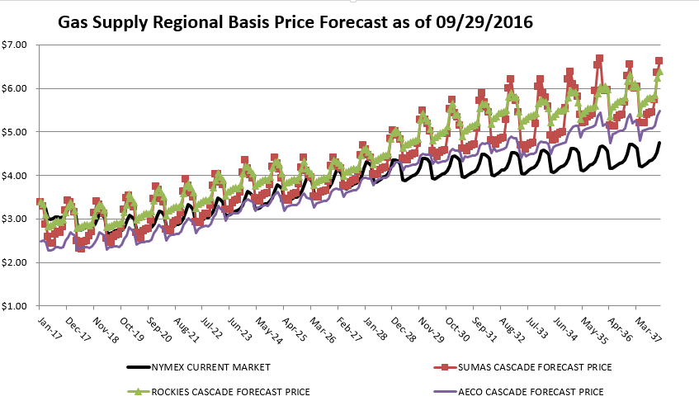

Cascade is currently participating in the WUTC’s hedging Docket UG-132019. Cascade is also an active participant in OPUC’s hedging Docket UM-1720. Docket UG-132019 is directed at hedging no more than approximately four or five years out. It also appears that any guidelines resulting from the docket will be focused on enhancing the analysis and reporting of each of the LDCs’ hedging activities. The OPUC initiated Docket UM-1720 as a result of long-term hedging guidelines proposed by NW Natural in their 2014 IRP. Throughout both processes Cascade has provided comments and explanations of its risk management efforts. As of the preparation of this IRP, no general consensus has materialized amongst the participants. The two hedging dockets are not synchronized, which is contributing to concerns on how to implement any guidelines. Cascade is hopeful that some level of consistency with the end product will develop between the two states. The Company will continue to participate actively in both Docket UG-132019 and Docket UM-1720.

Portfolio Purchasing Strategy

GSOC oversees the Company’s gas supply purchasing strategy. Based on current stable prices and a robust supply picture, the Company considers contracting physical supplies for up to five years (based on a warmer-than-normal weather pattern). The Company’s current gas procurement strategy is to secure physical gas supplies for approximately one-third of the core portfolio supply needs each year for the subsequent rolling three-year period. This method ensures some portion of the current market prices will affect a portion of the next three years of the portfolio.

In spring 2016, GSOC approved a portfolio design for three years as follows:

- Portfolio procurement design based on a declining percentage each year accordingly: Approximately Year 1: 80% of annual requirements; Year 2: 40%, Year 3: 20%. For the current portfolio design, GSOC approved a targeted base portfolio design with 80% of the average five-year annual load in Year 1, 40% in Year 2, 20% in Year 3.
- GSOC will consider a modification from a three-year rolling portfolio if: 1) reasonable concerns exist regarding the availability of supply in a particular basin; or 2) the outer year three-year forward price is 20% higher/lower than the front month over a reasonably sustained period.
- The first portfolio year “hedged” (fixed-price physical or financial swaps) is not to exceed approximately 40% of annual requirements in year 1. Second year should be set at 25%, and 20% hedged volumes for year three.
- GSOC will consider a modification of this plan if the outer year three-year forward price is 20% higher/lower than the front month over a reasonably sustained period.
- The portfolio can always be modified with additional years if a significant discount price materializes.
- Maintain a diversity of physical supplies from Alberta, British Columbia, and Rockies.
- Maximize supplies from the regions that afford the lowest prices. Gas from AECO is currently the lowest-cost gas in the Company’s supply portfolio. Station 2 is also relatively inexpensive but the Company has limited available T-South transport under contract. Sumas is often the highest-priced supply but in recent times it has been less expensive than Rockies except for certain times during the winter.
- Include a small level of annual supplies.
- Annual load expectation (Nov-Oct) is approximately 30,000,000 dths, consistent with recent load history.
- Considerations of structured products, caps, floors, etc., are not to exceed 5% of overall contract supply target.

Under this procurement strategy this leaves roughly 10% to 20% of the annual portfolio to be met with spot purchases. Spot purchase consist of either first of the month deals, executed during bid week for the upcoming month, or day purchases which are utilized to meet incremental daily needs.

Once GSOC has approved the portfolio procurement strategy and design, the Company employs a variety of methods for securing the best possible deal under existing market conditions. Cascade employs a bidding process when procuring fixed priced physical, indexed spot physical, as well as financial swaps used to hedge the price of underlying index based physical supplies. In the bidding process, the Company alerts a minimum of three suppliers and/or financial counterparties of the specific gas supply transactions Cascade plans to fill. Cascade then collects bids from these parties over a period of days or weeks depending on the number or time requirements of the packages sought, comparing the indicative pricing to each party as well as comparing the information to market intelligence available at the time. Ideally, after monitoring these indicatives and the market, Cascade awards the specific packages to individual parties. Naturally, price is the principle factor; however, Cascade also considers reliability, financial health, past performance, and the party’s share of the overall portfolio so that the Company ensures party diversity. It should be noted that there is always the possibility the lowest market price may be during period when the Company is initially gathering the price indicatives; in that situation there is a risk that a sudden price run-up may lead to filling the transaction at the higher end of the bids over time, or delay the acquisition to another time. However, the reverse is also true—the initial price indicatives may start high and drop over time allowing us to capture the transaction on the downward swing. In the end, timing is always a factor as the market cannot be predicted with any certainty.

Cascade follows a similar process when it submits a formal RFP to the various suppliers. Parties are asked to provide offers on specific packages, but are also encouraged to propose other transactions or packages that they feel may be of interest in helping Cascade secure financially attractive and flexible transactions to meet the Company’s needs. This process will require additional analysis regarding operational reasonableness, timing, and volumes. Price comparisons also become more complicated since pricing could be tiered; part of a structure deal may be tied to an index or contains floors, caps, etc. Cascade utilizes TruMarx’s COMET transaction bulletin board system to assist in communicating, tracking, and analyzing these RFP activities.

Conclusion

Cascade's 20-year supply side resource goal is to continue to meet the energy needs of its core market customers. This is accomplished through a package of services that combines adequate gas supplies and cost-effective winter peaking services with long-term pipeline transportation contracts and sufficient distribution system capacity at the lowest possible cost. The Company has identified several transport, storage, and other alternative resources which may be modeled to join the Company’s existing demand and supply side resources to address the load demand needs over the planning horizon.

See www.pse.com
EIA 2016 Annual Energy Outlook, Appendix C
GSOC annually determines the number of years (0 to 5) to include in the rolling portfolio plan.

