June 9, 2014

Steven V. King, Executive Director and Secretary
Utilities and Transportation Commission
1300 S. Evergreen Park Dr. SW
P.O. Box 47250
Olympia, WA 98504-7250

RE: Washington Utilities and Transportation Commission v. Jeffery K. Cummins

Commission Staff’s Response to Application for Mitigation of Penalties TG-141009

Dear Mr. King:

On May 22, 2014, the Utilities and Transportation Commission issued a $1,000 Penalty Assessment in Docket TG-141009 against Jeffery K. Cummins for 10 violations of Washington Administrative Code (WAC) 480-70-071, which requires solid waste companies to furnish annual reports to the commission no later than May 1 each year.¹

On June 2, 2014, Jeffery K. Cummins wrote the commission requesting mitigation of penalties (Mitigation Request).² In its Mitigation Request, Jeffery K. Cummins does not dispute that the violation occurred. The company states, “The penalty does not match the offence: If I charged my customers a 270% per day late fee, that rate would never be allowed. I see a double standard. To whom do I complain about this policy?”

It is the company’s responsibility to ensure that the regulatory fee is paid and the annual report is filed by the May 1 deadline. On February 28, 2014, Annual Report packets were mailed to all regulated solid waste companies. The instructions for annual report completion page of the annual report informed the regulated company that it must complete the annual report form, pay the regulatory fees, and return the materials by May 1, 2014, to avoid enforcement action.

UTC Annual Reports
June 9, 2014
Page 2

On May 15, 2014, Jeffery K. Cummins filed the 2013 annual report and paid the required regulatory fees. Jeffery K. Cummins has not previously missed the deadline for filing its annual report and paying its regulatory fees. Despite the company not presenting any new or compelling information, commission staff supports the company’s request for mitigation solely based on the companies past filing history. Staff recommends a reduced penalty assessment of $25 per day for a total assessed penalty of $250.

If you have any questions regarding this recommendation, please contact Amy Andrews, Regulatory Analyst, at (360) 664-1157, or aandrews@utc.wa.gov.

Sincerely,

Sondra Walsh, Director
Administrative Services

ATTACHMENT A
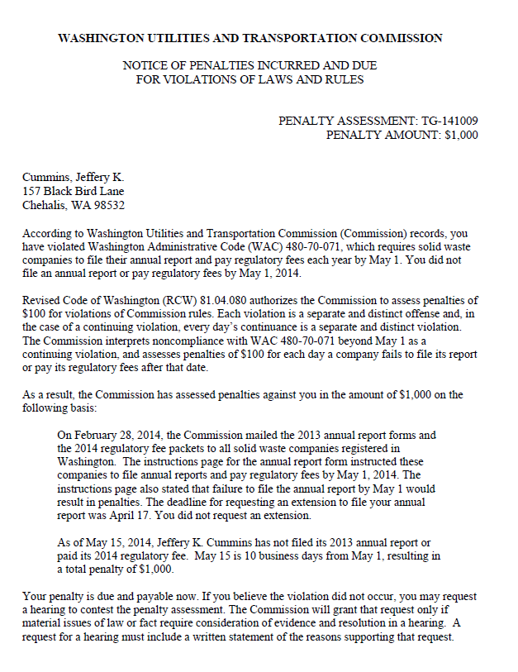

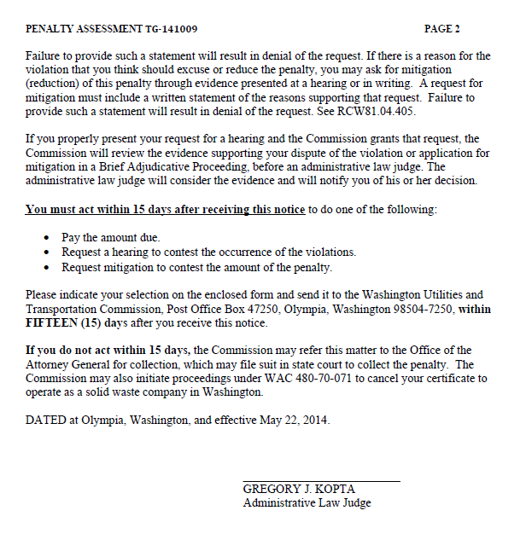

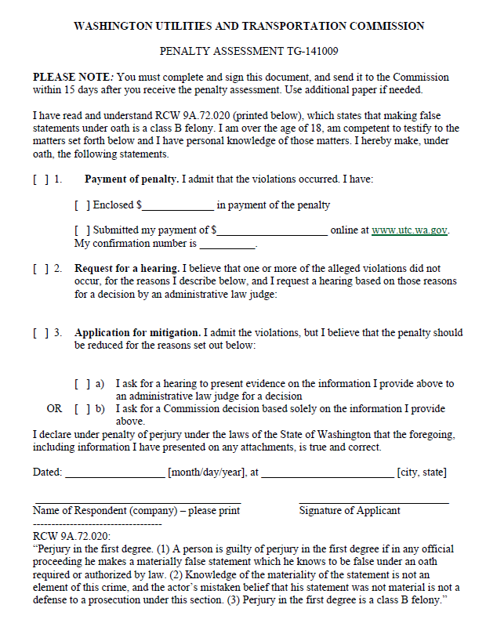

ATTACHMENT B
