Agenda Date: June 11, 2009
Item Number: B1

Docket: TC-090637
Company Name: San Juan Transit, Inc., C-1006

Staff: David Gomez, Deputy Assistant Director
Dennis Shutler, Consumer Protection Staff
Recommendation
- Dismiss the Complaint and Order Suspending Time Schedule 51 filed by San Juan Transit, Inc.; and

- Allow the revised temporary time schedule to become effective on June 12, 2009, on a permanent basis.
Discussion
On April 28, 2009, San Juan Transit, Inc., (San Juan Transit or company) filed a revised Time Schedule 51 replacing Time Schedule 50 that expired on September 14, 2008. The company requested that the time schedule take effect on May 15, 2009. The company provides scheduled auto transportation service between Friday Harbor and Roche Harbor on San Juan Island during the summer tourist season. In 2008, the company transported over 15,000 passengers.
On May 14, 2009, the Utilities and Transportation Commission (commission) allowed the proposed time schedule to become effective on May 15, 2009, on a temporary basis to allow customer comment. The company’s proposed schedule reduces from three to two the runs between Friday Harbor and Roche Harbor (including intermediate points) and eliminates service between Friday Harbor and American Camp located on the southeast part of the island (see Figure 1).
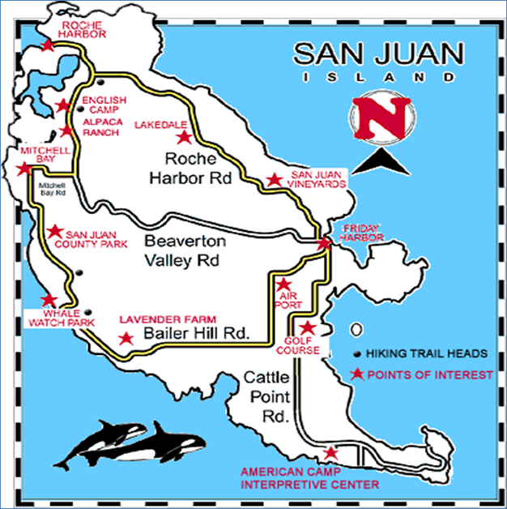
Figure 1, San Juan Transit, Inc. Service Area Map
Customer Comments
On May 8, 2009, San Juan Transit posted notice of the proposed time schedule at each vehicle, passenger facility, and on the company’s web site. Consumer Protection staff has not received any customer comments on the proposed time schedule at this time.
Conclusion
- Dismiss the Complaint and Order Suspending Time Schedule 51 filed by San Juan Transit, Inc.; and

- Allow the revised temporary time schedule to become effective on June 12, 2009, on a permanent basis.

