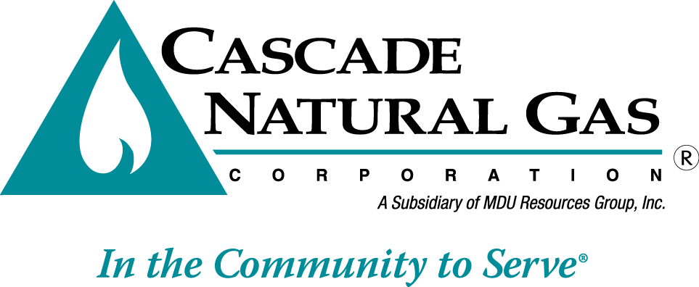
December 1, 2015
8113 W. GRANDRIDGE BLVD., KENNEWICK, WASHINGTON 99336-7166
TELEPHONE 509-734-4500 FACSIMILE 509-737-9803
www.cngc.com

Mr. Steven V. King
Executive Director and Secretary
Washington Utilities & Transportation Commission
P.O. Box 47250
Olympia, WA 98504-7250

Re: Cascade Natural Gas General Rate Case

Dear Mr. King,

Cascade Natural Gas Corporation (“Cascade” or “Company”) hereby submits the attached filing seeking Commission authorization to increase its rates and charges for natural gas services to its natural gas customers in the state of Washington. As a part of its filing, the Company is proposing an overall increase of 4.17% in base rates or $10.5 million for natural gas service. The filed tariffs have a requested effective date of January 1, 2016.

Additionally, Cascade Natural Gas Corporation requests that the Commission immediately suspend the operation of the general tariff revisions included in this filing, and promptly set the matter for hearing, including the establishment of a prehearing conference, at the earliest possible date in accordance with WAC 480-07-440(1)(a).

Service of documents pertaining to this filing should be to the following Cascade Natural Gas Corporation representatives:

Michael Parvinen  Director of Regulatory Affairs  Cascade Natural Gas Corporation  8113 West Grandridge Boulevard  Kennewick, WA 99336-7166  Telephone: (509)734-4593  Facsimile: (509)737-7166  Email: Michael.Parvinen@cngc.com | Lisa Rackner  McDowell Rackner & Gibson PC  419 SW 11th Avenue, Suite 400  Portland, OR 97205  Telephone: 503-595-3925  Facsimile: 503-595-3928  Email: lisa@mcd-law.com

Enclosed for filing are the following revisions to Cascade’s Tariff WN U-3, stated to become effective January 1, 2016. For each revised sheet, an original and two copies formatted with the coding are provided as required by WAC 480-80-105, and three copies in legislative format are also provided as required by WAC 480-07-510:

Thirty-Fifth Revision Sheet No. 2
Twentieth Revision Sheet No. 2-A
Third Revision Sheet No. 7
Fifth Revision Sheet No. 21
First Revision Sheet No. 25
Original Sheet No. 25-A
Original Sheet No. 25-B
Original Sheet No. 25-C
Third Revision Sheet No. 301
Fifty-Third Revision Sheet No. 502
Fifty-Eighth Revision Sheet No. 503
Forty-Second Revision Sheet No. 504
Forty-First Revision Sheet No. 505
Fifty-Eighth Revision Sheet No. 511
Thirty-Eighth Revision Sheet No. 512
Fifty-Second Revision Sheet No. 570
Forty-Ninth Revision Sheet No. 577
Original Sheet No. 594
Thirty-Fifth Revision Sheet No. 595
Eighty-First Revision Sheet No. 596
Third Revision Sheet No. 597
Sixteenth Revision Sheet No. 663
Fourth Revision Sheet No. 685-A
Fourth Revision Sheet No. 687

The Company is also withdrawing from Tariff WN-U3 the following sheets in their entirety:

Third Revision Sheet. No. 12-C
Fifty-Fourth Revision Sheet No. 541
Fifth Revision Sheet No. 545
Eighth Revision Sheet No. 599
Fifth Revision Sheet No. 664
First Revision Sheet No. 665
Fourth Revision Sheet No. 678
Third Revision Sheet No. 678-A
Second Revision Sheet No. 679
Ninth Revision Sheet No. 681
Substitute Sixth Revision Sheet No. 682
Fourth Revision Sheet No. 683
Substitute Fourth Revision Sheet no. 684
Substitute Third Revision Sheet No. 684-A
Original Sheet No. 699

As directed by Kippi Walker, the Company has enclosed 1 original and 8 copies of its prepared direct testimony and exhibits. 3 copies of work papers showing how test year data were adjusted will follow. A summary document pertaining to the filing is provided as well as the financial reports and other documents required under WAC 480-07-510. An electronic version of this filing and all supporting documents is enclosed as well. The Office of Public Counsel has also been served with a copy of all such documents at the time of filing with the Commission.

Please note that certain sections of the exhibits of Mark A. Chiles have CONFIDENTIAL information. Additionally, as required by WAC 480-07-160(3)(a), the Company is also submitting an Attorney’s Claim of Confidentiality regarding the submission of the unredacted versions of the above-referenced CONFIDENTIAL exhibits and work papers. These documents should be treated as CONFIDENTIAL per WAC 480-07-160.

In compliance with WAC 480-90-197, the Company will provide public notice once the public hearing dates have been selected. In compliance with WAC 480-90-193(1), the Company will post the proposed changes to its tariffs for public inspection and review on its website, and will provide access via request by telephone or mail. A service list is attached, with the parties on the service list receiving a complete copy of the pre-filed testimony and exhibits.

In compliance with WAC 480-07-510(3)(i), the Company states that there are no additional material affiliated transactions to report impacting the test year that otherwise were not already reported in the Company’s annual 2014 Report of Affiliated Interest Transactions. The Company’s 2014 annual report was filed on April 29, 2015 (See Docket UG-150733). The Company will file its annual 2015 Report of Affiliated Interest Transactions on or before April 30, 2016.

Please note that the Company has simultaneously filed “Cascade Natural Gas Corporation’s Motion for a Protective Order Pursuant to WAC 480-07-420”.

Additional copies of this filing, supporting testimony and exhibits are available from the Company upon request. Questions regarding this filing should be directed to Michael Parvinen at (509) 734-4593.

Sincerely,

Michael Parvinen
Director, Regulatory Affairs

Enclosures

Cc: See attached service lists

