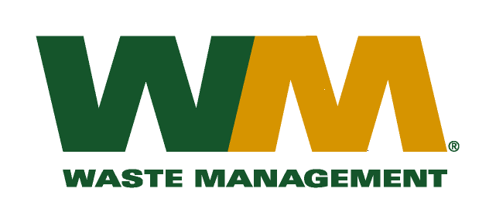
March 17, 2011
Washington Utilities and Transportation Commission
Chandler Plaza Building
1300 S. Evergreen Park Drive SW
P.O. Box 47250
Olympia, WA. 98504-7250

Dear Sirs:
Subject: Waste Management of Ellensburg, Docket TG-110496
Please find enclosed substitute tariff page 28 to the above-referenced docket. This page is being submitted to correct a clerical error. Please do not re-docket.

If you have any questions or need additional information, please contact me at (425) 814-7840.
Respectfully,

Michael A. Weinstein
Senior Pricing Manager, Pacific Northwest Market Area

