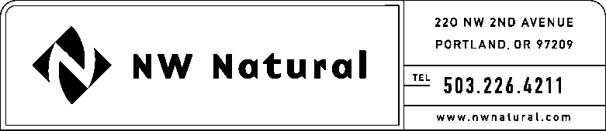

ONITA R. KING
Rates & Regulation
Tel: 503.721.2452
Fax: 503.721.2516
Email: ork@nwnatural.com

December 20, 2016

VIA ELECTRONIC FILING

Steven V. King, Executive Director and Secretary
WASHINGTON UTILITIES &
TRANSPORTATION COMMISSION
1300 S Evergreen Park Drive, SW

Post Office Box 47250
Olympia, Washington 98504-7250

Re: Request for Extended Effective Date
UG-161259 / NWN WUTC Advice No. 16-07
Schedule G, Energy Efficiency Services and Programs – Residential and Commercial
Schedule I, Washington Low-Income Energy Efficiency (WA-LIEE) Programs

Northwest Natural Gas Company, dba NW Natural (“NW Natural” or the “Company”), respectfully request that the effective date of the above-referenced advice filing be extended to January 27, 2017.

Please address correspondence on this matter to me with copies to the following:

eFiling

NW Natural Rates & Regulatory Affairs
220 NW Second Avenue

Portland, Oregon 97209
eFiling@nwnatural.com

Sincerely,

NW NATURAL

/s/ Onita King

Onita R. King
Rates and Regulation

