February 5, 2016

Mr. Steven King
Executive Director and Secretary
Washington Utilities and Transportation Commission
1300 South Evergreen Park Drive SW
Olympia WA 98504-7250

RE: Tariff Revision – WN U-5 for YCOM Networks, Inc. d/b/a FairPoint Communications; Docket UT-160171

Dear Mr. King:

On February 3, 2016 YCOM Networks, Inc. d/b/a FairPoint Communications submitted a one-day filing in the above referenced docket, to clean-up residual language left in the tariff related to WTAP, which has been removed.

Included in that filing was a sheet numbered Section IV, Second Revised Sheet No. 11. We have since discovered that this number incorrectly. Enclosed is a replacement sheet numbered Section VI, Second Revised Sheet No. 2. Please remove Sheet 11 from the February 3 filing and substitute this sheet instead.

Please contact Beth Westman at 207.535.4249 or bwestman@fairpoint.com with any questions or concerns regarding this filing.

Sincerely,
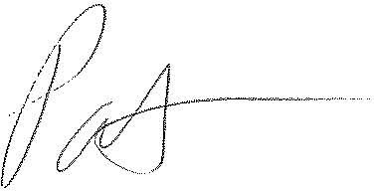
Patrick L. Morse
Senior VP Governmental Affairs
FairPoint Communications
P: 620-227-4409
F: 620-227-8576

