Eligible Telecommunications Carriers’ annual recertification on High Cost Fund pursuant to WAC 480-123-060, 070 and 080

June 29, 2016

Mr. Steven King, Executive Secretary
Washington Utilities and Transportation Commission
1300 South Evergreen Park Drive SW
Olympia, WA 98504-7250

Re: Request for Certification Pursuant to WAC 480-123-060 and 47 C.F.R. 54.314

Dear Mr. King:

Pursuant to WAC 480-123-070, The Toledo Telephone Co., Inc. (“Company”) hereby requests that the Washington State Utilities and Transportation Commission certify that the Company has met the requirements of 47. C.F.R. 54.314 for eligibility for continued receipt of federal high-cost funds.

The certifications and reports that are specified in WAC 480-123-060, WAC 480-123-070 and WAC 480-123-080 are enclosed.

Sincerely,

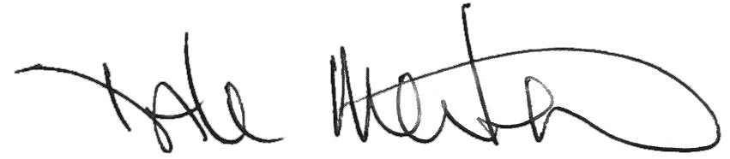

Dale Merten
Chief Operating Officer

