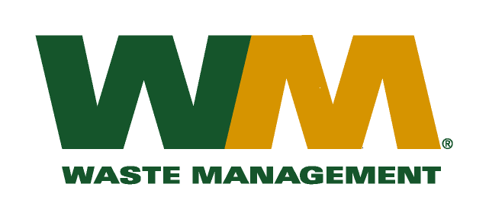

December 1, 2009

Washington Utilities and Transportation Commission
Chandler Plaza Building
1300 S. Evergreen Park Drive SW
P.O. Box 47250
Olympia, WA. 98504-7250

Subject: Waste Management – Sno-King, a division of Waste Management of Washington, Inc. (G-237); Tariff No. 15
Enclosed herein, you will find our new Tariff No.15 for the above-referenced company. This tariff replaces Waste Management – Sno-King Tariff No.14. In accordance with Commission Order 01 in docket TG-061433, the Company is required to file a general rate case upon the expiration of the “deferred fuel component” three year pilot program by December 1, 2009. We are submitting this filing as required in this order. We are also requesting adjustments to our rates attributed to increased disposal, maintenance, labor, fuel and other operating and administrative costs since our last general rate increase. This company received its last general rate increase on September 1, 2005 more than four years ago. This new tariff, if approved by the commission, would increase Company revenue by approximately $475,000 and collectively, residential and commercial rates by 4.9%. This new tariff is being filed with a proposed effective date of February 1, 2010.
Enclosed for your review are one paper and one electronic copy of our accounting workpapers and sample customer notices. Customer notices will be mailed on or before December 31, 2009. Also a copy of this transmittal letter was mailed to King County on December 1, 2009.
If you have any questions or need additional information, please contact me at (425) 814-7840.
Respectfully,

Michael A. Weinstein
Senior Pricing Manager, Pacific Northwest Market Area

cc: Dean Kattler
Tim Crosby
Joe Krukowski
Jeff McMahon
Clerk of the Board, King County

