By
Anna Hirtenstein

June 14, 2020 7:00 am ET

Safe Utilities Have Been More Volatile Than Broader Stock Market

Shares of utilities have been fluctuating more than the S&P 500 as investors fret about impact of coronavirus
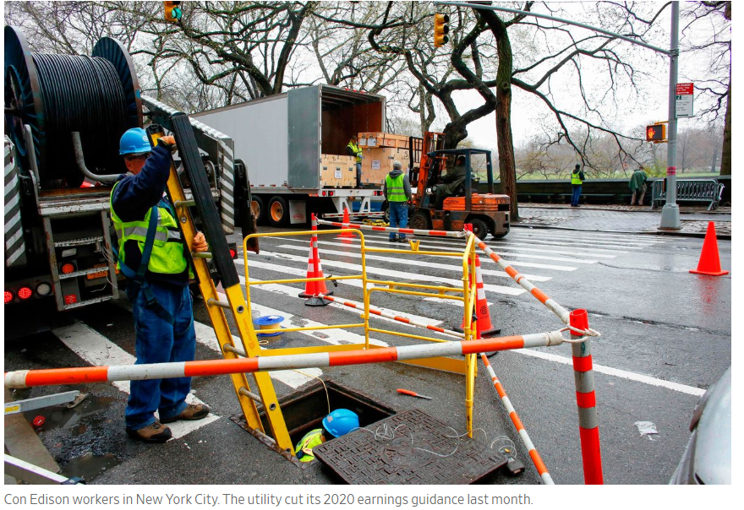
Utilities’ stocks have long been seen as a safe place to park cash and collect steady dividends. But as the coronavirus spread around the world this year, they have been more volatile than the broader market.
In March and April, shares of companies that sell electricity, water and gas posted bigger daily moves than the S&P 500 on a majority of days. The only other time this has happened in the past two years is during a bout of market volatility in February 2018. So far in June, it is a tie, with utilities moving more on five days.
The utilities sector within the S&P 500 is down almost 10% this year, even as the benchmark index rebounded to erase most of its losses.
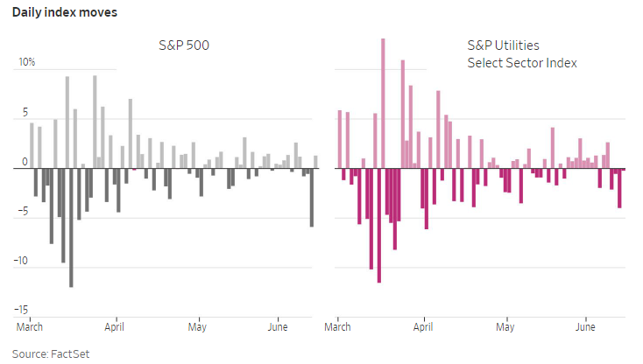
That is because of concerns about falling power demand and the spike in unemployment following the lockdowns put in place to curb the outbreak, analysts said. Millions of people have lost their jobs in recent months, prompting concerns that they may stop paying their bills. As dozens of companies cut or suspended their dividends to preserve their cash piles, some investors wondered if the major utilities could be next.
“Utility investors are not used to uncertainty,’’ said Jeremy Tonet, an equity research analyst at JPMorgan Chase & Co. “There were a lot of concerns with regard to Covid-19 and how much it could impact the space.”
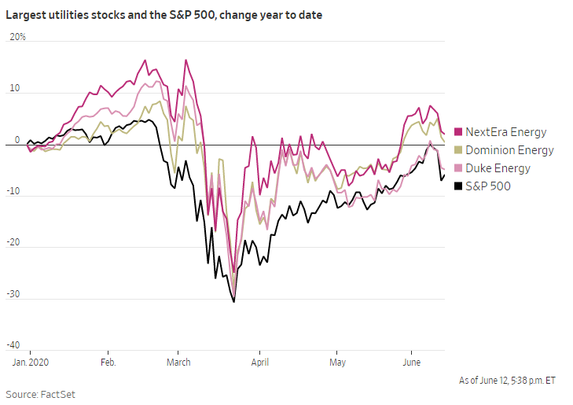
Utility stocks are normally popular with pension funds and insurers, who buy them for their stability and reliable dividend yields. Those expectations came into question during the peak of the market turmoil that ensued in March.
The lockdowns have resulted in a significant drop in energy use as commercial and industrial activity ground to a halt. A benchmark for wholesale power prices in the U.S. fell 20% in April, compared with the beginning of the year, and is still down nearly 15%, according to data from Bloomberg New Energy Finance. The Energy Information Administration said on June 9 that it expects electricity consumption in the U.S. to decline 5.7% in 2020. 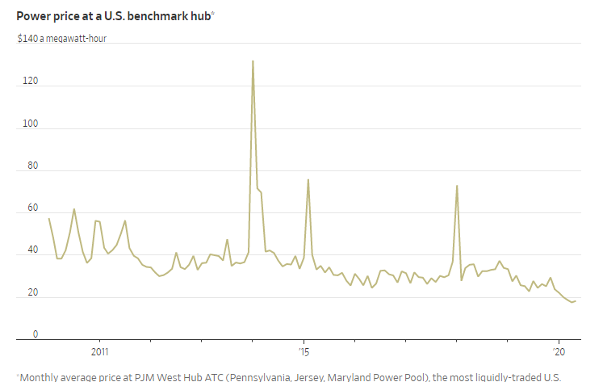
Despite this, nearly all major U.S. utilities have reaffirmed their full-year guidance, according to JPMorgan. One of the few exceptions is Consolidated Edison Inc., ED 0.95% which operates primarily in New York, the U.S. city that has been hardest-hit by the coronavirus. Con Ed last month cut its 2020 earnings guidance.
Meanwhile, CenterPoint Energy Inc. CNP 1.29% in Texas has been one of the few utilities to trim its quarterly dividend so far.
The regulated nature of the industry means that the revenue holds steady even if power prices fluctuate or sales fall, according to Noah Barrett, head of energy and utilities research at Janus Henderson. There are rules in place in many states that decouple energy demand from the companies’ cash flows and fix a rate of return on their investments to ensure that the businesses supplying the population with essential services remain in good health, he said.
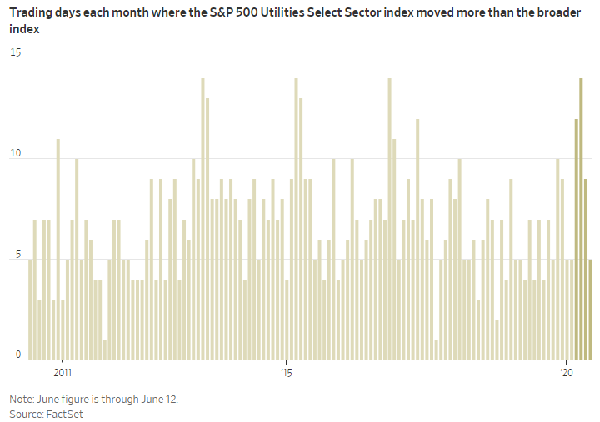
“The dynamic we saw this year with Covid-19 is something that no one knew how to model,” given the uncertainty around electricity or natural-gas demand, Mr. Barrett said. “If you look at the stability of the earnings, it hasn’t really changed.”
The utility companies’ very stability may now be working against them, he said. Some investors are seeking out stocks that have been hard-hit amid the economic downturn and could rebound sharply, or sectors such as technology that could benefit during lockdowns.
Another reason that utilities’ stocks are currently unloved is because of the sharp moves seen in March, said JPMorgan’s Mr. Tonet. Passively managed funds and asset managers that use algorithmic or quantitative strategies may not continue to view these stocks as predictable, low-volatility investments.
But in the long run, the companies still have strong fundamentals and “there’s room for utilities to regain their stance as a defensive stock,” he said.

