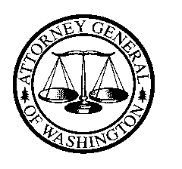
Bob Ferguson
ATTORNEY GENERAL OF WASHINGTON
Utilities and Transportation Division
PO Box 40128 • Olympia WA 98504-0128 • (360) 664-1183

Via Electronic and United States Mail

January 6, 2017

Rayne Pearson
Administrative Law Judge
Washington Utilities and Transportation Commission
1300 S. Evergreen Park Dr. S.W.
P.O. Box 47250
Olympia, Washington 98504-7250

RE: WUTC v. Pacific Power & Light Company
Docket UE-161204

Dear Administrative Law Judge Pearson:

All parties have agreed that March 13, 2017, is an appropriate date for the settlement conference in this matter and hereby jointly submit that date to comply with Order 03.

Thank you for your consideration of this matter.

Sincerely,

JEFF ROBERSON
Assistant Attorney General

LJR:emd
cc: All Parties

