July 21, 2015

Mr. Steven King
Executive Director and Secretary
Washington Utilities and Transportation Commission
1300 South Evergreen Park Drive SW
Olympia WA 98504-7250

RE: YCOM Networks, Inc. d/b/a FairPoint Communications – Required State USF Filing – Use of Funds; Docket UT-143023

Dear Mr. King:

Pursuant to WAC 480-123-130 and Order 01 in Docket UT-143023 which granted funds to YCOM Networks, Inc. from the State USF Program, please find the attached documentation in support of this distribution.

Please contact Beth Westman at 207.535.4249 or bwestman@fairpoint.com with any questions or concerns regarding this filing.

Sincerely,
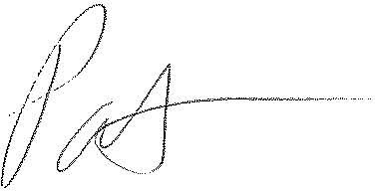
Patrick L. Morse
Senior VP Governmental Affairs
FairPoint Communications
P: 620-227-4409
F: 620-227-8576

