June 6, 2014

Steven V. King, Executive Director and Secretary
Utilities and Transportation Commission
1300 S. Evergreen Park Dr. SW
P.O. Box 47250
Olympia, WA 98504-7250

RE: Washington Utilities and Transportation Commission v. Andre C. Selfa

Commission Staff’s Response to Application for Mitigation of Penalties TE-141078

Dear Mr. King:

On May 28, 2014, the Utilities and Transportation Commission issued a $1,000 Penalty Assessment in Docket TE-141078 against Andre C. Selfa for 10 violations of Washington Administrative Code (WAC) 480-30-071, which requires charter and excursion carriers to furnish annual reports to the commission no later than May 1 each year.¹

On May 29, 2014, Andre C. Selfa wrote the commission requesting mitigation of penalties (Mitigation Request).² In its Mitigation Request, Andre C. Selfa. does not dispute that the violation occurred. The company states, “I have followed all other requirement set forth from the UTC including paying my yearly regulatory filings, safety audits, and additional requirements. I am not sure why this had not been filed, whether it was not received by me or was set aside; either way it was late and I did not realize the error an apologize for this inconvenience.” The mitigation request continues to state, “In my hopes to rectify this situation I have submitted the annual report and ask of you a reduced penalty. I am a business that only has one charter vehicle, I use it to do wine tours mainly on the weekend. Our revenue averages a little over $1200/mo at this time and it would be a very large burden for us”.

It is the company’s responsibility to ensure that the regulatory fee is paid and the annual report is filed by the May 1 deadline. On February 28, 2014, Annual Report packets were mailed to all regulated charter and excursion companies. The instructions for annual report completion page of the annual report informed the regulated company that it must complete the annual report form, pay the regulatory fees, and return the materials by May 1, 2014, to avoid enforcement action.
UTC Annual Reports
June 6, 2014
Page 2

Andre C. Selfa filed the 2013 annual report on May 29, 2014 and timely paid the required regulatory fees on December 23, 2013. The company has been active since May 16, 2013. The UTC also recently adopted new rules requiring the annual report to be filed by May 1 while the regulatory fees remained due on December 31. Despite the commission communication regarding these filing changes to all regulated charter and excursion companies, commission staff supports the company’s request for mitigation. Staff recommends a reduced penalty assessment of $200.

If you have any questions regarding this recommendation, please contact Amy Andrews, Regulatory Analyst, at (360) 664-1157, or aandrews@utc.wa.gov.

Sincerely,

Sondra Walsh, Director
Administrative Services

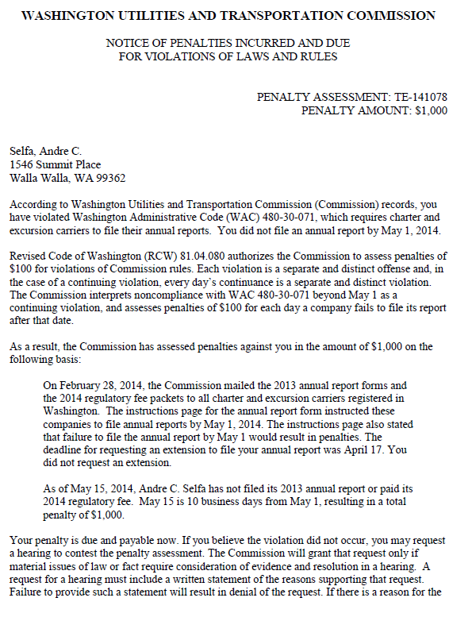
ATTACHMENT A

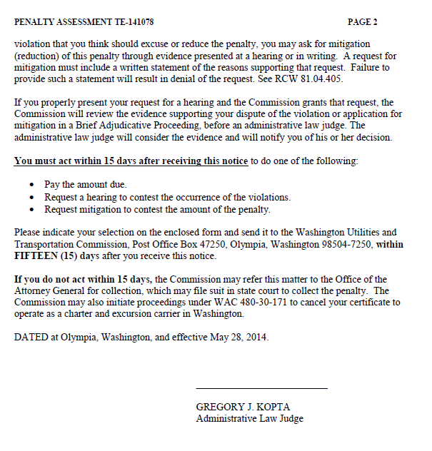

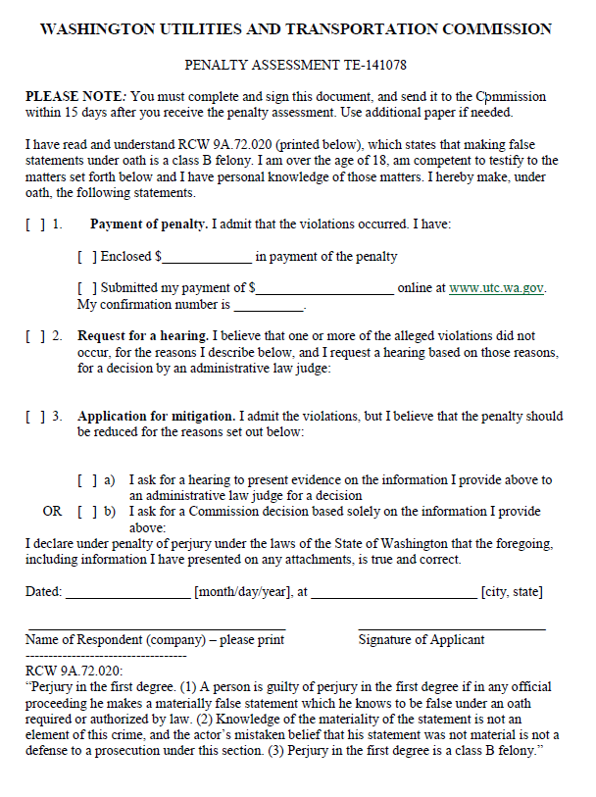

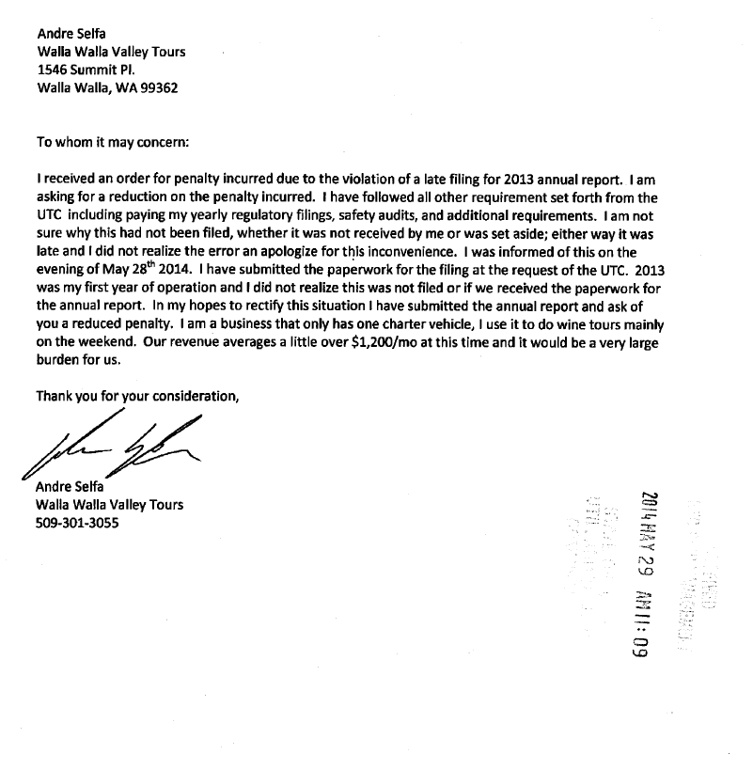
ATTACHMENT B

