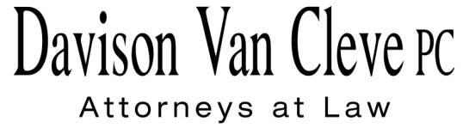
TEL (503) 241-7242 ● FAX (503) 241-8160 ● mail@dvclaw.com
Suite 400
333 S.W. Taylor
Portland, OR 97204

November 25, 2013

Via E-mail and Federal Express

Mr. Steven V. King
Acting Executive Director
Washington Utilities & Transportation Commission
1300 S. Evergreen Pk. Dr. S.W.
P. O. Box 47250
Olympia, WA 98504-7250

Re: In the Matter of PUGET SOUND ENERGY
For an Accounting Order Approving the Allocation of Proceeds of the Sale of Certain Assets to Public Utility District #1 of Jefferson County
Docket No. UE-132027

Dear Mr. King:

Enclosed please find an original and twelve (12) copies of the Petition to Intervene of the Industrial Customers of Northwest Utilities.

Thank you for your assistance, and please don’t hesitate to contact our office with any questions.

Sincerely yours,

/s/ Jesse Gorsuch
Jesse Gorsuch
Enclosures

cc: Service List

CERTIFICATE OF SERVICE

I hereby certify that I have this day served the attached Petition to Intervene upon all parties of record in this proceeding by sending a copy thereof via electronic mail and by mailing a copy via First Class U.S. Mail, postage prepaid, to each party’s last-known address, as shown below.
DATED this 25th day of November, 2013.
Davison Van Cleve, P.C.

/s/ Jesse Gorsuch
Jesse Gorsuch

PUGET SOUND ENERGY  KEN JOHNSON  PO BOX 97034 PSE-08N  BELLEVUE WA 98009-9734  ken.s.johnson@pse.com | PERKINS COIE  SHEREE STROM CARSON  10885 N.E. FOURTH STREET STE 700 BELLEVUE WA 98004-5579  scarson@perkinscoie.com
WASHINGTON UTILITIES & TRANSPORTATION COMMISSION  ROBERT D. CEDARBAUM  PO BOX 40128  OLYMPIA, WA 98504  bcedarba@utc.wa.gov | OFFICE OF THE ATTORNEY GENERAL  LISA W. GAFKEN  800 FIFTH AVENUE, SUITE 2000  SEATTLE, WA 98104-3188  lisa.gafken@atg.wa.gov

