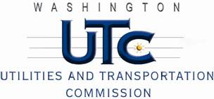

Memorandum
March 7, 2013

To: TR-121622 - File

From: Kathy Hunter, Deputy Director, Transportation Safety

Subject: TR-121622 – The Northwest Railway Museum
Grade Crossing Protective Fund (GCPF) project to modify a railroad-highway grade crossing at State Route 202/Bendigo Street (SR-202) in North Bend USDOT # 092040A

On October 18, 2012, the Washington Utilities and Transportation Commission (Commission) awarded The Northwest Railway Museum (Railway Museum) a GCPF grant in the amount of $20,000 to increase the length of the west bound approach block to a minimum of 270 feet at the SR-202 crossing in North Bend. The USDOT is #092040A. The estimated project cost was $42,300 with the Rail Museum paying for all costs exceeding $20,000.

On March 6, 2013, the Railway Museum submitted a request for reimbursement for work pursuant to Commission order. Commission staff conducted a site visit on February 12, 2013, and verified that the project was completed according to the specifications outlined in the order approving the grant.

Please close this docket.

