March 11, 2016

Mr. Steven King
Executive Director and Secretary
Washington Utilities and Transportation Commission
1300 South Evergreen Park Drive SW
Olympia WA 98504-7250

RE: Tariff Revision - YCOM Networks, Inc. d/b/a FairPoint Communications: Docket UT-160289

Dear Mr. King:

On March 10, 2016, YCOM Networks, Inc. d/b/a FairPoint Communications filed a tariff revision under rule WAC-480-80-123. This should have been filed under WAC 480-80-121 and the appropriate customer notices should have been included.

Attached for inclusion in this filing are the customer notices that will be included with customer statements dated March 15, 2016.

Please contact Beth Westman at 207.535.4249 or bwestman@fairpoint.com with any questions or concerns regarding this filing.

Sincerely,
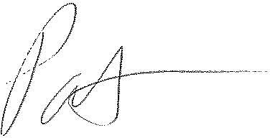
Patrick L. Morse
Senior VP Governmental Affairs
FairPoint Communications
P: 620-227-4409
F: 620-227-8576

