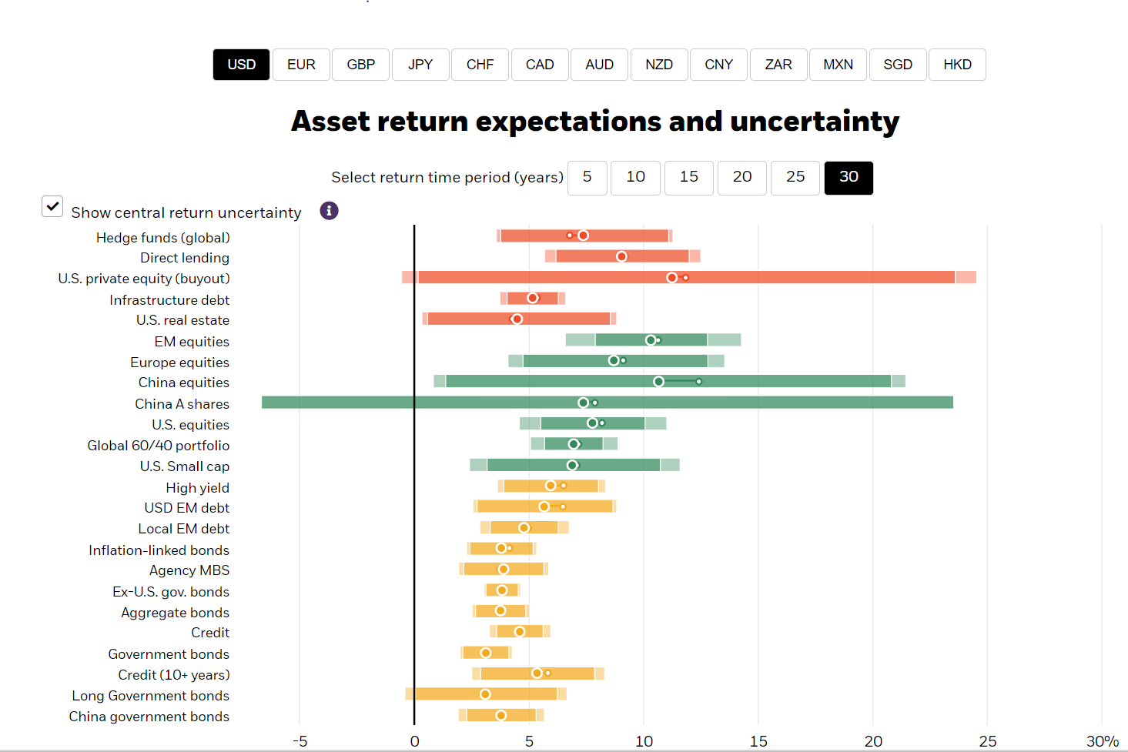
https://www.blackrock.com/institutions/en-us/insights/charts/capital-market-assumptions

7.8% - 3.1% = 4.7%

