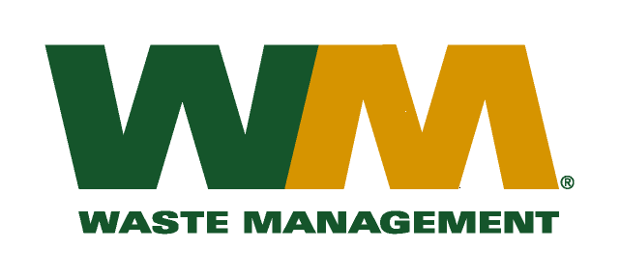

March 9, 2010
Washington Utilities and Transportation Commission
Chandler Plaza Building
1300 S. Evergreen Park Drive SW
P.O. Box 47250
Olympia, WA. 98504-7250

Subject: Waste Management of Greater Wenatchee, a division of Waste Management of Washington, Inc.(G-237); Tariff # 12
Dear Sirs:
Enclosed herein, please find revised pages 2 and 31 to the above-referenced tariff. These proposed revised tariff pages reflect the change in the Item 230 disposal fees charged at the Dryden Transfer Station. On February 23, 2010 the Board of County Commissioners for Chelan County passed Resolution No. 2010-24 establishing rates on a tonnage basis to reflect their recent installation of scales. Effective June 1, 2010, the rates charged at the Dryden Transfer Station will be revised from $16.89 per non-compacted yard and $25.34 per compacted yard to a new tonnage rate of $86.74 per ton.
Also enclosed for your review is a copy of Resolution No. 2010-24. Upon approval by the Commission, affected customers will be notified of this rate increase on their next regularly scheduled billing. If you have any questions or need additional information, please contact me at (425) 814-7840.
Very truly yours,

Michael A. Weinstein
Senior Pricing Manager, Pacific Northwest Market Area

cc: Clerk of the Board, Chelan County chair

