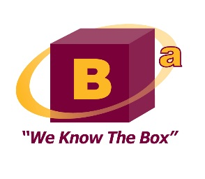
Bell & Associates, Inc.
1628 NW 33rd Way, Camas, WA 98607
Phone 360-210-4344

Danny Kermode, CPA January 5, 2015
Senior Energy Policy Analyst
Washington Utilities & Transportation Commission
1300 S. Evergreen Park Drive SW
Olympia, WA 98504-7250

RE: Solid Waste Rate Setting Methodology, Docket No. UG-131255

Bell & Associates, in a joint partnership with Sound Resource Economics, is pleased to submit our final report to the Washington Utilities & Transportation Commission (WUTC) on their method for setting collection rates for the regulated waste haulers. The report is the culmination of our efforts to assist the WUTC with their evaluation of the current Lurito Gallagher (L-G) rate model.
The WUTC currently uses the L-G methodology for determining revenue requirements for the solid waste collection companies that it regulates. The current L-G model is based on analyses conducted in the late 1980s and early 1990s of the empirically observed relationship between profit margins and capital turnover ratios among a set of comparable companies. Our report details the steps we took during the evaluation of the current rate setting approach, our findings, and recommendations to the WUTC.
Neal Johnson, PhD., Principal for Sound Resource Economics, and I greatly appreciate the opportunity provided by the WUTC to assist with this evaluation. If you have any further questions on this report, please contact me for further assistance.
Sincerely,

Christopher Bell, CPA
President, Bell & Associates, Inc.

