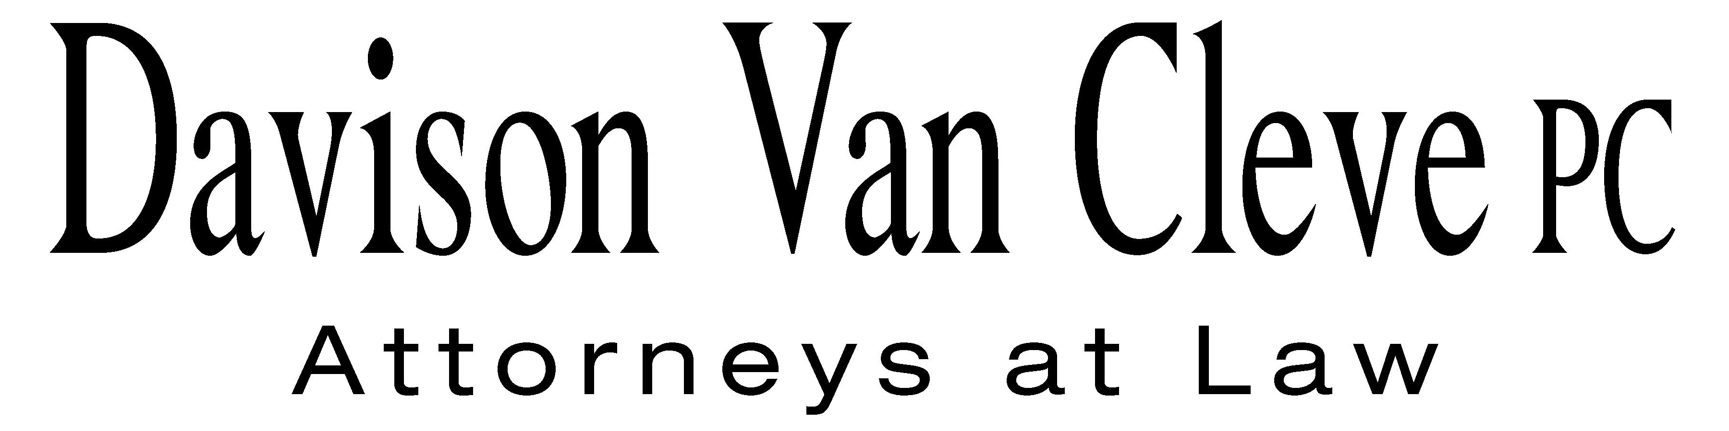
TEL (503) 241-7242 ● FAX (503) 241-8160 ● mjd@dvclaw.com
Suite 400
333 SW Taylor
Portland, OR 97204
March 20, 2015

Via Electronic Mail and U.S. Mail
Chairman Dave Danner
Commissioner Philip Jones
Commissioner Ann Rendahl
Washington Utilities and Transportation Commission
PO Box 47250
1300 S. Evergreen Park Drive, SW
Olympia, WA 98504-7250

Re: PacifiCorp Reliability Issues at the Boise White Paper, LLC Wallula Mill
Docket UE-121680

Dear Commissioners:

In October and November 2012, Boise White Paper, LLC (“Boise”) filed complaint letters against PacifiCorp (“Company”) with the Washington Utilities and Transportation Commission (“Commission”). The complaint letters requested a Commission investigation into power reliability and service quality issues concerning PacifiCorp’s transmission of electricity to Boise’s mill facility in Wallula, Washington (“Wallula Mill”). Copies of the 2012 complaint letters are attached.

There has been little recent progress from the Company to address the inherent system deficiencies which prompted the complaint, including unacceptably frequent outages caused by lightning strikes to the power lines serving the Wallula Mill. By not addressing the power reliability issues raised in the complaint, Boise continues to maintain that PacifiCorp has failed to meet service quality improvement obligations agreed to as part of the Company’s acquisition by Berkshire Hathaway Energy (formerly known as MidAmerican Energy Holding Company). As a result, Boise has had no choice but to spend incremental capital to secure internal protection against the risk of further outages—a wholly unnecessary and costly form of loss mitigation that Boise’s competitors, served by other utilities, simply do not have to bear.

Fortunately, the number of power outages and service quality occurrences has declined over the past twelve months. Boise can only attribute this reliability improvement to favorable weather conditions, however, rather than any beneficial system improvements recently implemented by PacifiCorp. Accordingly, in the event that more typical weather patterns resume, Boise will once again be faced with the likelihood of outage levels of unreasonably high frequency, severely impairing Boise’s operations.

In light of the strong possibility of future power service interruptions and quality issues, Boise asks the Commission to maintain the docket based upon Boise’s complaint. As presently favorable weather conditions have reduced the frequency of power fluctuations to more reasonable levels, Boise would not object to the placement of the current docket on “Inactive” status. Essentially, the lack of investigatory progress over the last two plus years has rendered the docket as inactive for some time, meaning that Boise’s request should not be onerous for the Commission, PacifiCorp, or Staff. Should a considerable amount of time pass without any significant outages or service quality issues caused by the Company’s power system—e.g., at least four years, given the decades of inadequate service previously—Boise would be willing to withdraw its complaint.

Thank you for your consideration of Boise’s concerns and request concerning the maintenance of its complaint docket. Boise believes that a continued, though potentially inactive docket is appropriate under the circumstances.

Sincerely yours,

/s/ Melinda J. Davison
Melinda J. Davison

cc: Patrick Loupin
Sarah Wallace
Bryce Dalley
David Nightingale

