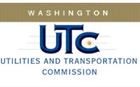

Memorandum

May 9, 2017

To: TR-161009 - File

From: Lori Halstead, Transportation Specialist

Subject: TR-161009 Tacoma Rail
Grade Crossing Protective Fund (GCPF) Project for Signage Upgrades

On October 6, 2016 the Washington Utilities and Transportation Commission (Commission) awarded a GCPF grant totaling $7,910 for signage upgrades at 70 Tacoma Rail private crossings.

On March 24, 2017, the applicant, Tacoma Rail, submitted a request for reimbursement pursuant to Commission order. Photographs of the signage were submitted by the applicant and accepted by Rail staff. The initial paperwork had some discrepancies and was resubmitted on May 2, 2017. The project was completed according to the specifications outlined in the order approving the grant.

Please close this docket.

