SECTION 3

DEMAND FORECAST

Overview

Each year Cascade develops a 20-year forecast of customers, therm sales and peak requirements for use in short (annual budgeting) and long-term (distribution and integrated resource planning) planning processes. This forecast is a robust portfolio of estimates created by enhancing a single best-estimate forecast with various potential economic, demographic and marketplace eventualities into low, medium and high growth forecast scenarios. The scenarios are used for distribution system enhancement planning and as inputs in optimization models to determine the least cost portfolio of supply and DSM resources, revenue budgeting, and load forecasts associated with the purchase gas costs process.

Demand Areas

In 2016, Cascade has decided to forecast at the citygates level. Cascade has a total of 74 citygates. There are nine city gates that only feed non-core customers, and 65 that have at least one core customer behind it. Of the 65 citygates that serve core customers, 18 citygates are grouped into 8 different loops. Each citygates is assigned to a weather location. The citygates were assigned to either the closest weather location by distance or the closest weather location by climatic simile. This is a change of methodology from previous years where certain models were built from the district or zonal level. The CityGate results are rolled up into zones and districts which segregate Cascade’s system based on pipelines and weather (see Appendix C). Table 3-1 provides a cross reference for the demand areas.

Table 3-1: Demand Areas

City Gate | Loop | State | Weather Location | Zone
7TH DAY SCHOOL |  | WA | Yakima | 10
A/M RENDERING |  | WA | Bellingham | 30-W
ACME |  | WA | Bellingham | 30-W
ARLINGTON |  | WA | Bellingham | 30-W
ATHENA |  | OR | Pendleton | ME-OR
BAKER |  | OR | Baker City | 24
BELLINGHAM 1 (FERNDALE) | Sumas SPE Loop | WA | Bellingham | 30-W
BEND | Bend Loop | OR | Redmond | GTN
BREMERTON (SHELTON) |  | WA | Bremerton | 30-S
BURBANK HEIGHTS | Burbank Heights Loop | WA | Walla Walla | 20
CASTLE ROCK |  | WA | Bremerton | 26
CHEMULT |  | OR | Redmond | GTN
DEHAWN DAIRY |  | WA | Yakima | 10
DEMING |  | WA | Bellingham | 30-W
EAST STANDWOOD | East Stanwood Loop | WA | Bellingham | 30-W
FINLEY |  | WA | Walla Walla | 20
GILCHRIST |  | OR | Redmond | GTN
GRANDVIEW |  | WA | Yakima | 10
HERMISTON |  | OR | Pendleton | ME-OR
HUNTINGTON |  | OR | Baker City | 24
KALAMA #1 |  | WA | Bremerton | 26
KALAMA #2 |  | WA | Bremerton | 26
KENNEWICK | Kennewick Loop | WA | Walla Walla | 20
LA PINE |  | OR | Redmond | GTN
LAWRENCE |  | WA | Bellingham | 30-W
LDS CHURCH |  | WA | Bellingham | 30-W
LONGVIEW-KELSO | Longview South Loop | WA | Bremerton | 26
LYNDEN | Sumas SPE Loop | WA | Bellingham | 30-W
MADRAS |  | OR | Redmond | GTN
MCCLEARY (ABERDEEN/HOQUIAM) |  | WA | Bremerton | 30-S
MILTON-FREEWATER |  | OR | Walla Walla | ME-OR
MISSION TAP |  | OR | Pendleton | ME-OR
MOSES LAKE |  | WA | Yakima | 20
MOUNT VERNON | Sedro-Woolley Loop | WA | Bellingham | 30-W
MOXEE (BEAUCHENE) |  | WA | Yakima | 11
NORTH BEND | Bend Loop | OR | Redmond | GTN
NORTH PASCO |  | WA | Walla Walla | 20
NYSSA-ONTARIO |  | OR | Baker City | 24
OAK HARBOR/STANWOOD | East Stanwood Loop | WA | Bellingham | 30-W
OTHELLO |  | WA | Walla Walla | 20
PASCO | Burbank Heights Loop | WA | Walla Walla | 20
PATTERSON |  | WA | Yakima | 26
PENDLETON |  | OR | Pendleton | ME-OR
PRINEVILLE |  | OR | Redmond | GTN
PRONGHORN |  | OR | Redmond | GTN
PROSSER |  | WA | Yakima | 10
QUINCY |  | WA | Yakima | 11
REDMOND |  | OR | Redmond | GTN
RICHLAND (Richland Y) | Kennewick Loop | WA | Walla Walla | 20
SEDRO/WOOLLEY | Sedro-Woolley Loop | WA | Bellingham | 30-W
SELAH | Yakima Loop | WA | Yakima | 11
SOUTH BEND | Bend Loop | OR | Redmond | GTN
SOUTH LONGVIEW | Longview South Loop | WA | Bremerton | 26
STANFIELD |  | OR | Pendleton | GTN
STEARNS (SUNRIVER) |  | OR | Redmond | GTN
SUNNYSIDE |  | WA | Yakima | 10
UMATILLA |  | OR | Pendleton | ME-OR
WALLA WALLA |  | WA | Walla Walla | ME-WA
WCT-CNG INTERCONNECT | Sumas SPE Loop | WA | Bellingham | 30-W
WENATCHEE |  | WA | Yakima | 11
WOODLAND |  | WA | Bremerton | 26
YAKIMA CHIEF RANCH |  | WA | Yakima | 10
YAKIMA TRAINING CENTER |  | WA | Yakima | 11
YAKIMA/UNION GAP | Yakima Loop | WA | Yakima | 11
ZILLAH (TOPPENISH) |  | WA | Yakima | 10

Weather

Historical weather is sourced from Schneider Electric. Future weather is based on Cascade’s 30-year normal developed in the forecast model. The forecast model takes the 30 previous years, converts the data to HDDs, then averages the HDDs into average months to create a normal year. Cascade has seven weather locations with four being located in Washington and three in Oregon. The 4 weather locations in Washington are Bellingham, Bremerton, Yakima, and Walla Walla.

In order to ensure satisfaction of core customer demand on the coldest days, Cascade develops peak day usage forecasts in conjunction with annual basis load forecasts. Peak day forecasts enable Cascade to make prudent distribution system and peak capacity planning decisions to fulfill its responsibility to provide heating under all but force majeure conditions, particularly as most space-heating customers will have no alternative heating source during the coldest of days in the event gas does not flow.

Historically, Cascade has developed peak day forecasts based on a 65 HDD day (0°F) to reflect the coldest day in Cascade’s 60-year weather history. Cascade’s 2008 IRP changed this practice to reflect the coldest day during the past 30 years. Cascade’s 2016 IRP will be based on a 60 HDD day (0°F) and will continue to reflect the coldest day during the past 30 years. Cascade chose to switch from a 65°F to a 60°F reference temperature because Cascades demand does not begin to significantly increase until temperatures dropped below 60°F. For further explanation, refer to pages 8-10 of the supporting Demand Forecast Design Document. This was tested and proved by the improved correlation between weather and demand. The coldest day on record for the past 30 years was December 21, 1990 at 56 HDDs. The peak day forecast is developed by applying the December 21, 1990 HDD to each citygates linear regression, by its respective weather location.

This method rests on the assumption that core market load shape does not significantly change throughout the forecast horizon. Cascade believes that the peak day forecast conservatively overestimates peak day usage as the base forecast does not explicitly include future conservation measures implemented by customers that would act to increase energy efficiency and reduce therm day usage.

Cascade will continue to investigate how the peak day standard affects those core demand load areas which are short of capacity. This investigation will include (but not be limited to) analysis of how other regional utilities look at peak day, discussions with the various weather services, and continued dialogue with commission staff and other interested parties.

Methodology

Customer count forecasts are designed to reflect both demographic trends and economic conditions both in the short and long term. Cascade uses population and employment growth data derived from Woods & Poole. Woods & Poole growth forecasts are provided at the county level and are directly assigned to a Citygate’s previous year’s customer count. It should be noted that Woods & Poole forecasts are adjusted based on near term billing information, whereas the internal intelligence about a demand area indicates a significant difference from Woods & Poole with regard to observed economic trends.

Customer count and therm forecasts are augmented by revisions to the base data and output to create a portfolio of potential scenarios. Low and high growth scenarios are created by applying Woods & Poole’s forecasts to accurately predict Cascade’s service territory’s strongest and weakest performance over the next 20 years (Appendix B). These scenarios, along with the original best-estimate mid-case scenario, encapsulate a range of most-likely possibilities given known data. The most recent Woods & Poole data indicates an average growth of 1.25% between 2017 and 2036 for Cascade’s service territory. The projected customer growth can be viewed in Appendix B. Based on historical experience; Cascade expects system load will likely remain within a range bounded by the low and high growth scenarios, given expected weather.

Cascade uses an ordinary least squares methodology with the goal of predicting demand based on weather and forecasted customers. Demand for each citygates and rate schedule takes on the formula:

$$y=\left[\left(a*x\right)+c\right]*customers \\ where, \\ y=dekatherms \\ a=UPC coefficient dekatherms per HDD per customer \\ x=HDD \\ c=baseload constant per customer in dekatherms \\ customers=forecasted customers$$
Cascade developed the Use per Customer (UPC) coefficient by gathering historical pipeline demand data by month. The pipeline demand data includes core and non-core usage. The non-core data is backed out using Cascade’s non-core Aligne system which leaves us with monthly core usage data. The monthly data is then allocated to a rate schedule for each citygates by using Cascade’s Customer Care and Billing System (CC&B). This data is then divided by customers to come up with a UPC number for each month for each rate schedule at each citygates. Then, a regression is run on the UPC and HDD actuals to come up with the formula above.

Sensitivity Analysis

Cascade stress tests the system in SENDOUT® by using alternative forecasting methodologies. These alternative forecasting methodologies refers to changing factors that influence demand. Alternative models include high and low customer growth, and high and low weather patterns, or a combination thereof. The combination between alternative growth and weather is high growth/cold weather, and low growth/warm weather because these test the extremes as they complement each other when it comes to influencing demand. Table 3-2 identifies the list of scenarios. Table 3-3 charts the sensitivity analysis over the planning horizon.

Table 3-2: Growth Scenarios

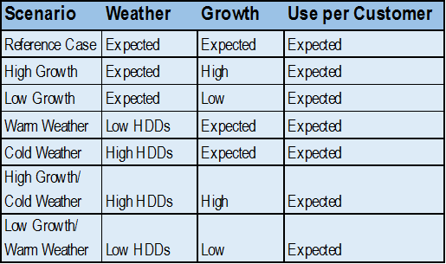

Figure 3-3: Sensitivity Analysis Demand Forecast (volumes in therms)
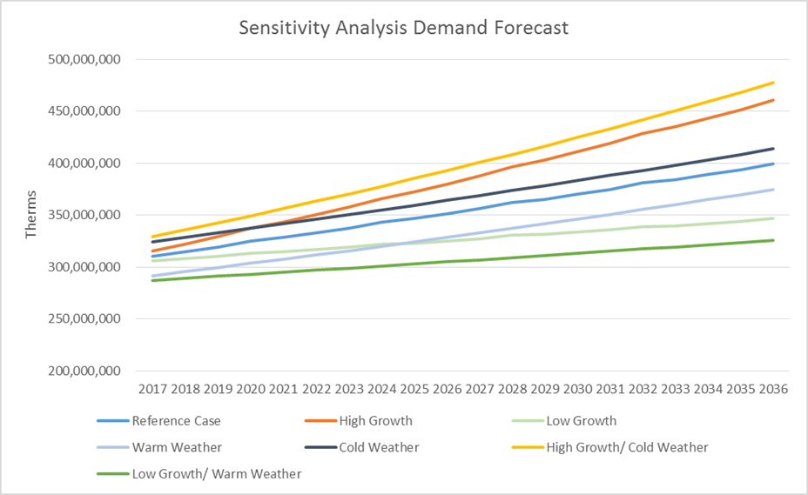

Forecast Results

Load growth across Cascade’s system through 2036 is expected to fluctuate between 1.16% and 1.31% annually after smoothing the leap year anomaly. Load growth is split between residential, commercial, and industrial customer. Residential and commercial customer classes are expected to grow at a rate above 1% annually while industrial expects a growth rate of around 0.5%. Table 3-3 shows the percentage of core growth by class over the planning horizon.

Table 3-3: Expected Load Growth by Class
 | Residential | Commercial | Industrial | System
2017 - 2021 | 1.25% | 1.69% | 0.75% | 1.31%
2022 - 2026 | 1.24% | 1.56% | 0.46% | 1.28%
2027 - 2031 | 1.21% | 1.48% | 0.33% | 1.24%
2032 - 2036 | 1.13% | 1.39% | 0.26% | 1.16%
2017 - 2036 | 1.21% | 1.53% | 0.45% | 1.25%

In absolute numbers, system load under normal weather conditions is expected to reach over 397 million therms in 2036. A majority of core load today is residential. Cascade projects the ratio between residential, commercial, and industrial to increase significantly in favor of commercial customers. Figure 3-1 displays the relative percentage relationship of expected loads by class.

Figure 3-1: Expected Load Growth by Class
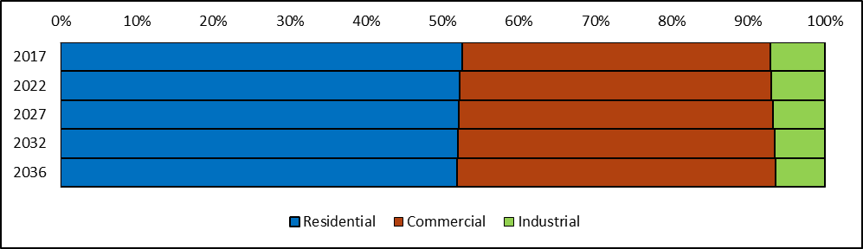

Cascade expects residential and commercial core customers to increase load by around 40-42 million therms each over the 20 -planning period. The industrial customer class expects to increase load by approximately 4 million therms over the same time period. Cascade expects load to increase by about 89 million therms. Table 3-4 displays the expected core load volumes by class.

Table 3-4: Expected Load Growth by Class (volumes in therms)

 | Residential | Commercial | Industrial
2017 | 162,191,299 | 124,556,975 | 21,888,875
2022 | 173,002,864 | 135,106,639 | 23,006,406
2027 | 184,425,511 | 145,676,974 | 23,892,422
2032 | 197,089,261 | 157,102,305 | 24,702,016
2036 | 206,484,956 | 165,833,234 | 25,233,289
2017 - 2036 | 27.31% | 33.14% | 15.28%

Load growth is primarily a result of increased customer counts. The number of commercial and industrial customers is expected to increase slightly faster than therm usage. Several factors are believed to be the cause of this phenomenon; among them are the adoption of soft conservation and more stringent building codes, and improved efficient technologies. Table 3-5 displays the expected customer counts by class.

Table 3-5: Expected Customer Counts by Class
 | Residential | Commercial | Industrial
2017 | 244,177 | 36,339 | 598
2022 | 259,872 | 39,483 | 620
2027 | 276,412 | 42,640 | 634
2032 | 293,424 | 45,863 | 644
2036 | 306,867 | 48,472 | 651
2017 - 2036 | 25.67% | 33.39% | 8.83%

Geography

Load across Cascade’s two-state service territory is expected to increase 26% over the planning horizon, with the Oregon portion outpacing Washington at 36% versus 26%. Table 3-6 shows the expected core load volumes by state.

Table 3-6: Expected Load by State (volumes in therms)
 | Washington | Oregon | System
2015 | 232,414,950 | 76,222,198 | 308,637,148
2020 | 248,096,580 | 83,019,329 | 331,115,909
2025 | 263,898,367 | 90,096,540 | 353,994,907
2030 | 281,006,139 | 97,887,443 | 378,893,582
2034 | 293,590,373 | 103,961,106 | 397,551,479

Within Washington, the western part of the state as well as Walla Walla is expected to see a large increase in growth. Yakima is expected to experience minimal growth. Commercial customers have a higher temperature sensitivity than residential customers. Because of their increasing profile on Cascade’s system over the coming 20 years, weather-sensitive peak demand will increase faster than annual load. The 2017 load on 56 HDDs is expected to be 3.5 million therms, rising to 4.5 million by 2036. Peak day load will increase at 1.33% annually, while annual load increases by 1.25%. Table 3-7 shows the percentage growth of load by each of Cascade’s weather locations. Table 3-8 shows the percentage growth of load by each pipeline zone over the planning horizon. Lastly, Table 3-9 displays a range of core peak day growth over the planning horizon along with a sampling peak day therms.

Table 3-7: Washington 20-Year Load Growth by Weather Location
Bellingham | 28.5%
Bremerton | 24.2%
Walla Walla | 30.5%
Yakima  Washington | 18.1%  26.1%

Table 3-8: System Load Growth by Pipeline Zone
Zone 10 | 15.9%
Zone 11 | 14.8%
Zone 20 | 32.8%
Zone 24  Zone 26  Zone 30-S  Zone 30-W  Zone GTN  Zone ME-OR  Zone ME-WA | 4.1%  23.2%  22.2%  27.0%  44.4%  14.0%  12.1%

Table 3-9: Expected Peak Day Growth (volumes in therms)
Period | Peak Growth | Year | Peak Day Therms
2017 - 2021 | 1.43% | 2021 | 3,776,574
2022 - 2026 | 1.36% | 2026 | 4,041,751
2027 - 2031 | 1.30% | 2031 | 4,313,247
2032 - 2036 | 1.22% | 2036 | 4,584,628

High and Low Scenarios

High and low scenarios were created by examining the percentage errors of previous Woods & Poole forecasts. The percentage errors show the average percentage difference between a Woods & Poole forecast and actual results. The previous forecasts averaged a percentage error of .5% or less of the actual forecast. Since Cascade is expecting about a 1.25% growth, a reasonable high and low scenario band is .65% above or below that growth level. Table 3-10 displays the expected total system load growth across various scenarios.

Table 3-10: Expected Total System Load Growth (by percentage) across Scenarios
 | Low | Mid | High
2017 - 2021 | 0.65% | 1.31% | 1.97%
2022 - 2026 | 0.64% | 1.28% | 1.94%
2027 - 2031 | 0.61% | 1.24% | 1.89%
2032 - 2036 | 0.57% | 1.16% | 1.78%
2017 - 2036 | 0.62% | 1.25% | 1.90%

Load growth under poor economic conditions is expected to be around 0.6% annually over the forecast period, while load growth under good economic conditions is expected to be around 1.9% annually. The cumulative effect of high growth over 20 years could result in additional load of 61 million therms, while low growth could result in a load with 52 million therms less than predicted in the medium growth scenario. Table 3-11 shows the expected total system load across these scenarios.

Table 3-11: Expected Total System Load Growth across Scenarios (volumes in therms)

 | Low | Mid | High
2017 | 303,968,666 | 308,637,148 | 313,346,208
2021 | 312,685,907 | 326,602,114 | 341,104,474
2026 | 323,326,756 | 349,373,660 | 377,602,786
2031 | 333,769,148 | 372,643,579 | 416,609,463
2036 | 345,227,222 | 397,551,479 | 458,654,121
Deviation | (52,324,257) |  | 61,102,642

Alternative Forecasting Methodologies

Cascade has made a slight change to the forecast methodology this year by using customers in the coefficient for the demand forecast formula. Cascade plans to continue to look at alternative forecast methodologies. Cascade has already purchased SAS, a statistical analysis software, and plans to look into non-linear forecasting methodologies.

Confounding regulatory principles are manifest in forecasting. These include:

- A desire for precision and a high degree of accuracy.
- A universal understanding that forecasts should be “close” to future realities but may have unanticipated swings in either direction.
- A disconnect between planning and operational functions, in that natural gas purchasing and dispatch will be based on immediate needs which, in actuality, are guaranteed to vary from the plan (per the previous bullet).
- An increased cost of improved precision sometimes has decreasing customer benefits.
- Regulators expect continual improvement because new tools are available and they expect to see what the Washington Commission calls “adaptive management” for all of its jurisdictional energy companies.
- Major differences in accounting treatment between the states regarding “test years” must be considered because, while these are for ratemaking purposes (that is, for general rate case filings) and not necessarily for planning, Oregon uses “future test year” accounting while Washington employs an “historic test year”.
- The “fuzziness” of historic data that includes effects of energy efficiency, retail price (from annual PGA—purchased gas adjustment—changes and other rate changes), sometimes abnormal weather, new technology, and then-unique economic conditions (e.g., recession, interest rates, etc.)
- Unknown and uncertain future changes such as the assumptions for CO₂ required for carbon policy and other environmental externalities.
- A need to demonstrate support for assumptions such as growth in customers, use per customer and changes from previous forecasts, type of use (i.e., heating, manufacturing, etc.), to name a few.

This illustrates the complexity of forecasting and highlights areas of stakeholder attention. Best efforts, at the appropriate cost, distills these factors into a generally-accepted forecast with recognition of inherent uncertainties.

Uncertainties

This forecast represents Cascade’s best estimate about future events. Several important factors make predictions of future load at this time particularly difficult – economic recovery, carbon legislation, building code changes, direct use campaigns, conservation, and long term weather patterns. The range of scenarios presented here encompasses the full range of possibilities through econometric analysis. These forecasts were created after running through a matrix of different functional forms and economic indicators. The chosen indicators were chosen because of their consistency in returning statistically valid results. While they may be the best results mathematically, they are not the sole and only determinants of load. As a result, while Cascade believes that the numbers presented here are accurate, and that the scenarios presented represent the full range of possibility, there are and always will be uncertainties in predicting the future.

