PSE Complaint No. 8
Case 16-047
Requestor:
Erika Hunter
Damage Prevention Program Manager
Puget Sound Energy
P.O. Box 97034, EST-11W
Bellevue, WA 98009-9734
Erika.Hunter@pse.com
425-456-2854

Alleged violator:
Charles Richmond
Employee: Unknown
Earthscapes NW Inc
PO Box 406
Conway, WA 98292

Date: 11/10/2016
Location: 18708 42nd Ave SE, Lot 28, Bothell WA
Violation: Digging without locates; RCW 19.122.30 (2) and (5)

Summary:
On November 17th^{th} 2016 PSE’s Damage Prevention Field Rep, Roger Arrington, came across a fence installation that had previously, on November 10th, had been identified as being installed without a valid locate ticket by Earthscapes NW Inc. in Bothell WA at 18708 42nd Ave SE, Lot 28. Roger noted that additional posts had been put in the ground to complete the fencing. Roger checked for a valid ticket on the ITIC site www.managetickets.com and found that Earthscapes NW Inc had completed the work without calling for locates, which is a violation of RCW 19.122.30 (2) and (5). To date, 11/17/2016, they have not called in for a ticket at that address.
Earthscapes NW has not called in any ticket for any excavation work since 05/27/2016.

Figure 1 "Before photo from 11/10/2016
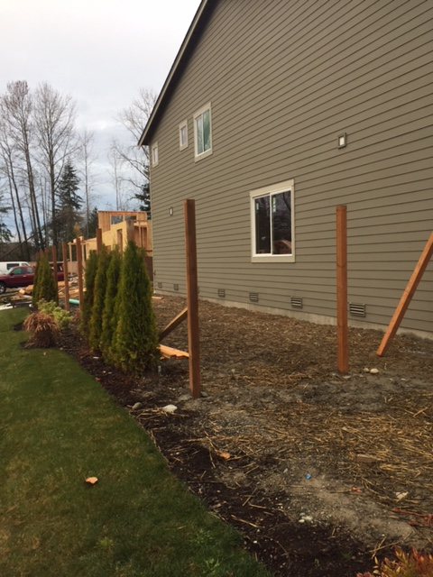

Figure 2 "After" photo on 11/17/2016