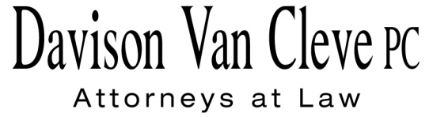
TEL (503) 241-7242 ● FAX (503) 241-8160 ● mail@dvclaw.com
Suite 400
333 SW Taylor
Portland, OR 97204

April 17, 2014

Via E-Mail and Federal Express

Mr. Steven V. King
Executive Director and Secretary
Washington Utilities and Transportation Commission
P.O. Box 47250
1300 S. Evergreen Park Drive
Olympia, WA 98504-7250

Re: WUTC Investigation Regarding Reliability
Docket No. UE-121680

Dear Mr. King:

Boise White Paper, L.L.C., as a party to the above-referenced proceeding, hereby serves notice that its name has changed to Packaging Corporation of America (“PCA”). PCA requests that the service list in the above-referenced docket be updated to reflect the name change. Please note that counsel of record for PCA in the above-referenced docket will remain the same.

Thank you for your assistance. If you have any questions, please do not hesitate to contact our office.

Sincerely,

/s/ Jesse O. Gorsuch
Jesse O. Gorsuch

Enclosures

