WSJ – October 31, 2019
U.S. Growth Settles in at Low Gear in Third Quarter
Consumer spending growth offsets business investment decline in 1.9% GDP increase
GDP, annualized quarterly change
Source: Commerce Department
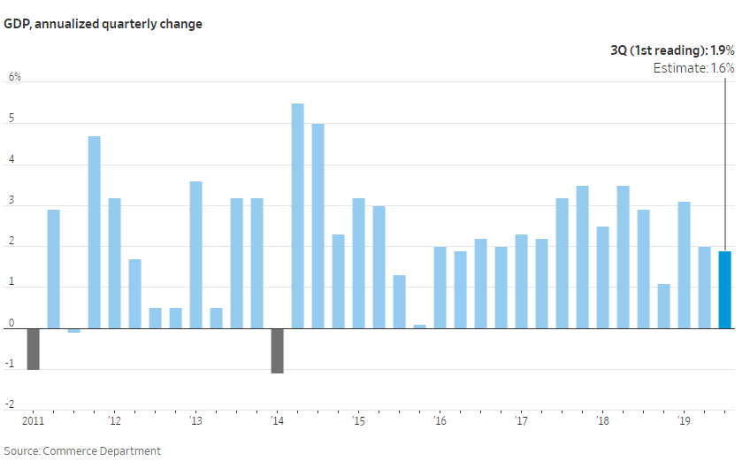

WASHINGTON—U.S. economic growth settled in at a lower gear in the third quarter, with consumer spending and housing investment increases offsetting a business investment drop.

Gross domestic product—the value of all goods and services produced in the U.S.—rose at an annual rate of 1.9% from July through September—adjusted for inflation and seasonality, the Commerce Department said Wednesday, compared with 2.0% in the second quarter.

“I think it’s consistent with an economy that’s just moving back towards trend,” Michael Feroli, an economist at JPMorgan Chase & Co., said of the growth reading.

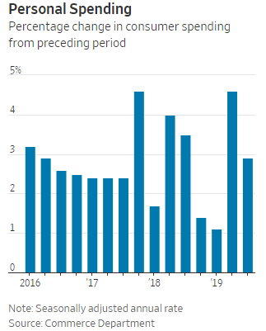

The stronger-than-expected growth rate was boosted by government and consumer spending, residential investment and exports. Still, business spending declined for the second quarter in a row. Investment in structures dropped sharply, particularly those related to the petroleum and natural gas industries.

The Commerce Department report showed the divergence between relatively solid consumer spending and falling business investment continued from the second quarter into the third, as the long-simmering trade war with China escalated.

Hours after the GDP report’s release, the Federal Reserve cut the benchmark federal-funds rate by a quarter percentage point, to a range between 1.50% and 1.75%, and began to play down expectations for further cuts. The move was the central bank’s third rate cut since late July to buffer the economy against a slowdown in business spending.

“We took this step to help keep the U.S. economy strong in the face of global developments and to provide some insurance against ongoing risks,” Fed Chairman Jerome Powell told a news conference, adding that the economy is growing at a moderate rate in its 11th year of expansion.

Consumer spending moderated to a 2.9% annual rate in the third quarter, from a 4.6% rate in the second. From a year earlier, consumer spending increased 2.5% in the third quarter, roughly consistent with the pace over the past year.

MORE
What ’s Driving the Economy—Before Trump and Now
Capital Account: Trump’s Tax Cut Underdelivers, Which Could Embolden Democrats Who Want It Reversed
Consumers are the lifeblood of the U.S. economy, as their spending accounts for nearly 70% of output. The report showed their spending on big-ticket items such as cars and appliances slowed but remained strong, while spending on services slowed.

Stephen Snow, a high-school teacher in New Port Richey, Fla., invested in a new boat this summer. Although he would like to get a golf cart too, Mr. Snow said his family is waiting for their tax return before making another large purchase. “The way I look at it, [the economy] is kind of up and down,” he said.

The slower pace of consumer spending in the third quarter came despite a solid financial foundation for many U.S. households. The unemployment rate was at half-century lows from July to September, and wages and incomes rose. Consumer sentiment has remained strong in recent months and rose slightly in October, according to the University of Michigan’s Surveys of Consumers.

The housing sector was a tailwind for growth as residential investment rose at a 5.1% annual pace. The boost, which followed six straight quarters of declines, likely reflected lower short-term interest rates propelling construction and improvements.

The Commerce Department data also offered evidence of slowing corporate demand. Nonresidential fixed investment—which reflects business spending on software, research and development, equipment and structures—fell at a 3.0% rate.
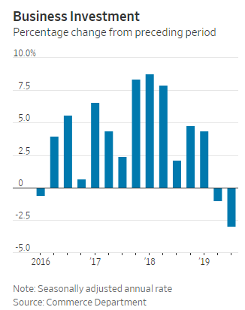
Equipment spending on aircraft also decreased amid the continuing grounding of Boeing Co.’s 737 MAX jetliner and probes into the causes of two deadly plane crashes involving the Boeing plane, a Lion Air jet in October 2018 and an Ethiopian Airlines MAX in March

Private investment in aircraft equipment was $22.5 billion annualized and adjusted for inflation in the third quarter, less than half the $48.1 billion rate in the final quarter of 2018.

Business-investment data can be volatile from one quarter to another, but the weak number in the latest report suggests factors including political uncertainty and the outlook for trade tariffs are weighing on business decisions to spend on new equipment and plants.

D’Anne McCumber, general manager at equipment maker Oilfield Improvements, Inc. in Broken Arrow, Okla., said “things have slowed down just a little bit, but not severely,” compared with the first and second quarters of this year.

“Right now people are in a bit of a holding pattern, it happens in the oil-and-gas industry at the beginning of a campaign year,” she said.

Low energy prices have “definitely restricted activity and investment in the oil and gas space,” said Aron Deen, director of marketing and business development at Fort Worth, Texas-based oil-drilling equipment maker Ulterra Drilling Technologies.
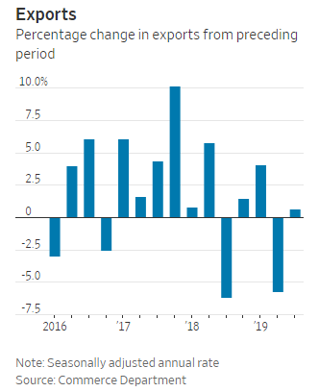
3Q 2016x6.1%
“The market buzz in oil and gas has been basically trying to restrict spending to cash flow,” he said.

The decline in business investment is a sign that the 2017 tax law isn’t having the effects its authors predicted and desired. The law cut corporate tax rates and allowed immediate deductions for capital investment, and raising the after-tax rate of return was supposed to encourage companies to spend on factories and equipment.

After a jump in early 2018, investment has slumped. It has been dragged down by uncertainty over the trade war and global economy. In addition, companies may not see the current corporate tax rules as stable over the longer term because Democrats are proposing to raise the corporate tax rate.

Trade was broadly neutral in the third quarter, as net exports subtracted a mild 0.08 percentage point from the quarter’s 1.9%

