July 1, 2015

Mr. Steven King
Executive Director and Secretary
Washington Utilities and Transportation Commission
1300 South Evergreen Park Drive SW
Olympia WA 98504-7250

RE: Ellensburg Telephone Company d/b/a FairPoint Communications – Required State USF Filing – Use of Funds; Docket UT-143022

Dear Mr. King:

Pursuant to Order 01 in Docket UT-143022 which granted funds to Ellensburg Telephone Company from the State USF Program, please find the following documentation:

- General Ledger Report
- Project Status Report
- Project Accounting Report

The order states that Ellensburg Telephone Company d/b/a FairPoint Communications is required to deposit funds from the State USF Program in a separate account dedicated to the projects described in the supplement petition, and provide an accounting of such funds to the Commission by July 1, 2015, and January 31, 2016. This report is in compliance with the first of these filing dates.

This information is being filed as CONFIDENTIAL pursuant to WAC 480-07-160. Ellensburg Telephone Company d/b/a FairPoint Communications believes that public availability of this information could cause potential, but irreparable, injury to the company because of the nature of this information. The submitted data includes specific proprietary information about the company accounting, engineering, and operations that is not normally released to the public.

Please contact Beth Westman at 207.535.4249 or bwestman@fairpoint.com with any questions or concerns regarding this filing.

Sincerely,
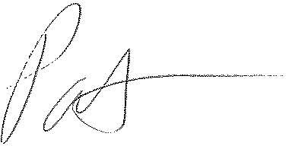
Patrick L. Morse
Senior VP Governmental Affairs
FairPoint Communications
P: 620-227-4409
F: 620-227-8576

