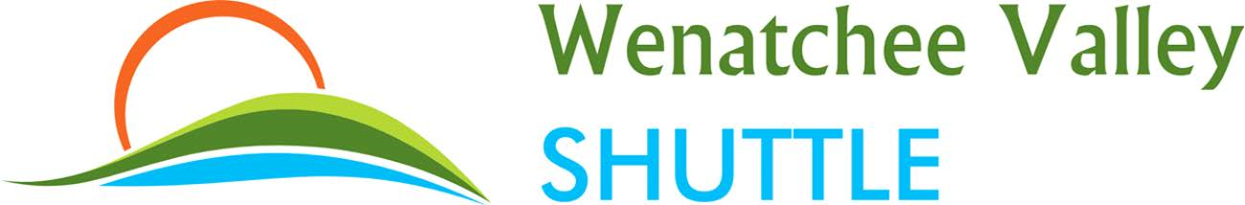

PUBLIC NOTICE May 15th, 2018
Fare Increase
EFFECTIVE June 15th, 2018

******************************************************************************

Wenatchee or Peshastin to/from North Bend, Bellevue or Sea-Tac Airport
Current fare: $45 one way/$85 round trip Proposed fare: $52 one way/$99 round trip

******************************************************************************

Pangborn Airport to/from North Bend, Bellevue or Sea-Tac Airport
Current fare: $50 one way/$95 round trip Proposed fare: $60 one way/$115 round trip

******************************************************************************

https://www.wenatcheevalleyshuttle.com/fares
If you have specific questions or need additional information about our proposed fare increase call us at 509-293-5773, stop by our office located at 400 S Wenatchee Avenue, Wenatchee, WA 98801 or mail us at Wenatchee Valley Shuttle, P.O. Box 1725, Wenatchee, WA 98807.
******************************************************************************
The Utilities and Transportation Commission regulates the rates and services offered by BML Investments LLC dba Wenatchee Valley Shuttle. If you would like to submit comments or oppose the proposed fare increase contact the commission at www.utc.wa.gov and click “Submit a Comment,” or by one of the following options:
Washington Utilities and Transportation Commission 1300 S. Evergreen Park Drive SW P.O. Box 47250, Olympia, WA 98504-7250
E-mail: comments@utc.wa.gov Telephone: 1-888-333-WUTC (9882)

