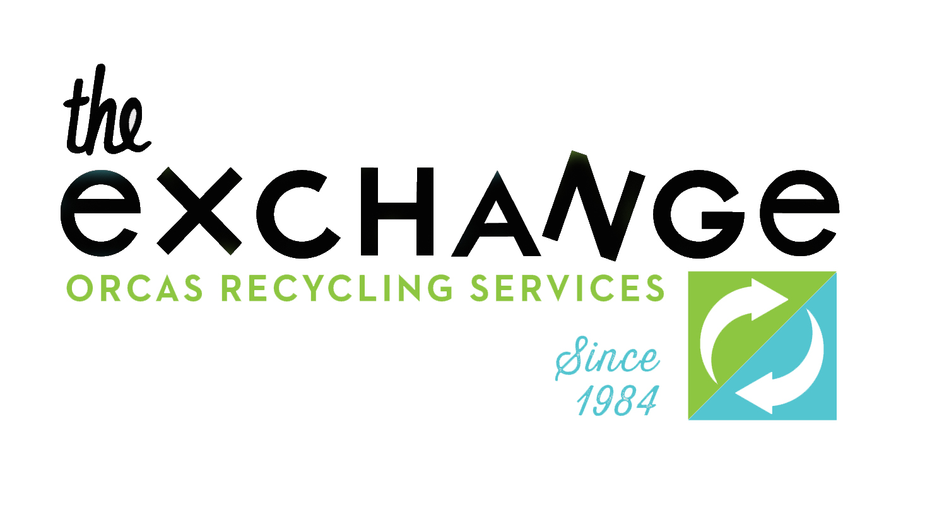

Calvin DenHartog
NVD/San Juan Sanitation
PO BOX 267
Lynden, WA 98264

Dear Calvin, July 7, 2014

Please be advised that ORS/The Exchange intends to raise most of the rates charged at the Orcas Transfer Station in the weeks to come.

Most importantly to SJS, we intend to raise the franchise rate for mixed solid waste to $195 per ton. We will also raise the franchise rate on co-mingled recycling to $130 per ton. A complete list is attached. As you know, these price adjustments were approved by the San Juan County Council on July 1, 2014.

We understand that there is a 75 day waiting period for these changes to go into effect, as per WUTC regulations. Please consider that clock stated as of today, July 7th 2014. The price changes will go into effect September 20th, 2014.

While we understand these price increases are not great news to you, we hope you can understand that we are merely trying to reach a sustainable budget model that will allow us to do the things we believe the community wants us to do.

Our doors are always open to SJS for further discussions. We honestly want to work with you guys to build a system that works well for everyone in the San Juan Islands.

Best regards,

Pete Moe
Executive Director
petemoe@gmail.com
360 298 2600

cc. Logan Luft, Tim Blanchard

3398 ORCAS ROAD • PO BOX 91 • EASTSOUND WA 98245 • 360 376 4809
WWW.EXCHANGEONORCAS.ORG

