Avista Corp.
1411 East Mission P.O. Box 3727
Spokane. Washington 99220-0500
Telephone 509-489-0500
Toll Free 800-727-9170

VIA – Electronic Mail

March 9, 2012

Dave Danner

Executive Director and Secretary

Washington Utilities and Transportation Commission

PO Box 47250

1300 S. Evergreen Park Drive SW

Olympia, WA 98504-7250

Re: Compliance Filing Docket No. UG-120195 – News Release

Dear Mr. Danner:

In compliance with Order 01 in the above referenced docket, Avista Utilities submits for filing a copy of the Company’s news release sent out on March 1, 2012. Avista serves approximately 149,000 natural gas customers in the state of Washington that may be affected by the rate decrease.

Please direct any questions on this matter to me at (509) 495-8620.

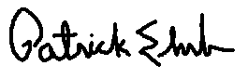
Sincerely,

Patrick Ehrbar
Manager, Rates & Tariffs

Enclosures

