June 16, 2014

Steven V. King, Executive Director and Secretary
Utilities and Transportation Commission
1300 S. Evergreen Park Dr. SW
P.O. Box 47250
Olympia, WA 98504-7250

RE: Washington Utilities and Transportation Commission v. Marvin Road Water Company

Commission Staff’s Response to Application for Mitigation of Penalties UW-140847

Dear Mr. King:

On May 28, 2014, the Utilities and Transportation Commission issued a $1,000 Penalty Assessment in Docket UW-140847 against Marvin Road Water Company for 10 violations of Washington Administrative Code (WAC) 480-110-505, which requires water companies to furnish annual reports to the commission no later than May 1 each year.¹

On June 5, 2014, Marvin Road Water Company wrote the commission requesting mitigation of penalties (Mitigation Request).² In its Mitigation Request, Marvin Road Water Company does not dispute that the violation occurred. The company provided information regarding the recent passing of the company president and subsequent sale of the company to Thurston County Public Utilities. The company states, “We were under the assumption based on comments from the PUD and our attorney that we did not need to do the annual report. We now know this is incorrect. We understand that even though we no longer own MRWC we did own it during the period of time the annual report would cover.”

It is the company’s responsibility to ensure that the regulatory fee is paid and the annual report is filed by the May 1 deadline. On February 28, 2014, Annual Report packets were mailed to all regulated telecommunication companies. The instructions for annual report completion page of
the annual report informed the regulated company that it must complete the annual report form, pay the regulatory fees, and return the materials by May 1, 2014, to avoid enforcement action.

UTC Annual Reports
June 16, 2014
Page 2

On May 30, 2014, Marvin Road Water Company filed documents regarding the sale of assets to Public Utility District No. 1 of Thurston County in Docket UW-141211.³ No prior violations of WAC 480-110-505 are on commission record. Staff supports the company’s request for mitigation. Staff recommends the penalty be waived due to the extraordinary circumstances provided in the company’s response to mitigation and recent sale of assets.

If you have any questions regarding this recommendation, please contact Amy Andrews, Regulatory Analyst, at (360) 664-1157, or aandrews@utc.wa.gov.

Sincerely,

Sondra Walsh, Director
Administrative Services

ATTACHMENT A
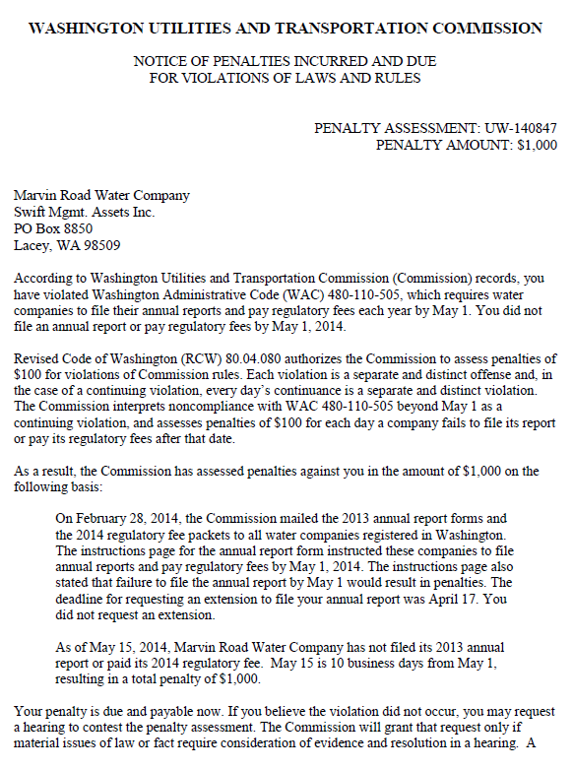
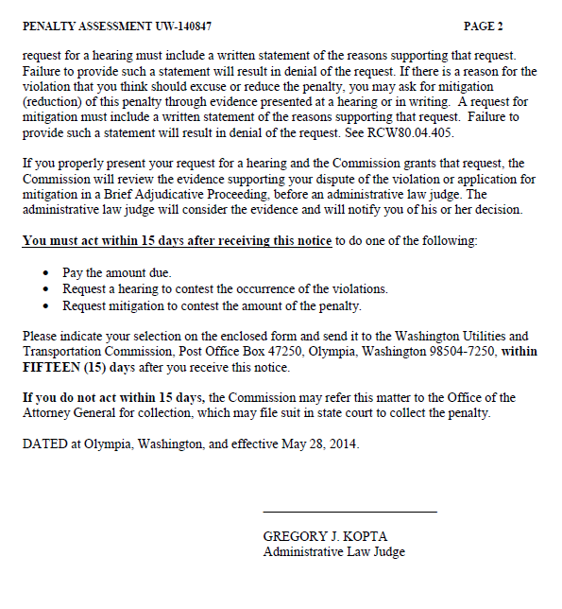

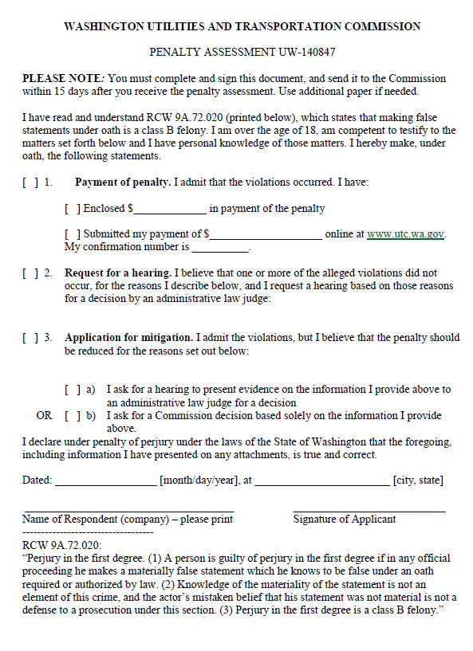

ATTACHMENT B
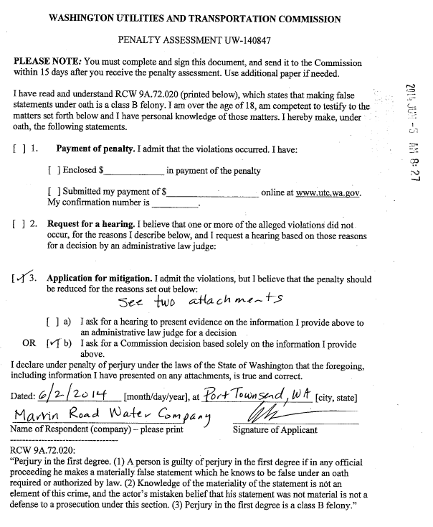

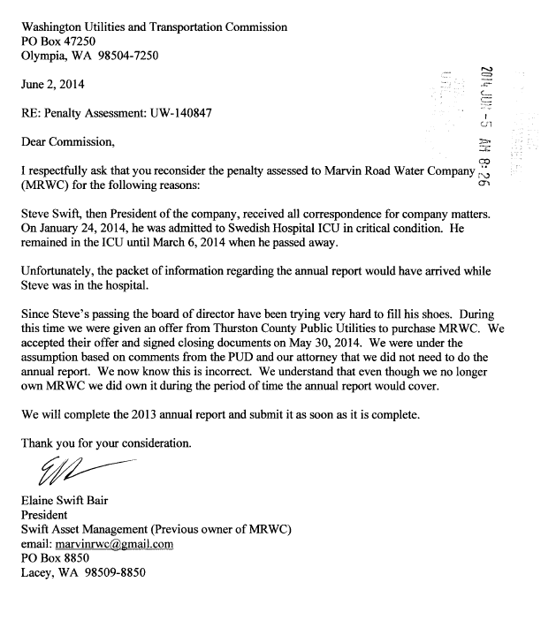

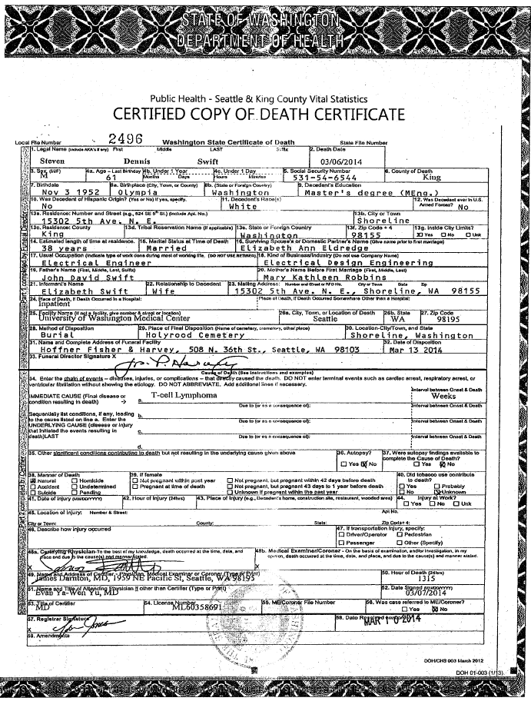

ATTACHMENT C
