https://www.seattletimes.com/business/economy/washington-adds-more-than-116000-unemployment-claims-even-as-state-reopens-from-coronavirus/

Unemployment claims in Washington state during coronavirus pandemic top 1 million
May 14, 2020 at 6:47 am Updated May 14, 2020 at 7:57 pm
Businesses on Fourth Avenue and Pike Street in downtown Seattle are boarded up, as seen on Wednesday. State officials expect claims for jobless... (Steve Ringman / The Seattle Times) More
By
Paul Roberts
Seattle Times business reporter
More than a million workers in Washington have filed for unemployment benefits or related assistance since early March, a grim milestone as the state continues to grapple with the unprecedented economic damage from the coronavirus pandemic.
State officials expect claims for jobless benefits will decline over coming months as Washington continues to reopen its shuttered economy. But “for now, these [jobless numbers] represent our new normal,” Suzi LeVine, Employment Security Department (ESD) commissioner, said at a Thursday news conference after the state released the latest claims data.
For the week ending May 9, the ESD received 109,425 initial weekly claims for unemployment insurance — an 8.6% increase from the previous week and a clear reminder that the job market will likely lag behind the state’s efforts to emerge from the coronavirus-induced shutdown.
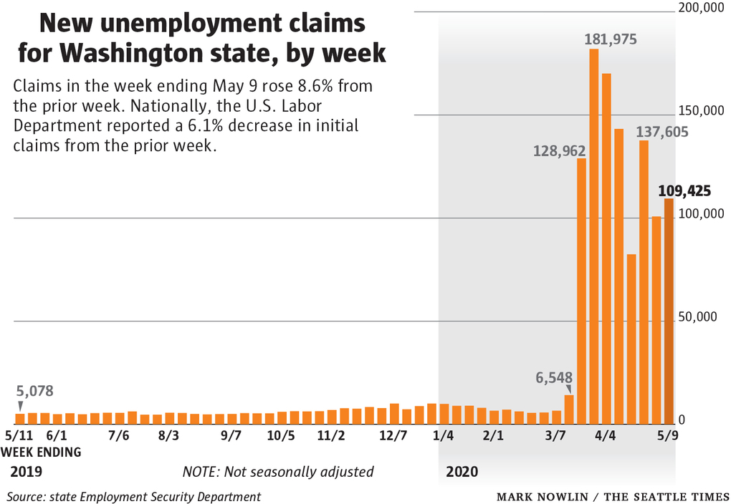
Washington was among the few states reporting an increase in jobless claims. The nation as a whole saw 2.98 million initial unemployment claims last week, down 6.1% from the prior week, the Labor Department reported Thursday.
Roughly 36 million people nationwide have sought jobless aid in just the two months since the coronavirus first forced businesses to close down and shrink their workforces. The figures point to a job market gripped by its worst crisis in decades and an economy that is sinking into a deep downturn.
A total of 1,027,292 workers in Washington, or roughly 1 in 3, have filed for unemployment benefits or related assistance since March 7, when layoffs began surging amid the pandemic, according to the ESD. That’s up from 810,538 the prior week, in part as the state has processed more claims for special federal assistance to workers who would not normally be eligible for state unemployment benefits.
ADVERTISING
The latest claims data comes as Washington and most other states move toward fewer coronavirus-related restrictions on some business activities.
Last week, Gov. Jay Inslee announced that nonessential retailers can reopen for curbside pickup in the first of the state’s four-phase reopening plan. The governor also said landscapers and pet walkers could return to work and that five counties — Columbia, Ferry, Garfield, Lincoln and Pend Oreille — could move to the second phase of reopening because they have fewer than 75,000 people and hadn’t reported a confirmed COVID-19 case in three weeks.
Phase 2 is expected to begin for most areas on June 1, provided public-health data looks favorable.

RELATED
Washington halts unemployment payments for 2 days after finding $1.6 million in fraudulent claims
The state also reported on Thursday that it has paid nearly $2.9 billion in benefits since March 7, including $767 million last week alone. Of the 1,027,292 individuals who have filed unemployment claims, 751,149 have received benefits. Many individuals who have not been paid have failed to file necessary claims, made mistakes in their claims or need to have their claims more closely reviewed by the department, ESD officials say.
That last category includes Bremerton resident Matthew Preus, 63, who lost his job as a car salesperson in March and said his unemployment claim has been stalled in the ESD’s “adjudication” process since mid-April. Last week, he said, the ESD cleared up one of three issues holding up his claim, but hasn’t indicated when he can expect resolution of the final two. In the meantime, Preus said, he has applied for food stamps.
“This is the first time I’ve ever needed public assistance,” said Preus, who said he has worked since he was 13. “That’s a crushing blow for a guy like me.”
ADVERTISING
Last week, LeVine announced a new effort to clear the roughly 57,000 claims that were under review. On Thursday, she said that number had dropped to 48,000.
That was welcome news for Evan Flay, 31, a strength and conditioning coach in the Issaquah area who is waiting on claims he filed in late March.
“It’s frustrating, but we’re healthy and there’s lot of people who are worse off,” said Flay, adding that he’s tried to maintain his perspective given the scale of the task the state faces. “No one could have foreseen millions of people all hitting unemployment all at once.”
The Associated Press contributed to this report.

