June 26, 2014

Steven V. King, Executive Director and Secretary
Utilities and Transportation Commission
1300 S. Evergreen Park Dr. SW
P.O. Box 47250
Olympia, WA 98504-7250

RE: Washington Utilities and Transportation Commission v. Yelm Adult Community Center

Commission Staff’s Response to Application for Mitigation of Penalties TN-141042

Dear Mr. King:

On May 22, 2014, the Utilities and Transportation Commission issued a $1,000 Penalty Assessment in Docket TN-141042 against Yelm Adult Community Center for 10 violations of Washington Administrative Code (WAC) 480-30-080, which requires nonprofit special needs transportation provider companies to furnish annual reports to the commission no later than May 1 each year.¹

On June 12, 2014, Yelm Adult Community Center wrote the commission requesting mitigation of penalties (Mitigation Request).² In its Mitigation Request, Yelm Adult Community Center does not dispute that the violation occurred. The company states, “Last September, their Center Manager was dismissed under allegations of financial mismanagement and theft. At that time, the Board of Directors was comprised of senior citizens who, though well intentioned, did not understand the governance and fiduciary responsibilities of a non-profit board.” The request continues to provide historical information regarding the company and the devastating effect a financial penalty would cause to the service being provided to the seniors of Yelm.

It is the company’s responsibility to ensure that the regulatory fee is paid and the annual report is filed by the May 1 deadline. On February 28, 2014, Annual Report packets were mailed to all regulated nonprofit special needs transportation provider companies. The instructions for annual report completion page of the annual report informed the regulated company that it must complete the annual report form, pay the regulatory fees, and return the materials by May 1, 2014, to avoid enforcement action.

UTC Annual Reports
June 26, 2014
Page 2

On June 16, 2014, Yelm Adult Community Center filed the 2013 annual report and paid the required regulatory fees and late payment penalty. The company has been active since August 4, 2006. No prior violations of WAC 480-30-080 are on commission record. Staff supports the company’s request for mitigation. Due to the compelling circumstances provided by the company and past filing history, staff recommends to waive the penalty in full.

If you have any questions regarding this recommendation, please contact Amy Andrews, Regulatory Analyst, at (360) 664-1157, or aandrews@utc.wa.gov.

Sincerely,

Sondra Walsh, Director
Administrative Services

ATTACHMENT A
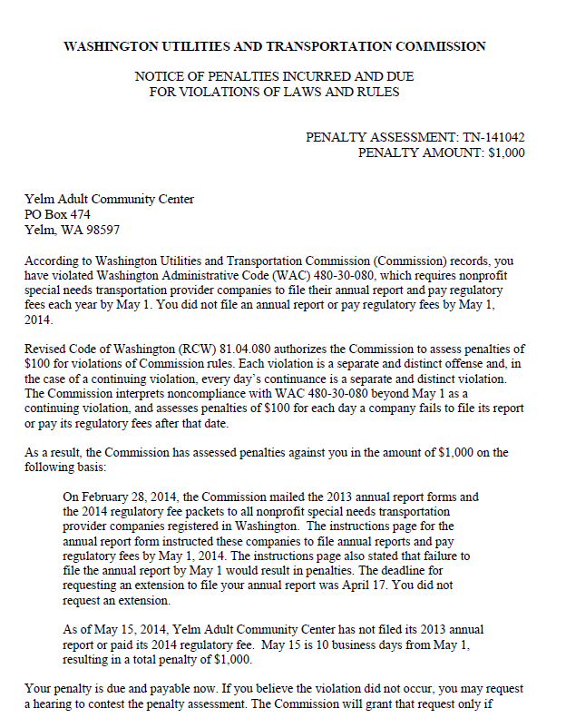

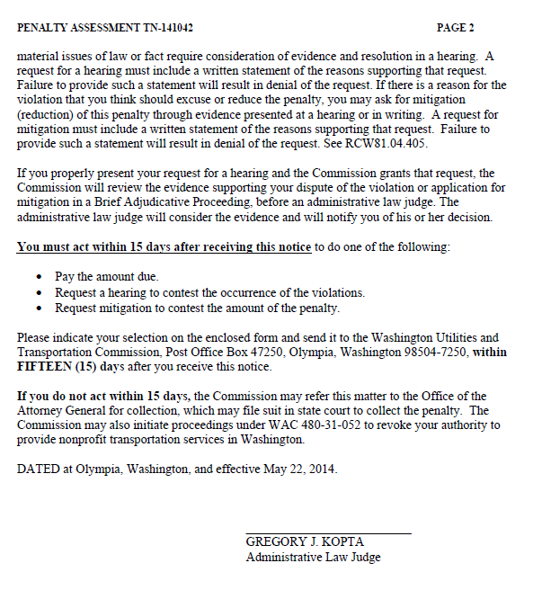

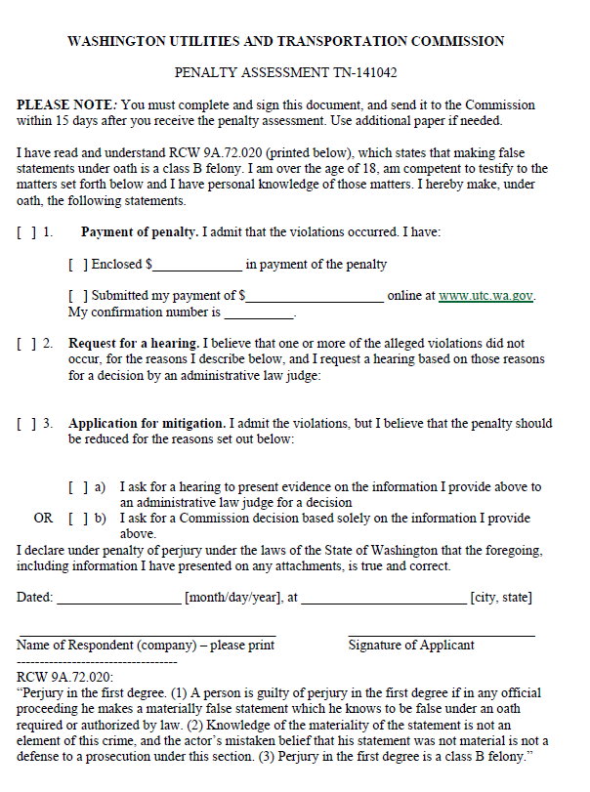

ATTACHMENT B
