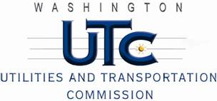

Memorandum
April 27, 2011

To: TR-110558 - File

From: Kathy Hunter, Deputy Assistant Director Transportation Safety

Subject: TR-110558 Washington and Idaho Railway
Grade Crossing Protective Fund (GCPF) Project at the Intersection of
State Route 271 (SR-271) and Washington and Idaho Railway’s Tracks in Whitman County, Washington

On April 8, 2011, the Washington Utilities and Transportation Commission (Commission) awarded a GCPF grant totaling $4,769.07 to install LED lights, replace the cross-bucks, install battery chargers and an LED power off light at the SR-271 crossing in Whitman County. The USDOT number assigned to this crossing is 058905N.

On April 27, 2011, the applicant, Washington and Idaho Railway submitted a request for reimbursement pursuant to Commission order. On April 26, 2011, Commission staff conducted a site visit and verified that the project is completed according to the specifications outlined in the order approving the grant.

Please close this docket.

