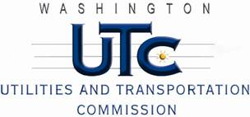

Memorandum
December 18, 2009

To: TR-091495 - File

From: Kathy Hunter, Deputy Assistant Director Transportation Safety

Subject: TR-091495 Columbia Basin Railroad
Grade Crossing Protective Fund (GCPF) Project at M Southeast Road in the City of Moses Lake, Washington

On September 23, 2009, the Washington Utilities and Transportation Commission (Commission) awarded a GCPF grant totaling $3,403 for replacing incandescent lights with LEDs at the M Southeast Road crossing in the City of Moses Lake. The USDOT number assigned to this crossing is 396959A.

On December 17, 2009, the applicant, Columbia Basin Railroad submitted a request for reimbursement in the amount of $3,628.81 pursuant to Commission order. The Commission will reimburse up to $3,403 which is the approved grant amount. On December 4, 2009, Commission staff conducted a site visit and verified that the project is completed according to the specifications outlined in the order approving the grant.

Please close this docket.

