EXHIBIT 9

CONTINUED OPERATIONS CERTIFICATE

I, Dale Merten, an officer of the Company, under penalty of perjury, hereby certify that if the Company receives Program support, the Company will continue to provide communications services pursuant to its tariffs on file with the Commission throughout its service territory in Washington for which the company is seeking and receives Program support during the entirety of 2015.

Dated this 27th day of July, 2016.

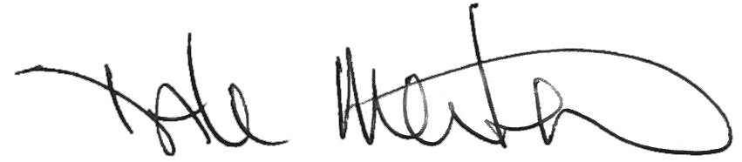
Dale Merten
C.O.O.

