August 18, 2014

Steven V. King, Executive Director and Secretary
Utilities and Transportation Commission
1300 S. Evergreen Park Dr. SW
P.O. Box 47250
Olympia, WA 98504-7250

RE: Washington Utilities and Transportation Commission v. Group Six Communications, LLC

Commission Staff’s Response to Application for Mitigation of Penalties UT-140889

Dear Mr. King:

On June 2, 2014, the Utilities and Transportation Commission issued a $1,000 Penalty Assessment in Docket UT-140889 against Group Six Communications, LLC for 10 violations of Washington Administrative Code (WAC) 480-120-382, which requires telecommunications companies to furnish annual reports to the commission no later than May 1 each year.¹

On August 13, 2014 Group Six Communications, LLC wrote the commission requesting mitigation of penalties (Mitigation Request).² In its Mitigation Request Group Six Communications, LLC does not dispute that the violation occurred. The company states, “It’s been a devastating time, picking up the pieces after our founder/President who was also my boss and friend passed away just as we were about to start a brand new year. We humbly request that the penalty be rescinded with our promise that this will not be an issue in the future”.

It is the company’s responsibility to ensure that the regulatory fee is paid and the annual report is filed by the May 1 deadline. On February 28, 2014, Annual Report packets were mailed to all regulated telecommunication companies. The instructions for annual report completion page of
the annual report informed the regulated company that it must complete the annual report form, pay the regulatory fees, and return the materials by May 1, 2014, to avoid enforcement action.

UTC Annual Reports
August 18, 2014
Page 2

On August 13, 2014 Group Six Communications, LLC filed its completed annual report and paid the regulatory and late payment fees due. The company has one prior violation of WAC 480-120-382 for the 2010 Annual Report. Staff does not support the company’s request to rescind the penalty due to prior violations. However, due to the extenuating circumstances experienced by the company during the 2014 process, staff does recommend partial mitigation. Staff recommends a reduced penalty of $25/day for a total assessed penalty of $250.

If you have any questions regarding this recommendation, please contact Amy Andrews, Regulatory Analyst, at (360) 664-1157, or aandrews@utc.wa.gov.

Sincerely,

Sondra Walsh, Director
Administrative Services

ATTACHMENT A
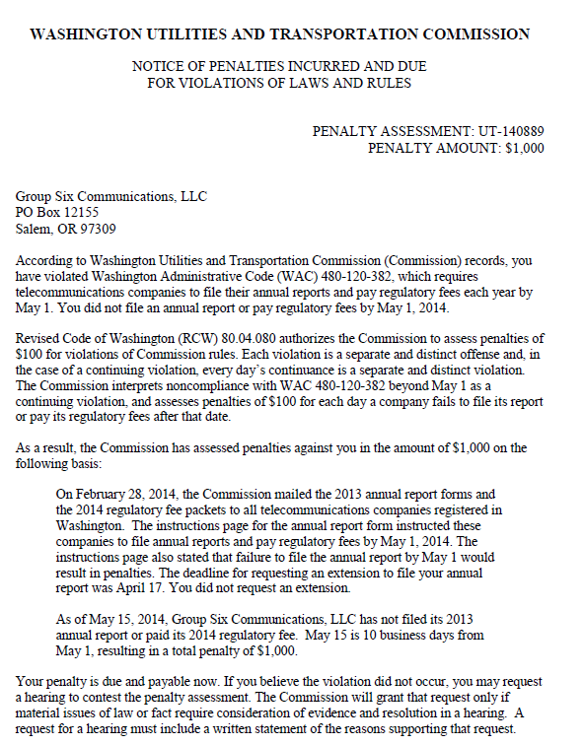

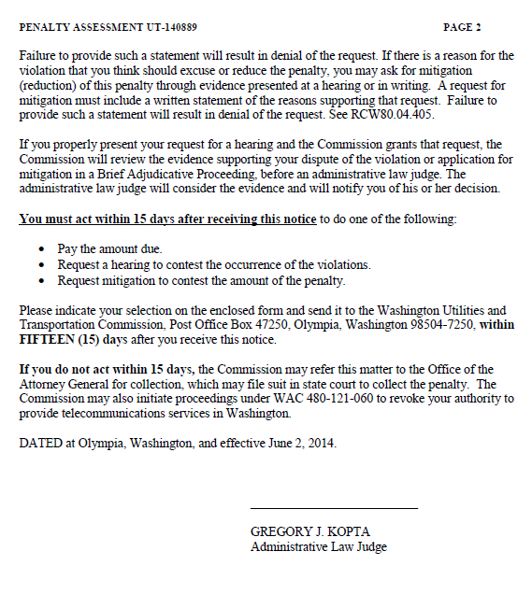

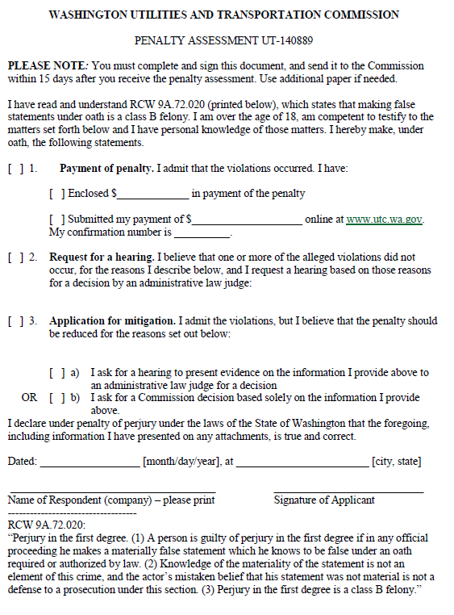

ATTACHMENT B
