June 24, 2014

Steven V. King, Executive Director and Secretary
Utilities and Transportation Commission
1300 S. Evergreen Park Dr. SW
P.O. Box 47250
Olympia, WA 98504-7250

RE: Washington Utilities and Transportation Commission v. Allwest Transportation, Inc.

Commission Staff’s Response to Application for Mitigation of Penalties TV-140940

Dear Mr. King:

On June 4, 2014, the Utilities and Transportation Commission issued a $1,000 Penalty Assessment in Docket TV-140940 against Allwest Transportation, Inc. for 10 violations of Washington Administrative Code (WAC) 480-15-480, which requires household goods carrier companies to furnish annual reports to the commission no later than May 1 each year.¹

On June 10, 2014, Allwest Transportation, Inc. wrote the commission requesting mitigation of penalties (Mitigation Request).² In its Mitigation Request, Allwest Transportation, Inc. does not dispute that the violation occurred. The company states, “On April 15th, I was forced to abruptly terminate our bookkeeper/office manager whose responsibility included completing this report.” The statement continues, “I was under the impression that this report had been completed and mailed well before her termination date. Obviously, I was mistaken; the report was completed, but had not been mailed.”

It is the company’s responsibility to ensure that the regulatory fee is paid and the annual report is filed by the May 1 deadline. On February 28, 2014, Annual Report packets were mailed to all regulated household goods companies. The instructions for annual report completion page of the annual report informed the regulated company that it must complete the annual report form, pay the regulatory fees, and return the materials by May 1, 2014, to avoid enforcement action.

UTC Annual Reports
June 24, 2014
Page 2

On June 11, 2014, Allwest Transportation, Inc. filed the 2013 annual report and paid the required regulatory fees and late payment penalty. The company has been active since April 8, 2005. No previous violations of WAC 480-15-480 are on commission record. Staff supports the company’s request for mitigation as this is the company’s first delinquent filing. Staff recommends a reduced penalty assessment of $200.

If you have any questions regarding this recommendation, please contact Amy Andrews, Regulatory Analyst, at (360) 664-1157, or aandrews@utc.wa.gov.

Sincerely,

Sondra Walsh, Director
Administrative Services

ATTACHMENT A
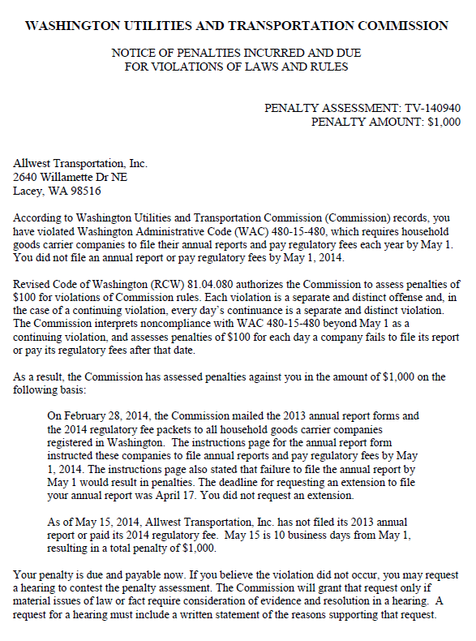

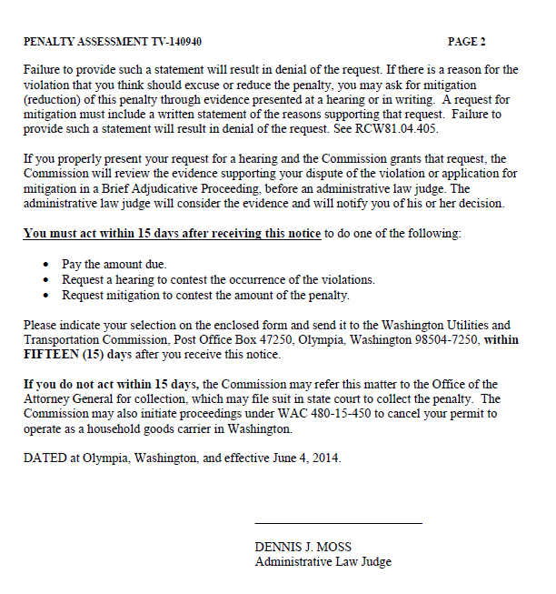

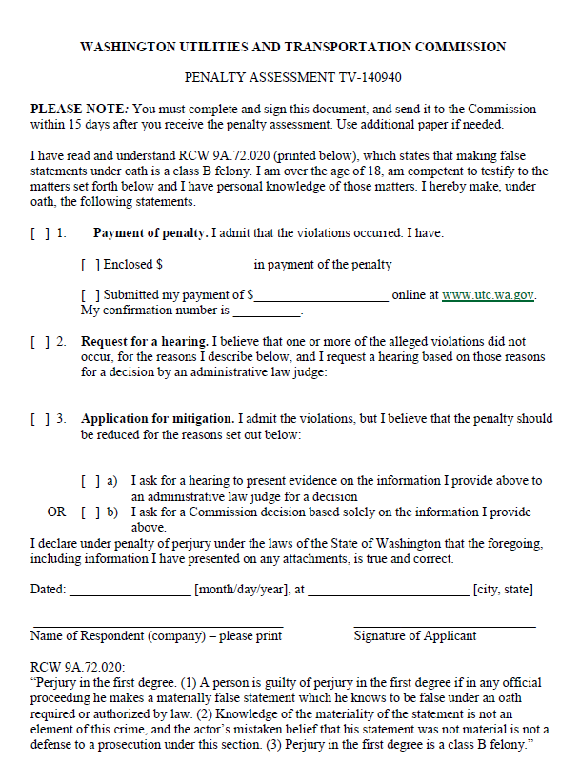

ATTACHMENT B
