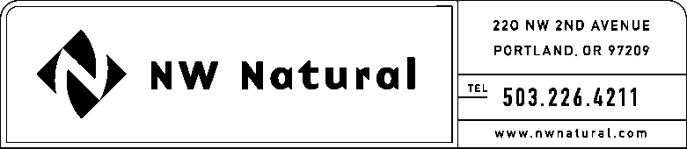

Onita R. King
Rates & Regulatory Affairs
Tel: 503.721.2452
Fax: 503.721.2516
email: ork@nwnatural.com

October 22, 2015 NWN WUTC Advice No.15-7 / UG-151827
DO NOT REDOCKET

Steven V. King, Executive Director & Secretary
Washington Utilities and Transportation Commission
1300 S Evergreen Park Drive SW
Post Office Box 47250
Olympia, Washington 98504-7250

Re: Tariff Sheet 230.2 – Correct Tariff Sheet Version Only
DO NOT REDOCKET

Northwest Natural Gas Company, dba NW Natural (NWN or the “Company”) files herewith the following revisions to its Tariff WN U-6, stated to become effective with service on and after November 1, 2015, as follows:

Fifth Revision of Sheet 230.2,
Schedule 230,
“Temporary Adjustments to Rates for Low-Income Programs.”

The purpose of this filing is to correct the sheet version which was incorrectly filed on September 11, 2015, as Fourth Revision of Sheet 230.2 and should have reflected Fifth Revision of Sheet 230.2, canceling the Fourth Revision.

Please address correspondence on this matter to me at ork@nwnatural.com, with copies to the following:

eFiling

Rates & Regulatory Affairs
NW Natural
220 NW Second Avenue

Portland, Oregon 97209
Telecopier: (503) 721-2516

Telephone: (503) 226-4211, ext. 3589
eFiling@nwnatural.com

Sincerely,

NW NATURAL

/s/ Onita R. King

Onita R. King
Rates & Regulatory Affairs

Attachment

