November 1, 2016  Via Electronic Filing and US Mail  Mr. Steven V. King  Executive Director  Washington Utilities & Transportation Commission  1300 S. Evergreen Pk. Dr. S.W.  P. O. Box 47250  Olympia, WA 98504-7250 |  | Elizabeth Thomas  liz.thomas@klgates.com  T 1 206 370 7631

Re: | Docket No. UE-161123 – Puget Sound Energy Schedule No. 451: Large Customer Retail Wheeling, Advice No. 2016-28
Dear Mr. King:
Enclosed for filing in the above-referenced docket, please find the following on behalf of Microsoft Corporation:
- Amended Notice of Appearance of Microsoft Corporation.
Thank you for your assistance. Please do not hesitate to call if you have any questions.
Sincerely yours,
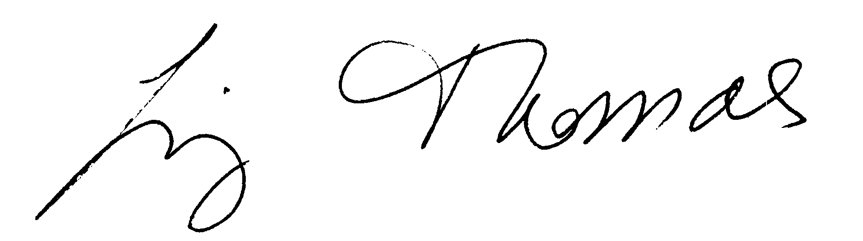
Elizabeth Thomas

Enclosures

CERTIFICATE OF SERVICE

I HEREBY CERTIFY that I have this day served the attached Amended Notice of Appearance of Microsoft Corporation upon all parties of record (listed below) in this proceeding by electronic mail and by mailing a copy properly addressed with first class postage prepaid.
Ken Johnson  Director – Rates & Regulatory Affairs  Puget Sound Energy  P.O. Box 97034, PSE-08N  Bellevue, WA 98009-9734  ken.s.johnson@pse.com | Sheree Carson  Perkins Coie, LLP  10885 N.E. Fourth St.  Bellevue, WA 98004-5579  scarson@perkinscoie.com | Jason Kuzma  Perkins Coie, LLP  10885 N.E. Fourth St.  Bellevue, WA 98004-5579  jkuzma@perkinscoie.com
Jennifer Cameron-Rulkowski  Assistant Attorney General  WUTC  P.O. Box 40128  Olympia, WA 98504-0128  jcameron@utc.wa.gov | Jennifer Snyder  Regulatory Analyst  WUTC  P.O. Box 40128  Olympia, WA 98504-0128  jsnyder@utc.wa.gov | Lisa Gafken  Office of the Attorney General  800 Fifth Avenue, Ste. 2000  Seattle, WA 98104-3188  LisaW4@atg.wa.gov
Industrial Customers of Northwest Utilities  818 SW 3rd Avenue #266  Portland, OR 97204 | Tyler C. Pepple  Davison Van Cleve, P.C.  333 S.W. Taylor, Suite 400  Portland, OR 97204  tcp@dvclaw.com | Simon J. ffitch  The Energy Project  321 High School Rd. NE, Suite D3, Box 383  Bainbridge Island, WA 98110  simon@ffitchlaw.com
Christopher M. Casey  Assistant Attorney General  Utilities & Transportation Division  PO Box 40128  Olympia, WA 98504-0218  ccasey@utc.wa.gov | Joni Bosh  NW Energy Coalition  811 1st Avenue, Suite 305  Seattle, WA 98104  joni@nwenergy.org | Jeff Roberson  Assistant Attorney General  Counsel for WUTC Staff  PO Box 40128  Olympia, WA 98504-0218  jroberso@utc.wa.gov
Dated this 1st day of November, 2016.
/s/ Liz Thomas
Liz Thomas
K&L Gates LLP
925 Fourth Avenue, Suite 2900
Seattle, WA 98104
Email: liz.thomas@klgates.com

Of Attorneys for
Microsoft Corporation

